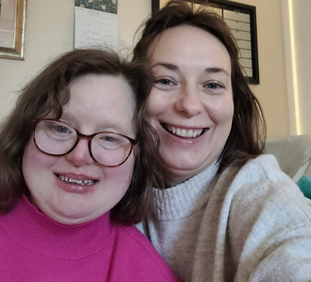 |  | Hello, we are Fiona Dawson and Andrea Tonner, we are researchers at the University of Strathclyde.
We are looking for people with a learning disability age 18 or over to take part in research we are doing.

Research means to study and learn more about something.

 |  | We want to know more about what you like and dislike about using digital technology
 |  | This will help us to know how to make digital technology better in the future
Your part will last for 1 month.
We will keep working on the research for 6 months.
What do you need to do?

Think about technology that you use and why you need to use it. We would like to know what could make technology better for you. This could be anywhere you use digital technology.

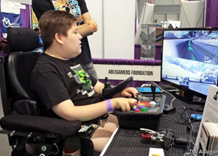
Fun | Work |  | Health
 |  | You can choose how you want to tell us about the digital technology you like and the digital technology you don’t like.
 |  | You can take photos or make videos or tell me stories about how you use digital technology.
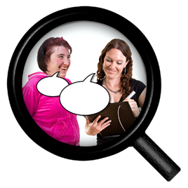 |  | We will record the information. This helps us to remember what you say and to tell other people about how to make digital technology better for you.
If you would like to take part, you can let us know in different ways. You can email Andrea on: a.tonner@strath.ac.uk
Phone, whatsapp or text Andrea: 07771 776 971

