Stand by Me Easy Read Report
Experiences of couples with a learning disability when one partner has dementia

Acknowledgements
Thanks are extended to the Stand by Me research advisory group: Andrew Doyle, Lynn Doyle, Louise Boustead, Jill Carson and Jan Murdoch. Thanks also to all participants who gave their time and valuable insight, and to the interns and students who contributed to our work: Gillian Fitzsimmons, Sumeiyah Koya, Rachel Carney and Laura McGenily.

Research team
Professor Karen Watchman, Dr Paula Jacobs, Dr Louise Hoyle, University of Stirling; Professor Heather Wilkinson, University of Edinburgh.

This research was supported by The Dunhill Medical Trust. For information about the Stand by Me project please visit: scld.org.uk/stand-by-me/

©2023 Karen Watchman

 | What is our research about?
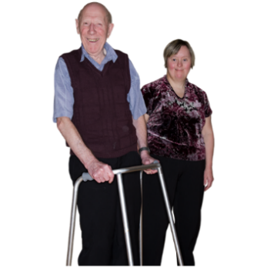 | As we get older, we are all more likely to get some illnesses. Some people get an illness called dementia.  We wanted to understand how couples with a learning disability feel when one partner has dementia.
The idea for the research came from a married man with a learning disability who had dementia.

He and two other people with a learning disability worked on all parts of the research.
 | What did we do?
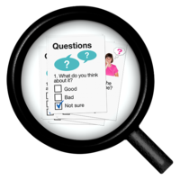 | We talked to:  - Five people with a learning disability  - Four family members  - Eight staff members who supported couples  The interviews helped us to understand the lives of eight couples with a learning disability.
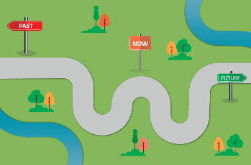 | We asked about the past present and future.  This included how couples met, what their life was like before dementia and what changed because of dementia.
 | What did people tell us about how the couples met?
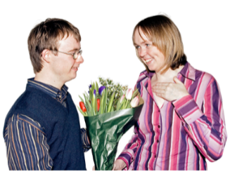 | Most couples had been together, or had known each other, for more than 20 years.  Four of the couples were married and seven had lived together.
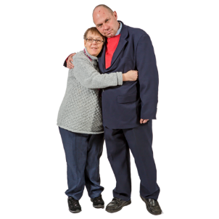 | Some couples needed to fight for their right to be in a relationship.  Other couples felt that their family and staff had been supportive.
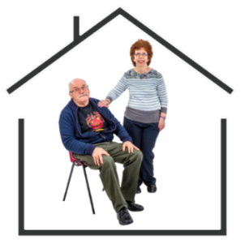 | When they were younger, many people with a learning disability had lived in large group homes or institutions with other people.  Having their own house or flat was important for couples.

 | What did people tell us about getting a dementia diagnosis?
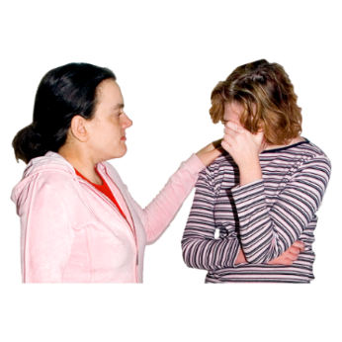 | Getting the dementia diagnosis was difficult and scary for most couples.  Some couples seemed to accept the diagnosis and did not ask questions. Later, people said or showed that the diagnosis had made them sad.
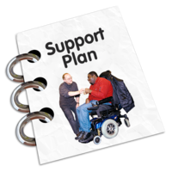 | People did not always know how to help their partner.  People with a learning disability talked about the importance of hope. It was important to find out what could help them and their partner.
Talking about dementia could be hard. But not talking about it made some people feel scared and worried.

It was important to help couples talk about how they were feeling after a diagnosis. Sometimes it was easier to do that separately.
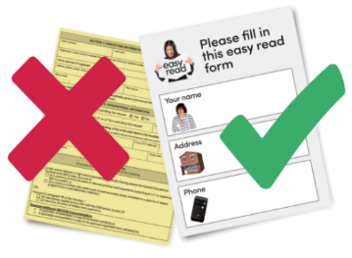 | Some information about dementia was difficult to understand.  Using easy read, pictures and videos helped to talk about dementia.
 | What did people tell us about how their lives changed because of dementia?
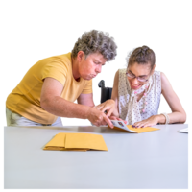 | Some routines and activities changed. With the right support other things stayed the same.  The partner with dementia needed more help.
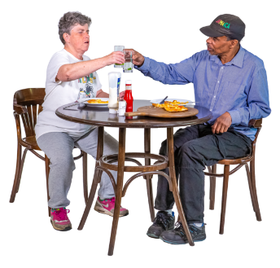 | Partners without dementia took on caring roles.  Partners without dementia talked about how looking after their partner could be difficult.  They also said that they wanted to be involved with caring for their partner.
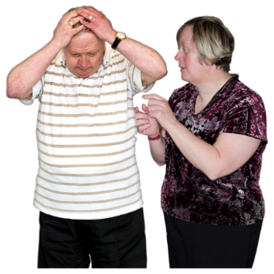 | People with a learning disability said it could be hard when their partner with dementia got angry, sad or confused.  People understood that their partner could get upset because of dementia.
 | What helped couples?
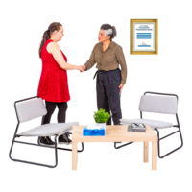 | Having someone to talk to was important for all couples.  Three people with a learning disability had counselling which they found helpful.
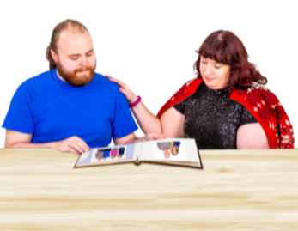 | Looking at photo albums, listening to favourite songs, preparing favourite food and talking about good memories all helped.  Learning disability staff were the main support for couples in this study.
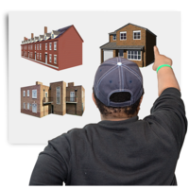 | Most couples were able to stay living together in their home with the right support for many years.  Two partners who moved to a care home were supported by staff and family members to see each other regularly.
 | There was a lot of love and care in the relationships.

This research was supported by The Dunhill Medical Trust

©2023 Karen Watchman

The University of Stirling is a charity registered in Scotland, number SC011159

