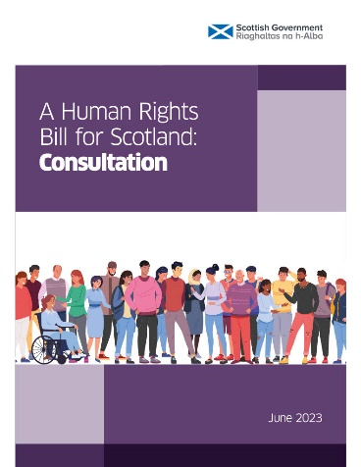 | Human Rights Bill for Scotland  Response to Scottish Government
What are your views on the new human rights bill for Scotland? (Question 4)

Are there any other rights you think should be included in the new Human Rights Bill for Scotland? (Question 5)
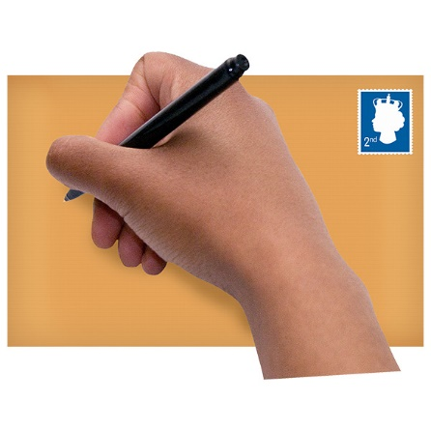 | Dear Scottish Government  My name is ………………………………………..  I am responding to the consultation on the Human Rights Bill for Scotland because I am worried that people with learning disabilities and other disabled people won’t have their human rights made real in Scotland  I think parts of the convention on the rights of persons with disabilities need to be included in the new human rights bill for Scotland  People with learning disabilities need to have their rights in law  Some rights that are really important to people with learning disabilities are:  Being treated equally in the law (CRPD: Article 12)  Being able to get justice (CRPD: Article 13)  And being able to live independently and being included in the community (CRPD: Article 19)  Some other things that are important to me are:  ……………………………………………  ……………………………………………  …………………………………………  ……………………………………………  Thank you and I hope you help make my human rights real.  From: ……………………………………  …………………………………………….

