Our Future Leaders
Sponsor Information
 |  | This easy read will give you some information about the course and about the role of the sponsor.
Who is the Our Future Leaders course for?

The course is designed for people who have learning/intellectual disabilities

They must already be involved in things like volunteering, paid work, be part of a board or a charity

The course is for people who want to learn leadership skills or improve the skills they already have.

Maybe they want to learn new skills to help them achieve a goal or to feel more confident leading in their life.
What will you learn on the course?

There are lots of different things you will learn on the course.

Here are a few:

- Know what being a leader means

- Be confident in your abilities

- Learn new skills

- Be able to advocate for yourself or others

- To achieve personal goals, for example getting a paid job or a volunteering role

- Be able to inspire and motivate others

- Be confident in taking on more responsibility

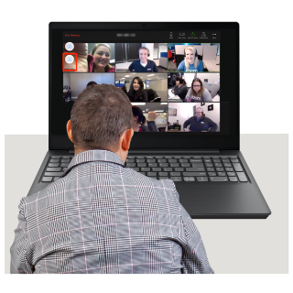 |  | What is the course structure?  - Sessions are every two weeks and all sessions are on Zoom  - Each session is two hours long with a break for 15 mins  - There are up to 12 people on the course  - It is a small group because we want to make sure each person gets the support they need and feels comfortable to participate  - You are asked to set goals at the start of the course  - Each session has an external trainer who specialises in the topic they are presenting  - Course workbooks and any other materials are sent out in easy read via email before the session. The workbooks are in Word  A special feature of the course is the sponsor
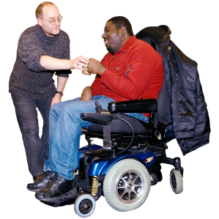 |  | Who should the sponsor be?  - Someone who knows you but is not related to you  - For example, the sponsor could be someone who knows you through work or volunteering  - Or they could be someone who knows you through their support service  - Or they could know you through an organisation or Board that you have both been involved in  What is the time commitment for the sponsor?  - 12 sessions of 2 hours each + pre-session work and post-session homework  - This adds up to a minimum of 36 hours in total  - Or around three hours per fortnight  - Time would also be needed at the end to write a short case study  If you do not think you can find a sponsor or you are not sure if you have the right sponsor please ask and we can help you.  Contact us at oflenquiries@inspiringscotland.org.uk
What does the sponsor do?

Being a sponsor is an important role. The sponsor supports you to engage with the course and get the most out of it.

The sponsor must be able to regularly check in with you to support you to put your learning into practice and make sure you understand the sessions

Before the session

The sponsor should support you with any preparation you need to do before the session

During the session

The sponsor should be a silent observer during the session. They are there mainly to observe and give any personal or technical support you might need

Sponsors are encouraged to take notes during the sessions. This is so they can follow up after the session with any questions, record progress and any support you might need
After the session

The sponsor should support you to complete your learning logs and encourage you to put your new skills and knowledge into practice

The sponsor also needs to add their thoughts on the session into the learning log

At the end of the course

You and the sponsor should write a short case study about your experience of the course. For example what you have learned, if you have noticed any changes in yourself and how you will use your leadership skills in real life
 |  | Remember: If you do not think you can find a sponsor or you are not sure if you have the right sponsor please ask and we can help you
If you have any questions please email

oflenquiries@inspiringscotland.org.uk

We look forward to receiving your application!

