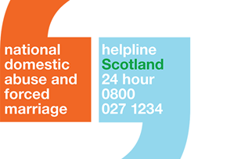 | If you have been affected by domestic abuse or forced marriage, phone Scotland’s Domestic Abuse and Forced Marriage Helpline on:  08000271234  The line is open 24 hours a day, 7 days a week.
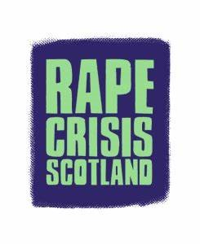 | If you have been affected by sexual violence phone Rape Crisis Scotland on:  08088010302
If you have been raped or sexually assaulted, phone the NHS Sexual Assault Response Coordination Service on:

0800 148 88 88

Calls are free from landlines and mobiles 24 hours a day, 7 days a week.

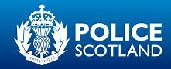 | To report domestic abuse when it is not an emergency phone Police Scotland on:  101
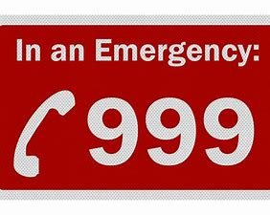 | If you are in danger phone 999.  If it’s not safe to speak try to reply to instructions by tapping or making a noise.  If you call from a mobile you may be asked to press 55. This lets the operator know it’s an emergency.

