Scottish Learning Disability Awards
Nomination form 2020
Social Impact Award
Please send back to SCLD by
5pm Monday 3rd February 2020
Useful information to help you
 |  | Social Impact Award
 |  | This award will go to a person or group of people with learning disabilities who have brought their product or business idea to life
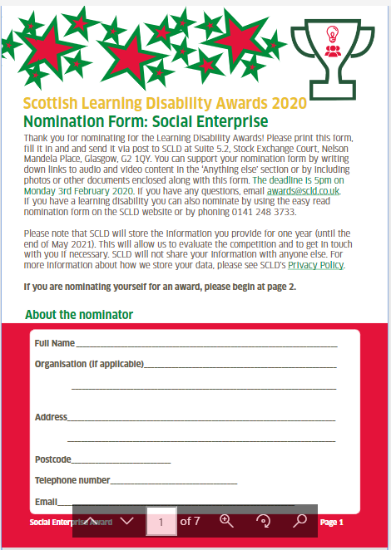 |  | The judges will be looking at the information in the nomination forms to decide on who the winners are
Please tell us about you
 | Name
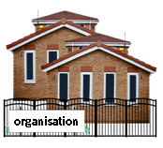 | Organisation name (if you are applying on behalf of your organisation)
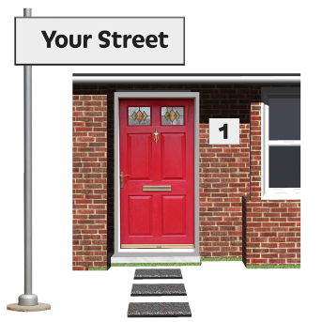 | Address
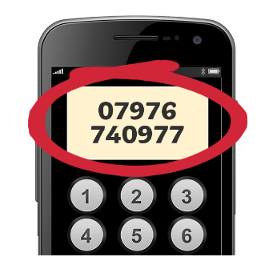 | Phone number
 | Email
Please tell us about the person or group you are nominating
 | Name
 | Address
 | Phone number
 | Email
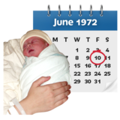 | Age

Please tell us
 | Tell us about the skill that the person or group of people has or the product that they have made
 | Tell us about the steps the person or group of people has taken to get their enterprise off the ground
 | Has the skill or product been used, sold or shared with others?
 | Tell us about the plans of the person or group of people
Anything else?
 | Is there anything else you would like to tell us about the person or group?
Your form will be stored on a secure digital filing system which is only accessible to SCLD staff

This will be kept for 1 year
Important Dates
Please send your form to SCLD at the address below by 5pm Monday 3rd February 2020

We will get in touch with you on the week beginning 23rd March 2020
Contact Us
SCLD
Suite 5.2
Stock Exchange Court
77 Nelson Mandela Place
Glasgow
G2 1QT

 |  | awards@scld.co.uk
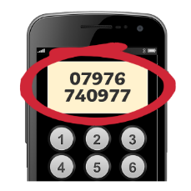 |  | 0141 248 3733

