Celebrate Learning Disability Week
- Monday 14th May 2018

Visit Wilton Lodge Park
Walk around the park
Treasure Trail

Meet Angela at 3:45pm
at Haugh Car Park.

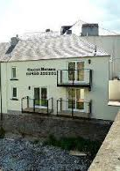
Celebrate with a meal Sonia’s Cafe
Cost will be £15 for 3 Courses.

This will need to be booked in advance so please email Angela if you want to take part on
Angela.Ramage@scotborders.gcsx.gov.uk.

