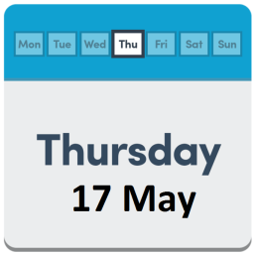
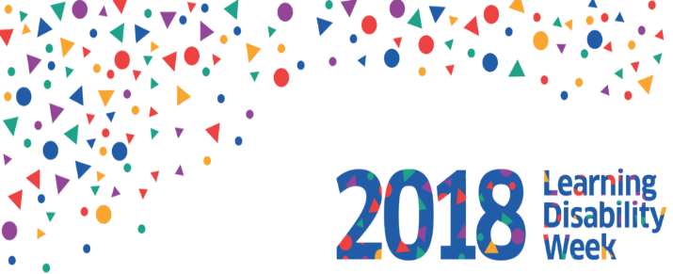
Celebrate Learning Disability Week
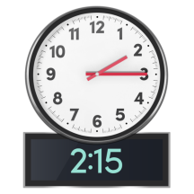
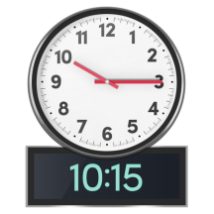

to

Langlee Community Centre Galashiels

Tell us your story
Something to celebrate?
A memory that you would like to share?
You can be filmed telling us what is important to you
With your permission, your Films will be put on Scottish commission for learning disability (SCLD) Facebook and Twitter.

6 ways to happiness
Talk about what makes you happy
What if you get upset?
Who can you talk to?

See me not my disability art collage
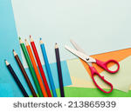
Plan and design a collage
Describe who you are using pictures and words

Lunch and drinks will be provided
Please bring your own snack
To book a place contact Caroline Hamilton
Telephone: 01835 825970
caroline.hamilton@borders.scot.nhs.uk

