Background information for course leader

Bones are made of collagen fibres filled in with calcium and other minerals to create a hard structure. During childhood and early adulthood they develop their strength and from our mid-30s onwards start to lose calcium slowly, causing bone thinning. Therefore, it is very important to strengthen bones in the first 30 years of life to 'stockpile' calcium and other minerals, helping to offset the effect of ageing on bone loss, and reducing the risk of osteoporosis.

To keep bones healthy people should be encouraged to keep active, spend time outside in the sunshine safely and have adequate vitamin D and calcium intakes.

Vitamin D

Vitamin D makes sure you absorb enough calcium from your diet for strong bones and teeth. Your body needs vitamin D to help it absorb calcium. Sunshine, not food, is where most of your vitamin D comes from. Even a healthy and well-balanced diet, which provides all the other vitamins and nutrients, is unlikely to provide enough vitamin D. To get enough vitamin D you need to spend some time outside. Most people in the UK get enough vitamin D by spending 15 minutes in the sun 2 to 3 times a week. Generally, normal levels that are built up in the summer will be enough to last through the winter.

How it affects our body:

- Vitamin D helps maintain a healthy immune system.
- Reduces the risk of some forms of cancer.
- Lack of vitamin D may increase the risk of chronic health conditions such as multiple sclerosis, osteoporosis (brittle bone disease) or osteomalacia which causes pain in adult bones
- Lack of vitamin D may mean adults are also more likely to get breast cancer or prostate cancer

Sources:

- Oily fish such as tuna, salmon, sardines, pilchards, trout and kippers are the only foods which naturally contain reasonable amounts of vitamin D.
- Egg yolks, meat and liver pate contain small amounts.
- Margarine and some breakfast cereals have added vitamin D

Should adults with learning disabilities take a Vitamin D supplement?

The current advice from SACN (Scottish Advisory Committee on Nutrition) is that ‘everyone aged 5 years and above should consider taking a daily supplement of Vitamin D particularly during the winter months’. Consideration should be made to those who are:
- underweight
- wheelchair bound/have impaired mobility
- those living with support
- have a history of epilepsy
    - have a history of bone fractures.

Calcium

Calcium is needed for building bones and keeping them strong throughout life. Calcium works with vitamin D to strengthen your bones. It also helps to keep nerves and muscles in the body healthy.

Reference intakes (RIs)

An ideal calcium intake for adults is between 700mg to 1000mg a day.
Sources:

- yoghurt
- milk
- cheese
- canned salmon and sardines – eaten with the bones
- peas, beans and lentils
- spinach and kale
- nuts and seeds
- tofu
- dried fruit

Smoking: Smoking leads to an increase in bone loss, and increased risk of osteoporosis.

Activity levels: weight-bearing activity puts pressure on the bones and helps them to strengthen. Try to include some weight-bearing activity every day, such as walking, running, gardening or other household chores, to help your body strengthen bones. Sedentary or bed-bound people will find it difficult to strengthen bones.

Low oestrogen levels: Oestrogens help your body to absorb calcium. Low levels of oestrogen can increase the risk of osteoporosis. You are at risk if you have had your ovaries removed or are post-menopausal, particularly if you had an early menopause.

Session 1: Healthy bones

Learning outcomes:

At the end of the session the group should:

- know why we need our bones
- know what to eat for strong bones
- know the benefits of exercise for strong bones
- have taken part in physical activity.

Activities and resources:

Activity | Preparation | Resources
Why do we need bones | Run through the presentation to familiarise yourself with content | Healthy bones presentation Laptop Projector
Strong bones, healthy bones | Print off or photocopy in colour the picture of person with broken bone | Picture of person with broken bone (page 294)
The Eatwell guide or activity mat | Buy items high in calcium and vitamin D or collect wrappers and containers or food photographs to use in the exercise | Eatwell guide or activity mat  Foods such as yogurt milks, cheeses, tofu, vegetables
3 portions of dairy a day | Photocopy or print off pictures of a small pot of yoghurt, a glass of milk and a small portion of cheese  You may also want to bring in red, green and blue top milk or cartons | Pictures of a small pot of yoghurt, a glass of milk and a small portion of cheese

Activity | Preparation | Resources
Other foods and exercise | If you decide to visit a gym you may want to ring ahead to arrange
Taste and try | Identify preparation area and hand washing facilities Check risk assessment for food allergies/ preferences  Store in a fridge until required  Print off taste and try activity sheets (page 295-296).  Prepare flipchart for exercise. See notes on page 292 for more detail | Crackers  Frozen yoghurt  Cottage cheese Sardines Green top milk Table cloth Tray  Paper plates Plastic spoons Plastic cups Napkins
Physical activity | Check the risk assessment sheets to make sure that groups can do the exercise that is suggested  Plan a walk to do with the group. | ‘You can do it’ from http://vimeo.com/21292 481  - Find out if your local authority has activities or facilities that you can access

Session 1: Healthy bones

Why do we need bones?

The purpose of this exercise is to: know why we need our bones.
Ask the group:

Point to a bone on your body.

Try to get a different answer from each group member if possible.
Why do we need our bones?
Answer: We need bones:

to talk and eat – touch chin bone
to walk and stand – touch legs
to protect us from injuries – touch head.
Show the ‘healthy bones’ presentation.
Explain that this is what our bones look like inside our body. This is called our skeleton.

Reinforce while showing the slides that we need the bones to:
- stand
- run
- sit
- dance
- do lots of different things

Strong bones, healthy bones!

The purpose of this exercise is to:

- know why we need our bones
- know what to eat for strong bones.

Ask the group:

What happens when bones are not strong?

Answer: They can easily break. If they break we may have to wear a plaster and it can be painful and uncomfortable.

Show board maker picture of someone with a broken leg in a plaster (page 294).

Hold discussion about broken bones, useful questions are: Has anyone had a broken bone?
Did you have to wear a plaster?
What did it feel like?
Did it stop you from doing anything?

Show boardmaker picture of someone with a broken leg in a plaster.

Eatwell guide or mat activity

The purpose of this exercise is to:

- know what to eat for strong bones
- be able to list dairy and other foods that are high in calcium.

Lay out the foods (or wrappers/containers or food photographs) high in calcium on a table.

For example:

- milk
- cheese
- yogurt or frozen yogurt
- sardines
- ice cream.

Invite each learner to choose a food and place it on the Eatwell guide or activity mat. Ask them to think about which section of the mat it should go onto. If they are not sure ask the rest of the group to help them. All the foods should go into the blue section, dairy foods and drinks except sardines which go in the meat group (pink section).

Ask the group:

What should we eat to keep our bones strong?

Answer: Dairy products like milk, cheese, and yogurt/ frozen yogurt.

Do you know why these types of foods are good for our bones?

Answer: These foods have something in them that we call calcium. Calcium makes our bones strong.

3 portions of dairy a day

The purpose of this exercise is to:
- know what to eat for strong bones.
Ask the group:
- Do you know how many portions of dairy foods we should eat?
Answer: It is important to eat 3 portions per day. This could be a:
- glass of milk
- small piece of cheese (size of a thumb or two dice)
- small pot of yogurt.
Show pictures of these foods. Ask the group:
- How many portions of dairy foods do you eat and drink in 1 day?
- What kind of milk do you drink?
- Have you seen milk with different colour tops?
- Which one do you think is better for you?
- Answer: Blue is full fat, green is semi-skimmed and red is skimmed. Green or red top milk are better for you than blue top as they have less fat. They have the same amount of calcium.

Other foods and exercise

The purpose of this exercise is to:

- know what to eat for strong bones
- know the benefits of exercise for strong bones.

Dairy products are good for us because they contain calcium. Calcium is good for our bones and helps them stay strong.

Ask the group:

- Do you know what else you could eat that contains calcium?
Answer: Sardines

Show a picture or an actual tin of sardines

Sardines are good because they also contain vitamin D. Vitamin D is important because it helps calcium to work. If we don’t have vitamin D the calcium won’t work.

- Does anyone know where else we can get vitamin D from? Oily fish such as salmon, sardines, pilchards, trout, kippers. Eggs and meat contain small amounts. Margarine and some breakfast cereals have added vitamin D. The best way of getting vitamin D is to spend time outside in the summer. The sun gives us the most vitamin D.
- What else should we do for healthy bones?

Answer: Exercise

- What type of exercise do you like to do?
- What other kinds of exercise could you do?

Show a picture of someone doing exercise.

If you have time you could visit a local gym to see what is on offer there.

Taste and try

The purpose of this exercise is to:

- know what to eat for strong bones.

Explain to the group that we are going to have fun tasting foods which are high in calcium.

Split into discussion groups of 3–4 people. Groups can call themselves a fun name if they wish to.

Give the following instructions:

- You will all be taste testing a variety of different foods and drinks.
- Give out taste and try activity sheet (page 295-296). Once you have tasted it, decide if you like it. Write or put the plate on either the like or don’t like page.
- When you have tasted everything and decided on your answers we will come back together as a large group and discuss what everyone thought.

Bring out the foods to be tasted. We suggest the following but you could add your own:

Yogurt with added fruit (strawberries, banana) | - Served in cups
Crackers with cottage cheese | - Served on paper plates
Crackers with sardines (mashed very well) | - Served on paper plates
Milk | - Served in cups

For large group discussion:

Prepare flip chart like this

Foods we like

Foods we do not like

Tear the flip chart off and place on table or floor where all in the group can see.

Go through the foods and drinks tasted and discuss whether the groups liked them or not.
Use the bottles, cartons and containers left from the tasting exercise and put them on the flip chart in the correct place (high or low in calcium) to demonstrate the answers.

Physical activity

The purpose of this exercise is to:

- have taken part in physical activity
Encourage the group do some exercise. You could:
- go for a walk.

Suggestion:

Why not ask the group what they would like to do for next time? If you have time you could watch the ‘You can do it’ SCLD video (http://vimeo.com/21292481) to get some ideas or talk to your local authority to find out if they run accessible physical activities.

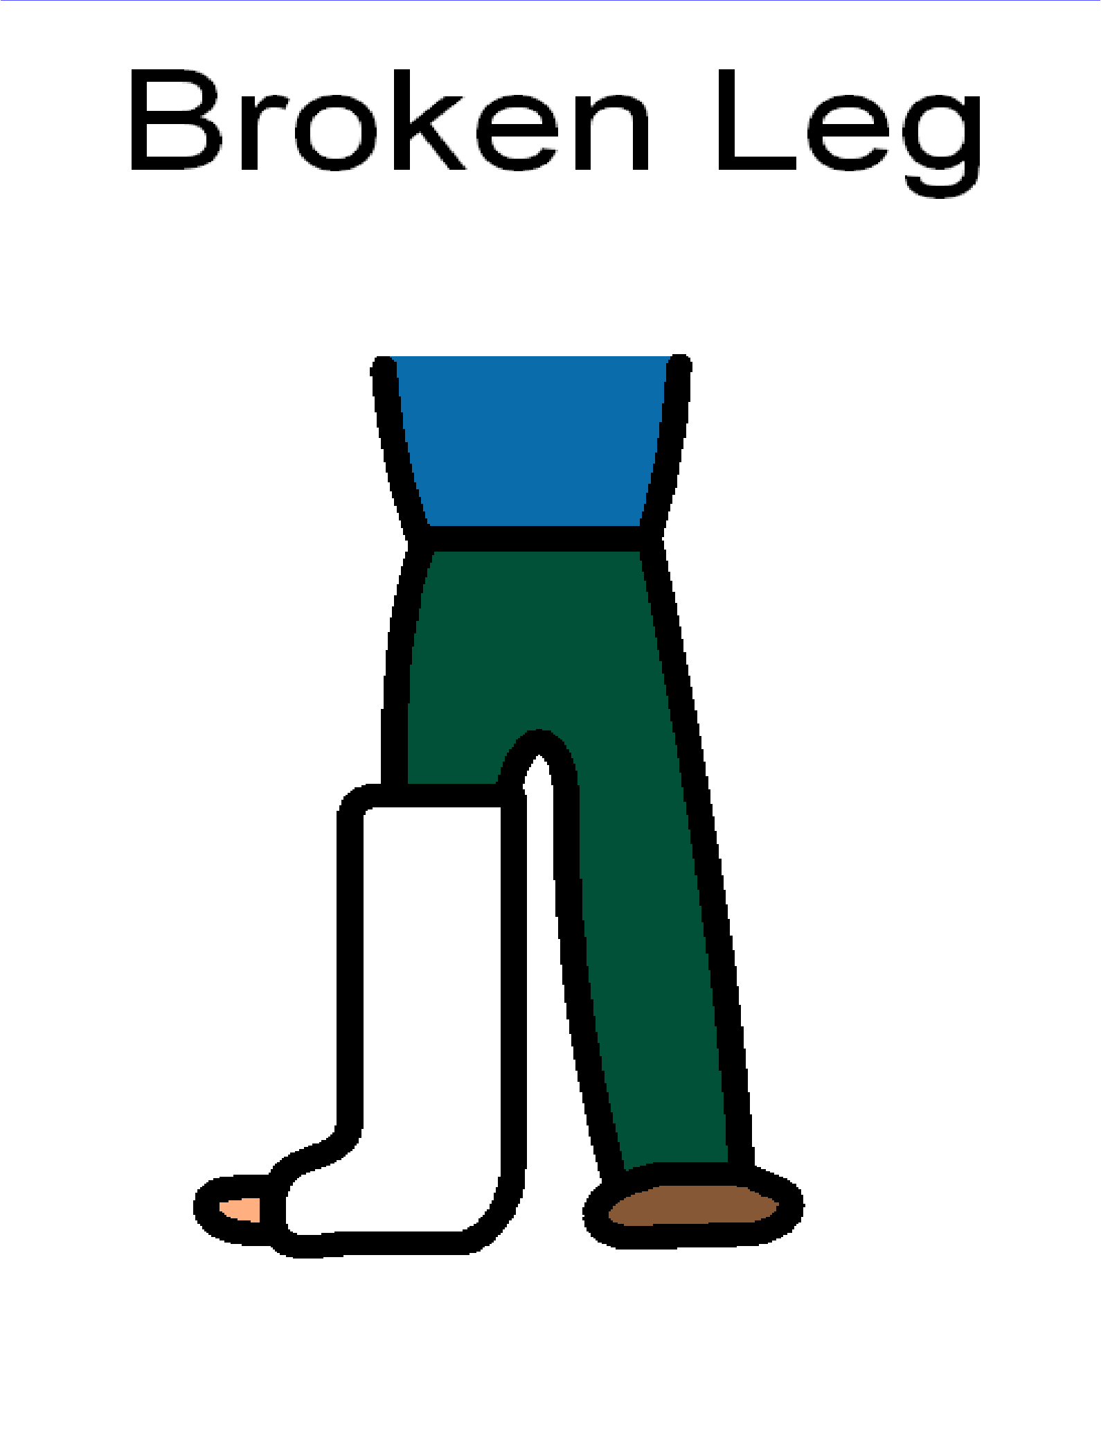
Healthy bones

Foods low in calcium

Foods high in calcium

