Session 3: Salt and cooking

Learning outcomes:

At the end of the session the group should:

Be aware of basic food safety guidelines through ‘Cook’s rules’ have increased their practical cooking skills
have experienced the process of raw foods to cooked know the task sequence
have experienced tasting the foods they cooked.

Activities and resources:

Activity | Preparation | Resources
Preparation for cooking | Buy aprons and hats (if using), disposable ones are available  Print off or photocopy Cook’s rules in colour if possible. It is best to laminate these so they can be used again. Matt laminate is recommended | Aprons  Hats (optional) Cook’s rules (page  279-280)
Cooking | Check risk assessment to help you choose group leaders  Print off or photocopy recipe (you may choose to laminate these) | Recipe sheets (page 267-269) Ingredients (page 265-266)  Cooking and serving utensils
Tasting | - Identify preparation area and hand washing facilities  Check risk assessment for food allergies/ preferences | - Plates  - Knives and forks

Activity | Preparation | Resources
Learning check | Look out the answer sheets from session 1 to see difference in knowledge around salt | Salt quiz sheets (page 270) and pens
Physical activity | Check the risk assessment sheets to make sure that groups can do the exercise that is suggested  Plan out a walk to do with the group. | ‘You can do it’ from http://vimeo.com/21292 481  - Find out if your local authority has activities or facilities that you can access

Session 3: Salt and cooking

Preparation for cooking:
The purpose of this part of the session is to:
be aware of basic food safety guidelines. Today you will bake Italian macaroni cheese.
Hand out and read through, explaining as you go the cook’s rules (page 279-280). Ask everyone to wash their hands and put on their aprons and hats (if using).

Cooking:

The purpose of this part of the session is to: increase their practical cooking skills
experience the process of raw foods to cooked foods be able to follow a task sequence
experience tasting the foods they cooked.

Lay out the ingredients on the table along with the equipment that is required.

You should have previously identified group leaders. Encourage them to perform the cooking tasks and those who may be less able can perform simple and safe activities such as:
putting the ingredients into bowls mixing the ingredients.

Split the group into smaller teams with at least one group leader in each.

Hand out the recipe cards. Depending on your group you may decide to go through the recipe step by step as one big group or leave the small teams to work their way through the recipe. Make sure you keep checking in with each group to ensure they are on track and know what they are doing.

Important notice: Please follow the cooking rules to avoid problems with food safety. Everything used has to be clean and safe.

Tasting
Make sure that everyone has washed their hands. Enjoy your Italian macaroni cheese!

Ask the group:
Do you like it?
What unhealthy foods could you replace in your meal with Italian macaroni cheese?
Would you make this at home? Who could help you?

You might want to give the Cook’s rules (page 279-280), shopping list and recipe cards as handouts so that members of the group can take them home and make them again.

Learning check

The purpose of this activity is to:
- Be able to recall the main messages from the previous sessions

Split the group into 2 teams and ask them to come up with a team name.
- Explain that you will ask 3 questions (see salt quiz sheet page 270)
- Give a quiz sheet to each group.
- Ask groups to tick or circle what they think as a group is the correct answer for each.
- Go through answers for each, briefly reinforcing the main messages.

Alternatively you may wish to ask each individual to complete the quiz again and reconsider their answers from session 1.

Physical activity

The purpose of this exercise is to:
have taken part in physical activity.

Encourage the group do some exercise. You could:
- go for a walk,

Suggestion:
Why not ask the group what they would like to do for next time? If you have time you could watch the ‘You can do it’ SCLD video (http://vimeo.com/21292481) to get some ideas or talk to your local authority to find out if they run accessible physical activities.
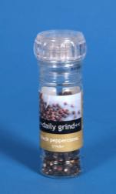
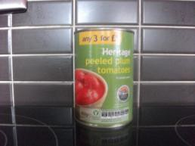

Italian macaroni cheese
What I need:
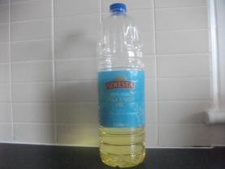 | Olive oil or vegetable oil
 | Small tin of tomatoes (200grams)
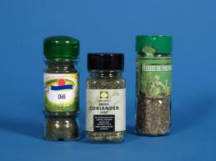 | Dried herbs or fresh basil
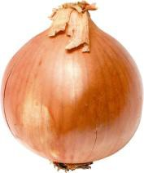 | 1 onion
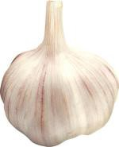 | Garlic
 | Black pepper

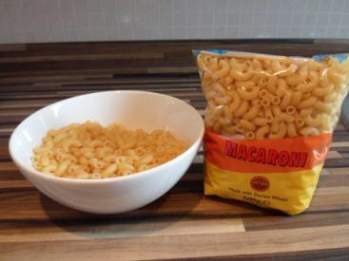

 | Macaroni
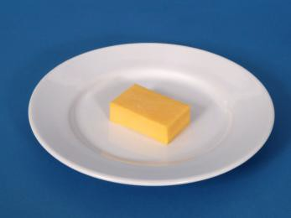 | Low-fat cheese
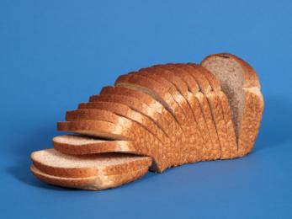 | Bread

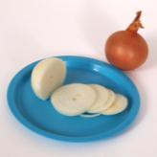
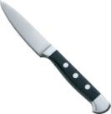
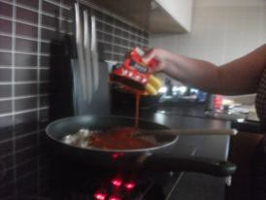

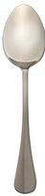
What do I do?

 | If using fresh basil tear or cut into small pieces. If using dried herbs measure out 1 teaspoon.
 | Peel the onion. Cut into small pieces.
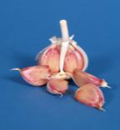 | Take 1 clove of garlic. Peel clove of garlic. Use a garlic crusher or cut into very small pieces.
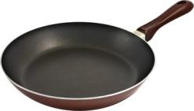 | Add oil to frying pan. Put frying pan onto the cooker hob on a medium heat.
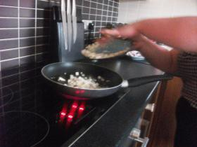 | When oil is hot add onion and garlic pieces to frying pan.  Fry for 3 minutes.
 | Add tin of tomatoes to frying pan. Cook for 5 minutes.

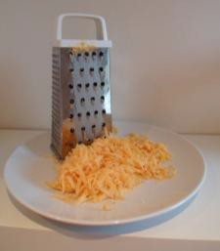

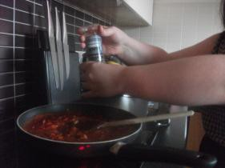 | Add some pepper. Add the herbs.  Turn the heat down to low. Cook for 15 minutes. Leave in the pan until you have cooked the pasta
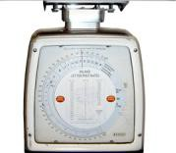 | Weigh out 40 grams of cheese.
 | Grate cheese.
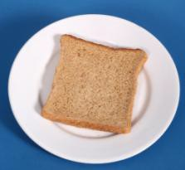 | Make breadcrumbs by grating 1 slice of bread. This works better if you leave the bread out for a while to go stale.
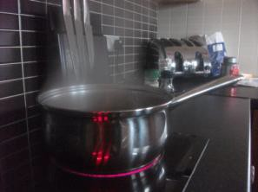 | Put water in the pan. Now put pan on the hob.  Turn on the ring to high. Wait for the water to start boiling.

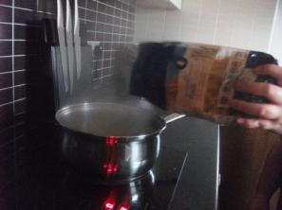

Add pasta to pan.
Wait for water to boil again.

Cook for 10–12 minutes until pasta is soft.
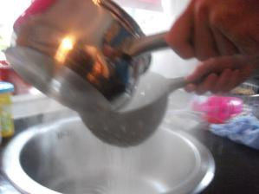 | Pour pasta and water into a colander over the sink. Add pasta to Italian tomato sauce.
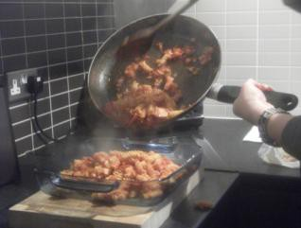 | Pour pasta and sauce into an oven proof dish. Sprinkle cheese and breadcrumbs on top.
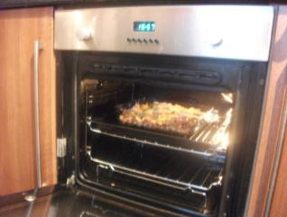 | Turn the grill to medium.  Put your pasta dish under the grill for 5 minutes until cheese has melted.

