# Session 2: Salt and shopping

## Learning outcomes:

At the end of the session the group should:

know where to buy low salt foods and salt alternatives be able to choose ingredients for one recipe

have tasted new foods low in salt.

## Activities and resources

|  |  |  |
| --- | --- | --- |
| **Activity** | **Preparation** | **Resources** |
| Supermarket visit | * Contact supermarket manager for permission to take photographs * Arrange transport * Visit supermarket to be aware of where to find ingredients   Consider high and low salt alternatives and where to find them  Consider cost and buy low salt options | Pictorial shopping list for macaroni cheese (page  258-259)  Petty cash for food tasters  Low-salt options to try |
| Tasting | Identify preparation area and hand washing facilities  Check risk assessment for food allergies/ preferences | Plates or cups depending on what you buy to taste |

## Supermarket visit

The purpose of this exercise is to:

know where to buy low salt foods and salt alternatives be able to choose ingredients for one recipe.

At the visit with the group:

* Find foods that exist in two forms - low salt or high in salt for example: low-salt crisps and normal crisps.
* Ask the group which food they should choose and why? Answer: Low salt foods because they do not cause high blood pressure.

High blood pressure can cause heart problems and stroke. Repeat the activity with other products.

For example:

beans and baked beans low in salt

tomato ketchup and no added salt tomato ketchup Canned soups and ingredients for home-made soups

breakfast cereals – Cornflakes, Rice Crispies or Special K are much higher in salt than Weetabix or Shredded Wheat

salted nuts and unsalted nuts baked table salt and herbs

garlic and lemons

smoked fish and meat and not smoked fish and meat.

You can choose other items that have no salt or no added salt to look at and/or buy too.

* Buy the foods that you will use for the cooking session next week.
* Buy a herb in a pot such as basil and ask the group to take care of it for the rest of the sessions.

## Tasting what we bought

The purpose of this exercise is to:

have tasted new foods low in salt.

When you return to the learning base prepare for the tasting exercise.

Make sure the group wash their hands and then taste the things that you bought at the supermarket.

Discuss:

how things taste

which unhealthy foods you could replace with these healthier alternatives

your experience at the supermarket.

Try to reinforce messages discussed in previous sessions such as: why salt is bad for us

the benefits of foods that are low in salt alternative foods to try.

|  |  |
| --- | --- |
| Shopping list for Italian macaroni cheese | |
|  | Olive oil or vegetable oil |
|  | Tomatoes canned or fresh |
|  | Dried herbs or fresh basil |
|  | 1 onion |
|  | Garlic  Black pepper |

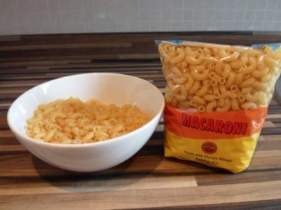

|  |  |
| --- | --- |
|  | Macaroni |
|  | Low-fat cheese |
|  | Bread |