# Background information for course leader

Salt is sodium chloride which is a mineral. It is needed in the body in very small amounts to regulate the water content of the body and to help the nervous system work. The nervous system sends messages through the body, making the body move and work.

Salt in our diet comes from:

hidden salts in food

the salt we add during cooking the salt we add at the table.

Eating too much salt increases our chances of having high blood pressure. This can lead to heart disease and strokes. This is because salt affects the function of the kidneys, decreasing the amount of water we get rid of as urine. The increased amount of water stays in the blood stream, making the heart work harder.

Average blood pressure = 120/80 mmHg (millimetres of mercury) Should be below = 140/85 mmHg

Sources of salt:

processed meats

processed foods, such as soup and ready meals

sauces, such as ketchup, gravy, pasta sauce and soya sauce cheese

salty snacks such as crisps, salted nuts pies

bread, cereals and biscuits can be high in salt. Reference intakes (RIs)

Needed by average adults of normal weight and average activity levels

|  |  |  |
| --- | --- | --- |
| Each day | Women | Men |
| Salt (g) | Less than 6g | Less than 6g |

6g is about 1 teaspoon.

How to reduce salt intake:

* Eat less processed, canned, tinned food.
* Reduce the amount used in cooking.
* Use dried herbs and pepper to flavour foods rather than salt.
* Do not add salt at the table.
* Compare brands of food, some have a lot less salt.
* Look for labels that say ‘reduced salt’.

# Session 1: Salt and health

## Learning outcomes:

At the end of the session the group should:

know that salt in food can affect blood pressure

know what happens when you get your blood pressure checked know that they should eat less salt

be able to list foods that are high in salt

be aware of the health benefits of eating less salt have taken part in physical activity.

## Activities and resources:

|  |  |  |
| --- | --- | --- |
| **Activity** | **Preparation** | **Resources** |
| Questions assessing knowledge about salt | Print off copies or photocopy salt quiz | Salt quiz sheets (page 270) Pens |
| Salt is bad for you | Photocopy or print off heart attack and stroke pictures in colour | Heart attack and stroke pictures (page 272-273) |
| How do you measure your blood pressure? | Invite a nurse to demonstrate how blood pressure is measured | Nurse and blood pressure cuff |
| How to keep blood pressure healthy | * Photocopy or print off doctor, pressure cuff and salt pictures in colour | Doctor, pressure cuff, table salt pictures (page 274-276) |





|  |  |  |
| --- | --- | --- |
| **Activity** | **Preparation** | **Resources** |
| Which foods are high in salt | Print off the photos of table salt, salt cellar, tinned/plate of soup, ready meals, bacon, pot noodles, hot dogs and crisps in colour. You may choose to matt laminate these.  Prepare a flip chart with the title ‘These foods have lots of salt’ | Photographs of table salt, salt cellar, tinned/plate of soup, ready meals, bacon, pot noodles, hot dogs and crisps  Flip chart and pen |
| Cutting down on salt in cooking | Buy some salt  Print off photos of or buy onions, herbs, mustard, lemon juice, garlic | Salt  Photos of or buy onions, herbs, mustard, lemon juice, garlic |
| Taste and try | Check risk assessment for food allergies/ preferences  Make up servings of low-salt crisps, salty crisps, dried fruit, digestive biscuits and rich tea biscuits. All can be served on paper plates  Label plates crisps A, crisps B and make sure you know which is which  Print off taste and try activity sheets (pages 277-278)  Prepare flipchart for exercise. See page 253 for more detail | Tablecloth Disposable plates Labels  Salty crisps Low-salt crisps Dried fruits  Digestive biscuits Rich tea biscuits Flip chart and pens |

|  |  |  |
| --- | --- | --- |
| **Activity** | **Preparation** | **Resources** |
| Physical activity | Check the risk assessment sheets to make sure that groups can do the exercise that is suggested  Plan out a walk to do with the group | ‘You can do it’ from [http://vimeo.com/21292](http://vimeo.com/21292481) [481](http://vimeo.com/21292481)   * Find out if your local authority has activities or facilities that you can access |

# Session 1 Salt and health

## Questions assessing knowledge about salt

The purpose of this exercise is to:

* Find out the group’s existing knowledge about salt.

Hand out the salt quiz (page 270) and a pen to each group member.

Ask the group one question at a time.

Ask the group to tick beside the picture/s they think are the answers.

Collect in their answer sheets, to be used again at the end of the salt topic to find out if they have learned from the sessions.

### Salt is bad for you

The purpose of this exercise is to:

know that salty food can affect blood pressure

know what happens when you get your blood pressure checked know that they should eat less salt

be aware of the health benefits of eating less salt.

Ask the group:

What happens if you eat too much salt?

**Answer:** It can make your blood pressure high.

Your heart pumps blood around your body. The force which pumps blood is called blood pressure. High blood pressure can damage blood vessels and makes them likely to block.

A block in the heart can cause a heart attack. A block in the head can cause a stroke.

Show the pictures of heart attack and stroke (page 272-273).

High blood pressure can also affect the kidneys. You have two kidneys. Show group where they are by pointing on your body – on either side of the spine, just below the rib cage. Your kidneys act like a sieve. They keep some things in your body that you need, and get rid of other things that you don't.

### How do you measure your blood pressure?

Invite a nurse to demonstrate how blood pressure is measured. An option is for a group leader to volunteer to have their blood pressure checked. It is not advisable to measure the blood pressure of any of the group members.

Ask the group:

Has anyone had their blood pressure checked before? How did it feel?

Was it sore?

If a nurse is not available then explain to the group:

a cuff is placed around the arm and “start” is pressed on the blood pressure monitor

the cuff fills with air and becomes tight on the arm – this should not be sore

the cuff slowly releases air until a blood pressure reading is picked up

the average blood pressure is 120/80 mmHg (millimetres of mercury) and should be below 140/85

if it is too high, the doctor will firstly suggest a healthier diet and more exercise, and then medication might be needed.

## How to keep blood pressure healthy

The purpose of this exercise is to:

know that salt in food can affect blood pressure know that they should eat less salt.

Ask the group:

What can you do to keep your blood pressure right? Answers:

* Eat less salt.
* Do not shake salt on your dinner.
* Use herbs instead of salt.
* Avoid foods that contain salt.
* Ask your doctor to check your blood pressure.

Show doctor, pressure cuff, table salt pictures (page 275-276) to demonstrate your points.

These also help keep a healthy blood pressure: Do not smoke.

Try to keep a healthy weight.

Eat fruit and vegetables.

Do not drink lots of alcohol. Do more exercise.

## What foods are high in salt?

The purpose of this exercise is to:

be able to list foods that are high in salt.

Lay the photos out on a table where all can see or if the group is small enough you can give each learner a photo.

Ask the group:

Which items are high in salt?

Invite the learners to stick the photographs on the prepared flipchart ‘These foods have lots of salt’.

Answer:

Table salt. Salt cellar.

Tinned/plate soup. Ready meals. Bacon.

Pot Noodles. Tinned hot dogs. Crisps.

In general foods that contain most salt are tinned, smoked, readymade foods – these foods are bad for you.

## Cutting down on salt in cooking

The purpose of this exercise is to:

know that they should eat less salt

be able to list foods that are high in salt.

We want to give you some new ideas on simple alternatives to use less salt in cooking.

Ask the group:

How much salt would you normally add to potatoes or vegetables when cooking?

Advise using no salt or only a pinch of salt. Show what is meant by a pinch of salt.

Suggest other foods which can be used to make food tasty and show pictures of actual foods:

Onions. Herbs. Mustard. Lemon juice. Garlic.

Note: Low-salt products are not recommended because they have a different salt which can be bad for you.

## Taste and try

The purpose of this exercise is to:

know that foods high in salt can affect blood pressure know that they should eat less salt

be able to list foods that are high in salt

be aware of the health benefits of eating less salt have taken part in physical activity.

Explain to the group that we are going to have fun tasting foods which are either low or high in salt.

Split into discussion groups of 3–4 people. Groups can call themselves a fun name if they wish to.

Give the following instructions:

You will all be taste testing a variety of different foods and drinks.

* + - Each food type you taste will have 2 versions, one with salt and one with no salt or much less salt.

When you have tasted each version, have a chat in your groups and decide which one was low in salt and which one was high in salt.

Give out taste and try salt activity sheet (page 277-278). Explain once you have decided whether it is high in salt or low in salt. you can draw, write or put the cup on either the high in salt page or low in salt page.

When you have tasted everything and decided on your answers we will come back together as a large group and discuss what everyone thought.

Bring out the foods to be tasted. We suggest the following but you could add your own:

|  |  |
| --- | --- |
| Low-salt crisps | - Serve on a paper plate |
| Salty crisps | - Serve on a paper plate |
| Dried fruit  Rich tea biscuits Digestive biscuits | * Serve on a paper plate * Serve on a paper plate * Serve on a paper plate |

For large group discussion:

Prepare flip chart like this

Foods low in salt

Foods high in salt

Tear the flip chart off and place on table or floor where all in the group can see.



Go through the foods and drinks tasted and discuss whether the groups thought they were high in salt or low in salt.

Reveal the answers to the group and use the packets, cartons and containers left from the tasting exercise and put them on the flip chart in the correct place (high or low in salt) to demonstrate the answers.

Things to talk about when going through the answers:

* Low salt crisps are good and readily available to buy. They have lower salt than normal crisps.
* Dried fruits are low in salt and also provide fibre and vitamins.
* Digestives are high in salt a rich tea biscuit has less salt.

## Physical activity

The purpose of this exercise is to:

have taken part in physical activity.

Encourage the group do some exercise. You could: go for a walk.

### Suggestion:

Why not ask the group what they would like to do for next time? If you have time you could watch the ‘You can do it’ SCLD video - <http://vimeo.com/21292481>) to get some ideas or talk to your local authority to find out if they run accessible physical activities.

# Session 2: Salt and shopping

## Learning outcomes:

At the end of the session the group should:

know where to buy low salt foods and salt alternatives be able to choose ingredients for one recipe

have tasted new foods low in salt.

## Activities and resources

|  |  |  |
| --- | --- | --- |
| **Activity** | **Preparation** | **Resources** |
| Supermarket visit | * Contact supermarket manager for permission to take photographs * Arrange transport * Visit supermarket to be aware of where to find ingredients   Consider high and low salt alternatives and where to find them  Consider cost and buy low salt options | Pictorial shopping list for macaroni cheese (page  258-259)  Petty cash for food tasters  Low-salt options to try |
| Tasting | Identify preparation area and hand washing facilities  Check risk assessment for food allergies/ preferences | Plates or cups depending on what you buy to taste |

## Supermarket visit

The purpose of this exercise is to:

know where to buy low salt foods and salt alternatives be able to choose ingredients for one recipe.

At the visit with the group:

* Find foods that exist in two forms - low salt or high in salt for example: low-salt crisps and normal crisps.
* Ask the group which food they should choose and why? Answer: Low salt foods because they do not cause high blood pressure.

High blood pressure can cause heart problems and stroke. Repeat the activity with other products.

For example:

beans and baked beans low in salt

tomato ketchup and no added salt tomato ketchup Canned soups and ingredients for home-made soups

breakfast cereals – Cornflakes, Rice Crispies or Special K are much higher in salt than Weetabix or Shredded Wheat

salted nuts and unsalted nuts baked table salt and herbs

garlic and lemons

smoked fish and meat and not smoked fish and meat.

You can choose other items that have no salt or no added salt to look at and/or buy too.

* Buy the foods that you will use for the cooking session next week.
* Buy a herb in a pot such as basil and ask the group to take care of it for the rest of the sessions.

## Tasting what we bought

The purpose of this exercise is to:

have tasted new foods low in salt.

When you return to the learning base prepare for the tasting exercise.

Make sure the group wash their hands and then taste the things that you bought at the supermarket.

Discuss:

how things taste

which unhealthy foods you could replace with these healthier alternatives

your experience at the supermarket.

Try to reinforce messages discussed in previous sessions such as: why salt is bad for us

the benefits of foods that are low in salt alternative foods to try.

|  |  |
| --- | --- |
| Shopping list for Italian macaroni cheese | |
|  | Olive oil or vegetable oil |
|  | Tomatoes canned or fresh |
|  | Dried herbs or fresh basil |
|  | 1 onion |
|  | Garlic  Black pepper |

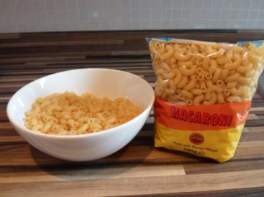

|  |  |
| --- | --- |
|  | Macaroni |
|  | Low-fat cheese |
|  | Bread |

# Session 3: Salt and cooking

## Learning outcomes:

At the end of the session the group should:

Be aware of basic food safety guidelines through ‘Cook’s rules’ have increased their practical cooking skills

have experienced the process of raw foods to cooked know the task sequence

have experienced tasting the foods they cooked.

## Activities and resources:

|  |  |  |
| --- | --- | --- |
| **Activity** | **Preparation** | **Resources** |
| Preparation for cooking | Buy aprons and hats (if using), disposable ones are available  Print off or photocopy Cook’s rules in colour if possible. It is best to laminate these so they can be used again. Matt laminate is recommended | Aprons  Hats (optional) Cook’s rules (page  279-280) |
| Cooking | Check risk assessment to help you choose group leaders  Print off or photocopy recipe (you may choose to laminate these) | Recipe sheets (page 267-269) Ingredients (page 265-266)  Cooking and serving utensils |
| Tasting | * Identify preparation area and hand washing facilities   Check risk assessment for food allergies/ preferences | * Plates * Knives and forks |

|  |  |  |
| --- | --- | --- |
| **Activity** | **Preparation** | **Resources** |
| Learning check | Look out the answer sheets from session 1 to see difference in knowledge around salt | Salt quiz sheets (page 270) and pens |
| Physical activity | Check the risk assessment sheets to make sure that groups can do the exercise that is suggested  Plan out a walk to do with the group. | ‘You can do it’ from [http://vimeo.com/21292](http://vimeo.com/21292481) [481](http://vimeo.com/21292481)   * Find out if your local authority has activities or facilities that you can access |

# Session 3: Salt and cooking

## Preparation for cooking:

The purpose of this part of the session is to:

be aware of basic food safety guidelines. Today you will bake Italian macaroni cheese.

Hand out and read through, explaining as you go the cook’s rules (page 279-280). Ask everyone to wash their hands and put on their aprons and hats (if using).

## Cooking:

The purpose of this part of the session is to: increase their practical cooking skills

experience the process of raw foods to cooked foods be able to follow a task sequence

experience tasting the foods they cooked.

Lay out the ingredients on the table along with the equipment that is required.

You should have previously identified group leaders. Encourage them to perform the cooking tasks and those who may be less able can perform simple and safe activities such as:

putting the ingredients into bowls mixing the ingredients.

Split the group into smaller teams with at least one group leader in each.

Hand out the recipe cards. Depending on your group you may decide to go through the recipe step by step as one big group or leave the small teams to work their way through the recipe. Make sure you keep checking in with each group to ensure they are on track and know what they are doing.

**Important notice:** Please follow the cooking rules to avoid problems with food safety. Everything used has to be clean and safe.

## Tasting

Make sure that everyone has washed their hands. Enjoy your Italian macaroni cheese!

Ask the group:

Do you like it?

What unhealthy foods could you replace in your meal with Italian macaroni cheese?

Would you make this at home? Who could help you?

You might want to give the Cook’s rules (page 279-280), shopping list and recipe cards as handouts so that members of the group can take them home and make them again.

## Learning check

The purpose of this activity is to:

* Be able to recall the main messages from the previous sessions

Split the group into 2 teams and ask them to come up with a team name.

* Explain that you will ask 3 questions (see salt quiz sheet page 270)
* Give a quiz sheet to each group.
* Ask groups to tick or circle what they think as a group is the correct answer for each.
* Go through answers for each, briefly reinforcing the main messages.

Alternatively you may wish to ask each individual to complete the quiz again and reconsider their answers from session 1.

## Physical activity

The purpose of this exercise is to:

have taken part in physical activity.

Encourage the group do some exercise. You could:

* go for a walk,

## Suggestion:

Why not ask the group what they would like to do for next time? If you have time you could watch the ‘You can do it’ SCLD video (<http://vimeo.com/21292481>) to get some ideas or talk to your local authority to find out if they run accessible physical activities.

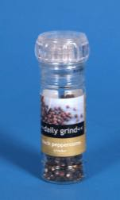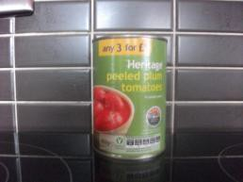

|  |  |
| --- | --- |
| Italian macaroni cheese What I need: | |
|  | Olive oil or vegetable oil |
|  | Small tin of tomatoes (200grams) |
|  | Dried herbs or fresh basil |
|  | 1 onion |
|  | Garlic |
|  | Black pepper |



|  |  |
| --- | --- |
|  | Macaroni |
|  | Low-fat cheese |
|  | Bread |

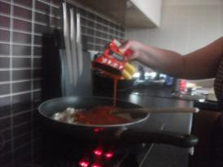

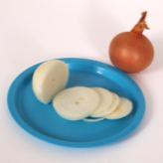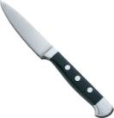

### What do I do?

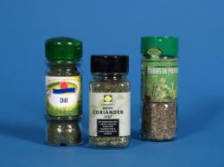

|  |  |
| --- | --- |
|  | If using fresh basil tear or cut into small pieces. If using dried herbs measure out 1 teaspoon. |
|  | Peel the onion. Cut into small pieces. |
|  | Take 1 clove of garlic. Peel clove of garlic. Use a garlic crusher or cut into very small pieces. |
|  | Add oil to frying pan. Put frying pan onto the cooker hob on a medium heat. |
|  | When oil is hot add onion and garlic pieces to frying pan.  Fry for 3 minutes. |
|  | Add tin of tomatoes to frying pan. Cook for 5 minutes. |

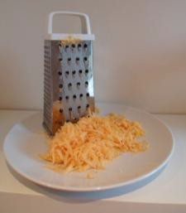

|  |  |
| --- | --- |
|  | Add some pepper. Add the herbs.  Turn the heat down to low. Cook for 15 minutes. Leave in the pan until you have cooked the pasta |
|  | Weigh out 40 grams of cheese. |
|  | Grate cheese. |
|  | Make breadcrumbs by grating 1 slice of bread. This works better if you leave the bread out for a while to go stale. |
|  | Put water in the pan. Now put pan on the hob.  Turn on the ring to high. Wait for the water to start boiling. |

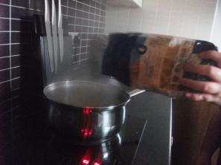

|  |  |
| --- | --- |
|  | Add pasta to pan.  Wait for water to boil again.  Cook for 10–12 minutes until pasta is soft. |
|  | Pour pasta and water into a colander over the sink. Add pasta to Italian tomato sauce. |
|  | Pour pasta and sauce into an oven proof dish. Sprinkle cheese and breadcrumbs on top. |
|  | Turn the grill to medium.  Put your pasta dish under the grill for 5 minutes until cheese has melted. |

# Salt Quiz Sheet

## Tick or circle the correct answer.

1. What can happen if we eat too many salty foods?
2. 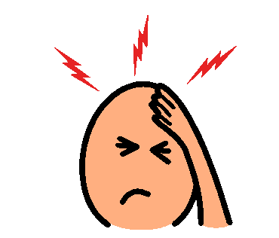stroke
3. 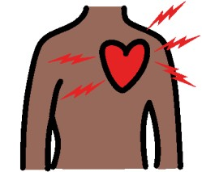heart attack

c)

both

1. Which is the healthy choice?

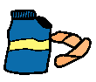a) Crisps with salt b) Crisps with no salt

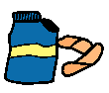

1. Which is healthiest for you?
   1. salt b) herbs

Question Answer

|  |  |
| --- | --- |
| Q1 | c) Too much salt can cause heart attack and stroke because the blood pressure gets high |
| Q2 | b) Crisps with no salt |
| Q3 | b) Herbs: such as basil, oregano, coriander |

**Salt**

Heart attack

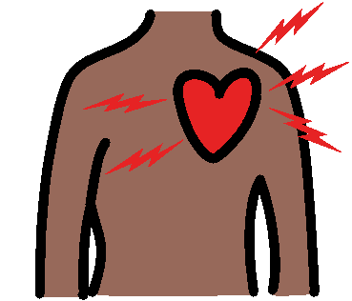

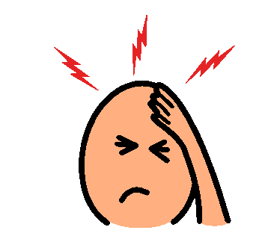

**Salt**

Stroke



**Salt**

Pressure cuff

**Salt**

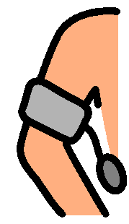

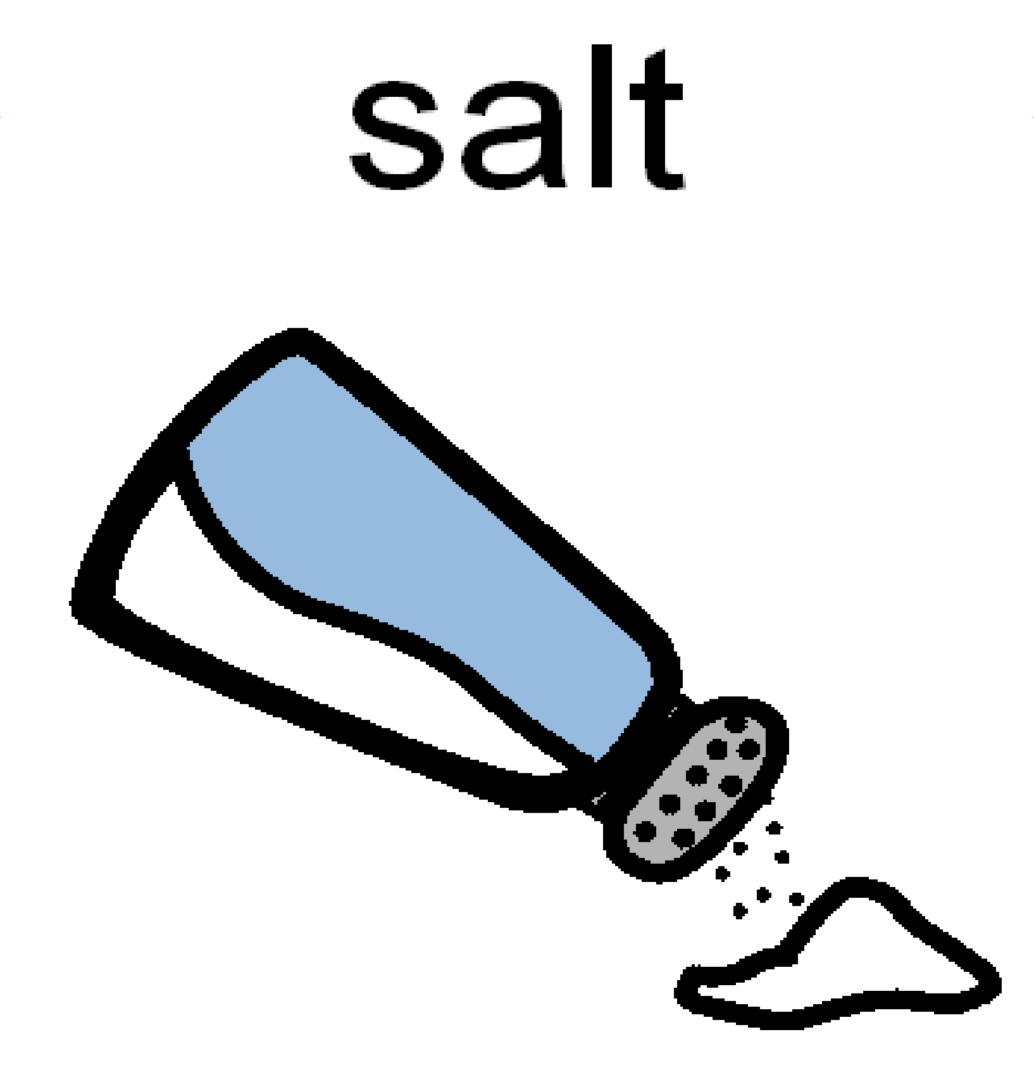

**Salt**

# Foods low in salt

Foods high in salt

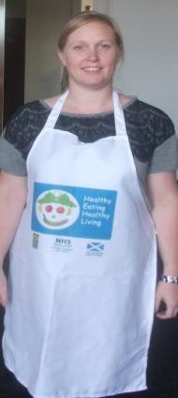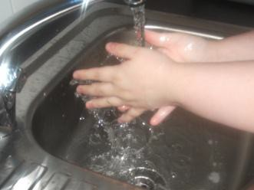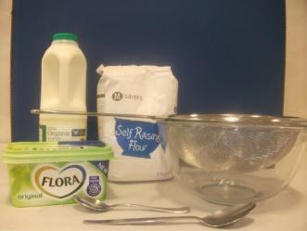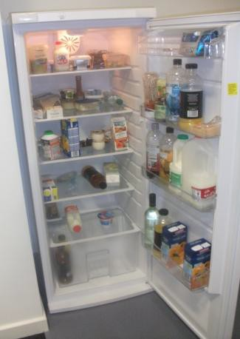

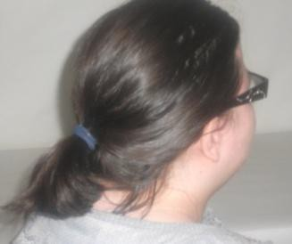**Cook’s rules**

|  |
| --- |
| Tie your hair back. |
| Wear an apron. |
| Wash your hands with soap and dry them before you start. |
| Get everything out that you will need before you start. |
| Keep milk, meat, cheese, and yogurt in the fridge until you are ready to use them. |

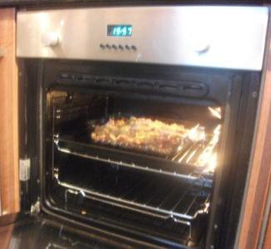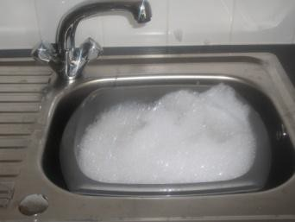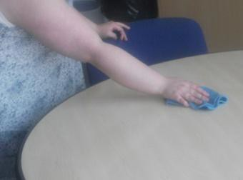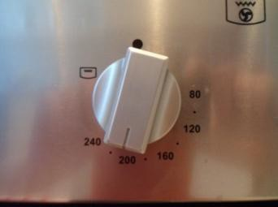

|  |
| --- |
| If you need help putting things in and taking things out of the oven, ask your support worker. |
| Remember to switch off the oven when you are finished. |
| Wash up using hot soapy water. |
| Wipe worktops with a clean cloth and hot soapy water. |
| Enjoy your food! |