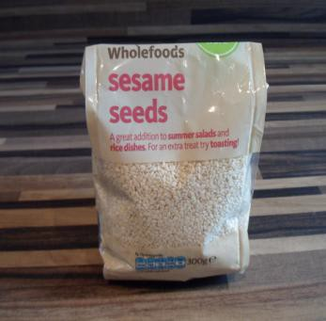

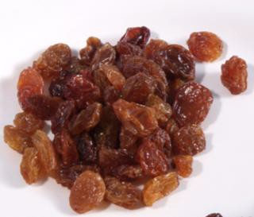

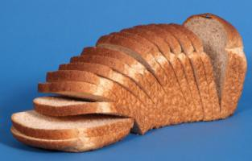
Bread making

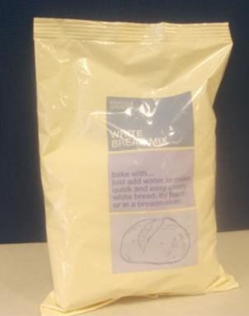
What I need

Bread mix
Water

Raisins

You may choose not to include these
Sesame seeds

You may choose not to include these

What do I do?

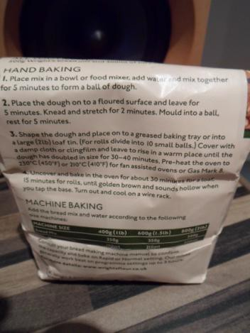

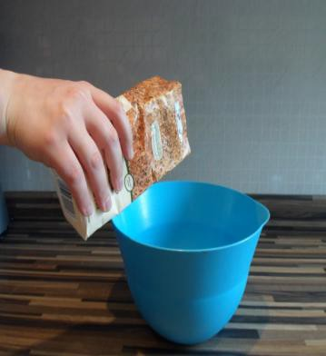

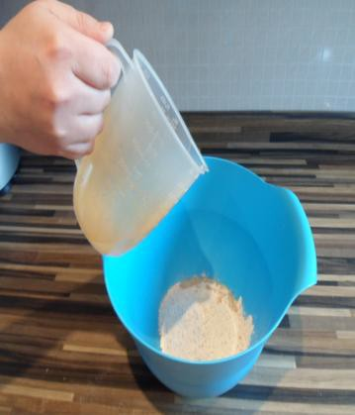

Follow the instructions for making bread on the back of the bread mix packet

Empty bread mix into a large mixing bowl

Use a measuring jug to pour the correct amount of water into the bread mix

The bread mix packet will tell you how much to add

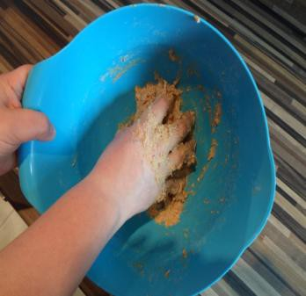
Mix the bread mix and water together Do this until it looks like a ball of dough

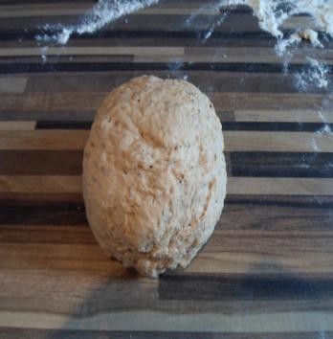
Place the dough on a floured surface

Leave for the amount of time shown in the instructions on the back of the bread mix packet

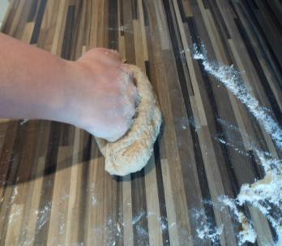
Knead the dough using a punching motion

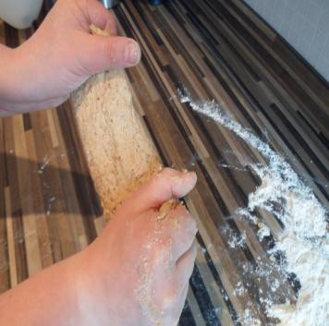
Stretch the dough
Continue to knead and stretch the dough for as long as the instructions say. It should become smooth and stretchy
Leave the dough to rest for as long as the instructions say

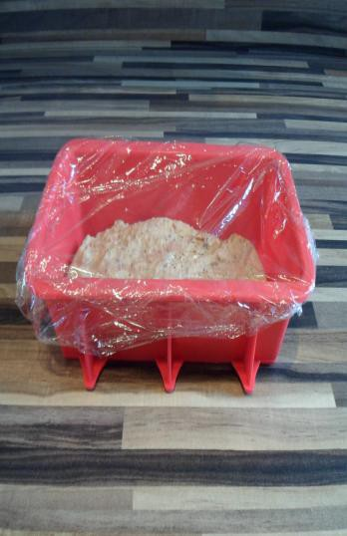
Shape the dough into a large loaf tin (2lb)

Or shape into small balls and place on a greased baking tray to make rolls

Cover with a damp cloth or cling film

Leave in a warm place until the dough has got a lot bigger

Check the instructions on the bread mix packet for times

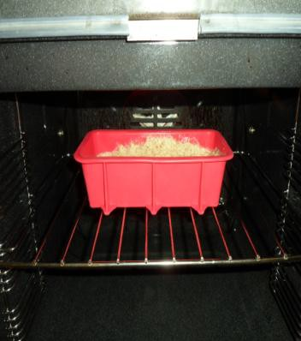
Place in a pre-heated oven

Check the instructions on the back of the bread mix packet for temperature and time

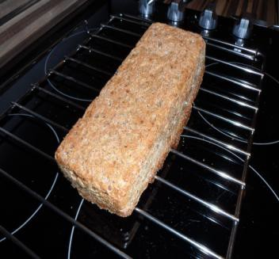
Turn out the loaf from the tin and leave to cool on a wire rack

Enjoy!

