## Background information for course leader

Fibre is the indigestible carbohydrate found on the outsides of foods. Although it contributes nothing in terms of nutrients to the diet, fibre is very important because it controls and regulates the process of food absorption and enables food to pass easily and smoothly through the body. Eating plenty of fibre:

* prevents constipation
* protects against hemorrhoids (piles)
* prevents stomach and bowel conditions
* prevents certain types of cancer
* reduces the risk of heart disease
* reduces the risk of type 2 diabetes
* reduces the risk of obesity, as it makes us feel fuller for longer, so we avoid snacking.

Fibre is even more important for older people and people who are less mobile. This is because the digestive system slows down with age and people who are less mobile, for example people in wheelchairs do not get enough physical activity to make their bowels move.

There are two main types of fibre, soluble and insoluble.

Insoluble fibre can’t be digested and passes through the gut, helping other food and waste move through the gut more easily. Foods rich in this sort of fibre are more bulky and so help make us feel fuller for longer. The best sources are wholemeal bread, brown pasta and nuts.

Soluble fibre is partially digested in the body. It soaks up water like a sponge and contributes to helping the food waste move through the gut. It also helps to reduce the level of cholesterol in the blood. The best sources are oats, barley, seeds, peas, beans and lentils.

Good sources of fibre include:

* wholemeal or wholegrain bread*
* wholewheat pasta or brown rice
* wholegrain breakfast cereals
* multigrain or seeded crackers
* fruit and vegetables, especially ones with skins, for example pears, apples, oranges, cabbage, peas, mushrooms
* peas, beans, lentils.

*to simplify the message wholemeal and wholegrain bread is termed ‘brown’ bread in the teaching.

Reference intakes (RIs):

An average adult of healthy weight and average activity levels needs:

|  |  |  |
| --- | --- | --- |
| **Each day** | **Women** | **Men** |
| Fibre (g) | More than 30g | More than 30g |
|  |  |  |

RIs are discussed more fully in the food labelling session High-fibre food substitutes:

|  |  |  |  |
| --- | --- | --- | --- |
| **Food** | **Low fibre (g)** | **Food** | **High fibre (g)** |
| 1 cup puffed white cereal | 0.4 | 2 whole-wheat cereal biscuits | 3.8 |
| 2 slices white bread | 1.5 | 2 slices wholegrain bread | 2.8 |
| 100g mashed potato | 1.5 | Boiled potato with skin | 2.8 |
| 2 plain biscuits | 0.4 | 2 wholemeal biscuits | 1.5 |

### Fibre and fluids

A high-fibre diet needs to be accompanied by lots of water and other drinks to prevent and ease constipation.

Around 2 litres of fluid (8–10 glasses) a day is an average amount of fluid to aim for from all sources. Remember that foods like soup, melon, cucumber and tomatoes are also good sources of water for people who are unwilling to drink liquids.

How to increase intake of fibre:

* Choose a breakfast cereal which contains barley, wheat or oats.
* Choose wholegrain, whole-wheat or wholemeal bread, brown pasta and rice.
* Keep the skins on potatoes, other vegetables and fruit.
* Eat at least 5 portions of fruit and vegetables per day.
* Snack on dried fruit, nuts or whole-wheat crackers.

## Session 1: Fibre and health

### Learning outcomes

At the end of the session the group should:

* know that they should eat foods that are high in fibre
* be able to list the foods that are high in fibre
* be aware of the health benefits of fibre
* recognise foods high in fibre
* know the importance of having fluids along with fibre
* have taken part in physical activity

### Activities and resources

|  |  |  |
| --- | --- | --- |
| **Activity** | **Preparation** | **Resources** |
| Questions assessing knowledge about fibre | * Photocopy or print off ‘Say yes to fibre’ quiz | * ‘Say yes to fibre’ quiz sheets (page 232-233) * Pens |
| Eatwell guide or activity mat | * Buy items high in fibre or collect wrappers and containers to use in exercise * If this is not possible you could print off food photographs from the SCLD website | * Eatwell guide or activity mat * White and brown (wholemeal) bread * White and brown rice * White and brown pasta * White and brown (wholemeal) flour * Tinned pears in juice * Tinned or frozen peas * Can of beans * Apples and pears with their skin * Oranges * Cornflakes, Weetabix and Bran flakes |

|  |  |  |
| --- | --- | --- |
| **Activity** | **Preparation** | **Resources** |
| Health benefits of fibre | * Print off or photocopy Boardmaker pictures | * 15-metre long piece of tube, ribbon or string * Boardmaker fibre pictures (page 235-237) |
| Which foods have more fibre? |  | * Eatwell guide or activity mat |
| Fibre needs fluid |  | * Weetabix * Semi-skimmed milk * Small bowl * 10 plastic cups |
| The journey of food in the body | * Run through the presentation to familiarise yourself with the content | * Laptop * Projector * PowerPoint of the ‘The Journey of Food through the body’ |
| Taste and try | * Put cereals into disposable cups * Make up white and brown jam sandwiches * Put beans into disposable cups * Put peas into disposable cups * Chop fruit, some with skin on and some with no skin * Store in a fridge until required * Print off ‘taste and try’ activity sheets (A3) (page 238–239) * Prepare flipchart for exercise. See notes on (page 209) for more detail | * Table cloth * Tray * Disposable plastic cups * Disposable plastic plates * Disposable plastic spoons * Napkins * Flipchart and pens * White and brown bread * Jam * Semi-skimmed milk * Weetabix and/or Bran flakes * Cornflakes * Apples and pears with their skin * Tinned peas * Tinned beans |

|  |  |  |
| --- | --- | --- |
|  | * Identify preparation area and hand washing facilities * Check risk assessment for food allergies/ preferences |  |
| Physical activity | * Check the risk assessment sheets to make sure that groups can do the exercise that is suggested * Plan a walk to do with the group | ‘You can do it’ from [http://vimeo.com/21292](http://vimeo.com/21292481) [481](http://vimeo.com/21292481)   * Find out if your local authority has activities or facilities that you can access |

## Session 1: Fibre and health questions – assessing knowledge about fibre

The purpose of this exercise is to:

* Find out the group’s existing knowledge about fibre

Hand out the fibre quiz (page 232-233) and a pen to each group member.

* Ask the group one question at a time.
* Ask the group to tick beside the picture/s they think are the answers.
* Collect in their answer sheets, to be used again at the end of the fibre topic to find out if they have learned from the sessions.

##### Fibre is good for you

Ask the group:

* Have you tried brown bread, brown rice or wholewheat pasta?
* Do you eat the skin of your potatoes?
* Do you think that we should eat brown bread instead of white bread?

Try to get an answer from each group member if possible.

For the next session we are going to talk about fibre. We will talk about the benefits of foods that are high in fibre such as bread, pasta, rice and potatoes and especially those that are usually brown such as brown bread and bran flakes.

### Eatwell guide or mat activity

The purpose of this exercise is to:

* know that they should eat foods that are high in fibre
* be able to list the foods that are high in fibre
* recognise foods high in fibre.

Lay out the foods (or wrappers/containers/photographs) high in fibre on a table.

For example:

* pasta (white and brown)
* rice (white and brown)
* potatoes with their skin
* bread (white and brown)
* breakfast cereals (Cornflakes, Weetabix and Bran flakes)
* flour (white and brown)
* some fruit that you could eat with their skins on such as pears, apples, and grapes
* fruit that have fibre in their flesh such as oranges
* dried fruit such as apricots, tinned or frozen peas and beans

Explain that some foods can exist as white or brown such as bread, rice, pasta and breakfast cereals. The best brown bread is wholemeal or wholegrain.

Invite each learner to choose a food and place it on the Eatwell guide or activity mat. Ask them to think about which section of the mat it should go onto. If they are not sure ask the rest of the group to help them.

The foods should go into the yellow section, which has bread, rice potatoes and pasta and into the green section which has fruit and vegetables.

Ask the group once more:

* Have you tried both white and brown bread, cereal, etc.?
* Have you ever eaten fruit with the skin on?

Tell them it is better to eat their fruit with their skin on. Please make sure that none of your participants has swallowing problems. People with swallowing problems should have their fruit with no skin.

### Health benefits of fibre

The purpose of this exercise is to:

* know that they should eat foods that are high in fibre
* be aware of the health benefits of fibre.

Ask the group:

* Do you know why foods like these on the Eatwell guide or activity mat are good for you?

Food takes a 15-metre long journey through our body. Ask the group if they know how long 15 metres is?

Take a 15-metre long tube, ribbon or piece of string to show the length of the journey. You could ask the learners to hold it and unravel it between themselves; this could be done in a large space possibly outside or passed round and round the group. Once the group has done this remind them that the food takes a 15-metre journey inside our stomach. Fold the tube, ribbon or string up to show how this is possible.

Explain that sometimes the food does not reach the other end very easily and may stop travelling for some time and cause pain in the tummy. This is what we call constipation.

Show the Boardmaker picture of a man on the toilet in pain (page 235) and ask the group:

* Do you ever have a sore tummy when you go to the toilet?

This happens when we do not eat foods with enough fibre. Fibre in foods keeps us regular. Show Boardmaker picture of a man in the toilet with no pain (page 236).

Fibre is also good for our heart. Show Boardmaker picture of a happy man with a healthy heart (page 237).

### Which foods have more fibre?

The purpose of this exercise is to:

* be able to list the foods that are high in fibre
* recognise foods high in fibre.

Show the foods on the Eatwell guide or activity mat and explain that more fibre can be found in:

* the stalk and the skin of fruit and veg, e.g. apples and pears with their skin, the flesh of oranges instead of making juice, dried fruit like plums and apricots, all types of veg
* peas and beans – tinned or fresh
* brown cereals such as Weetabix and bran flakes
* brown bread.

* **Safety issue:** If anyone has difficulty with swallowing, care is needed to avoid coughing or choking.

### The journey of food through the body

The purpose of this exercise is to:

* know that they should eat foods that are high in fibre
* be aware of the health benefits of fibre.

Take the group through the PowerPoint ‘The journey of food through the body’.

During the presentation learners may like to go and point at what they see. The presentation can also be used later to summarise and illustrate potential points.

When we eat, food takes a long trip inside our bodies. Sometimes there can be problems along the way.

|  |
| --- |
| 1. Left click mouse - A banana appears Ask the group:  Do you recognise the fruit? It is a banana. |
| 2. Left click mouse – a piece of banana appears near the mouth. |

|  |
| --- |
| 3. Left click mouse - When we eat the banana it enters the mouth and travels through the oesophagus (this connects our mouths to our stomachs) to the stomach  Ask the group to show you on their body the trip that the food has done till now |
| 4. Left click mouse – the banana disappears |
| 5. Left click mouse – the banana reappears |
| 6. Left click mouse – the banana continues its journey through the stomach |

However, when we have constipation this journey may not happen very easily. Do the presentation again and show that the food may not move. However, if you eat foods high in fibre then the food moves.

|  |
| --- |
| 1. Left click mouse - A burger appears Ask the group:  What do you see? It is a burger. |
| 2. Left click mouse – a piece of the burger appears near the mouth |
| 3. Left click mouse - When we eat the burger it enters the mouth and travels through the oesophagus (this connects our mouths to our stomachs) to the stomach |
| 4. Left click mouse – the burger disappears |
| 5. Left click mouse – the burger reappears |
| 6. Left click mouse – the burger begins its journey through the stomach but it gets stuck. When we don’t eat enough fibre food can sometimes get stuck in our stomach. We go to the toilet less. Sometimes this makes our stomachs sore. Sometimes it can be hard and painful to go to the toilet (to pass stools) and this is called constipation. |
| 7. Left click mouse – a glass of water appears Ask the group:  What do you see? A glass of water |

|  |
| --- |
| 8. Left click mouse – a bowl of fruit appears  Ask group:  What do you see?  A bowl of fruit – fruit contains fibre |
| 9. Left click mouse – a piece of fruit appears near the mouth (green circle) |
| 10. Left click mouse – When we eat the fruit or drink the water it enters the mouth and travels through the oesophagus (this connects our mouths to our stomachs) to the stomach. |
| 11. Left click mouse – the piece of fruit disappears |
| 12. Left click mouse – the piece of fruit reappears |
| 13. Left click mouse – the piece of fruit continues its journey through the stomach and helps the undigested burger to move also. Any constipation is eased |

### Fibre needs fluids

Explain to the group that you need to eat foods which have fibre like brown cereal, fruit and vegetables and also drink plenty of fluids.

Show Weetabix in a bowl to the group to demonstrate how dry it is. People may wish to touch and feel how dry it is. Then add milk to show how the fibre in the Weetabix soaks up the milk and makes it soft.

Explain that this is what happens with all the fibre foods such as

brown rice, brown pasta, beans and peas and that this is why you need lots of drinks each day such as water, milk, tea, coffee, juice and squash. The fibre soaks up fluids as food moves through your body and keeps everything soft to help you go to the toilet easily.

Ask the group:

* If they know how many cups of fluids they should drink per day?
* The answer is 10 cups per day. Put cups one by one on the table.

Ask the group:

* How many drinks do you have throughout the day?
* You can count them out with the 10 cups and try and work out where they could fit more in (if needed).
* Drinks can be water, milk, tea, coffee, fruit juice or squash. Some foods like soup and jelly also give you fluid.

### Taste and try

The purpose of this exercise is to:

* be able to list the foods that are high in fibre
* recognise foods high in fibre
* have fun tasting foods that are high in fibre.

Explain to the group that we are going to have fun tasting foods that are either low or high in fibre.

Split into discussion groups of 3–4 people. Groups can call themselves a fun name if they wish to.

Give the following instructions:

* You will all be taste testing a variety of different foods and drinks.
* Give out ‘taste and try fibre’ activity sheet. Explain once you have decided whether it is high fibre or low in fibre you can draw, write or put the cup on either the high in fibre page or low in fibre page. (page 238-239)
* When you have tasted everything and decided on your answers we will come back together as a large group and discuss what everyone thought.

Bring out the foods to be tasted. We suggest the following but you could add your own:

|  |  |
| --- | --- |
| Brown cereals like Weetabix and bran flakes with semi skimmed milk | Serve in disposable cups with plastic spoons |
| Corn flakes | Serve in disposable cups with plastic spoons |
| Squares of brown bread with jam | Serve on disposable plates |
| Squares of white bread with jam | Serve on disposable plates |
| Tinned peas | Serve in disposable cups with plastic spoons |
| Tinned beans | Serve in disposable cups with disposable spoons |
| Apple and pear without skin | Serve on disposable plates |
| Apple and pear with skin on | Serve on disposable plates |

For large group discussions:

Foods high in fibre

Foods low in fibre

* Prepare flip chart like this.
* Tear the flip chart off and place on table or floor where all in the group can see.
* Go through the foods and drinks tasted and discuss whether the groups thought they were high in fibre or low in fibre.
* Reveal the answers to the group and use the bottles, cartons and containers left from the tasting exercise and put them on the flip chart in the correct place (high or low in fibre) to demonstrate the answers

Points to discuss further:

* Brown cereals, brown bread, tinned peas and beans, apples and pears with their skin are high in fibre and they are good for us because they keep us regular.
* Cornflakes, apples and pears without their skin are still good for you but are not as high in fibre.

### Physical activity

The purpose of this exercise is to:

* have taken part in physical activity.

Encourage the group do some exercise. You could:

* go for a walk.

Suggestion:

Why not ask the group what they would like to do for next time? If you have time you could watch the ‘You can do it’ SCLD video – (<http://vimeo.com/21292481>) to get some ideas or talk to your local authority to find out if they run accessible physical activities.

## Session 2: Fibre and shopping

### Learning outcomes

At the end of the session the group should:

* be able to recall the previous session
* know where to buy foods high in fibre
* be able to choose ingredients for one recipe
* have tasted new foods high in fibre.

### Activities and resources

|  |  |  |
| --- | --- | --- |
| **Activity** | **Preparation** | **Resources** |
| Supermarket visit | * Contact supermarket manager for permission to take photographs * Arrange transport * Visit supermarket to be aware of where to find ingredients * Consider high- and low-fibre alternatives and where to find them * Consider cost * Choose ingredients for baking bread | * Shopping list for bread recipe (page 214) * Petty cash for food tasting |
| Tasting | * Identify preparation area and hand washing facilities * Check risk assessment for food allergies/preferences | * Knife * Chopping board * Plates * Foods high in fibre bought from the supermarket |

## Session 2: Fibre and shopping

### Supermarket visit

The purpose of this exercise is to:

* be able to recall the previous session
* know where to buy foods high in fibre
* be able to choose ingredients for one recipe.

At the visit with the group

1. Find foods that exist in two forms – low in fibre or high in fibre,

for example brown (wholemeal) and white bread.

1. Ask the group which food they should choose and why.

Group may be able to remember this from the previous session

Answer: Brown bread - high in fibre foods because they keep us regular and are good for the heart.

Repeat the activity with other products. For example:

* + white bread and brown bread
  + white rice and brown rice
  + tinned or frozen peas
  + tinned or frozen beans
  + bran flakes with fruit added and cornflakes
  + fruit and vegetables with their skins on
  + fresh pears have more fibre than tinned, but still count towards our 5 a day
  + dried fruit
  + exotic fruit that can be eaten with their skin such as Chinese pears.

You can choose other items that have high fibre to look at and/or buy too.

You also need to buy the foods that you will use for baking bread in the next session.

### Tasting what we bought

The purpose of this exercise is to:

* have tasted new foods high in fibre.

When you return to the learning base prepare for the tasting exercise.

Make sure the group wash their hands and then taste the things that you bought at the supermarket.

Discuss:

* how things taste
* which unhealthy foods you could swap for these healthier alternatives
* your experience at the supermarket.

Try to reinforce messages discussed in previous sessions such as:

* why foods high in fibre are good for us
* which foods are high in fibre
* what are the health benefits of fibre
* the importance of having fluids along with fibre.

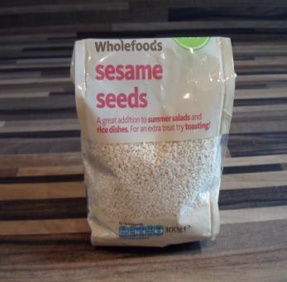

|  |  |
| --- | --- |
|  | **Shopping list for bread making** |
|  | Bread mix  Bread mix comes in different varieties.  Some have added dried tomatoes and onions. Always choose a brown or wholemeal bread mix. |
|  | Raisins  Group can choose to put these in or not |
|  | Sesame seeds  Group can choose to put these in or not |

## Session 3: Fibre and cooking learning outcomes

At the end of the session the group should:

* be aware of basic food safety guidelines
* have increased their practical cooking skills
* have experienced the process of raw foods to cooked foods
* be able to follow a task sequence
* have experienced tasting the foods they cooked

##### Activities and resources

|  |  |  |
| --- | --- | --- |
| **Activity** | **Preparation** | **Resources** |
| Preparation for cooking | * Buy aprons and hats (if using), disposable ones are available * Print off or photocopy cook’s rules in colour if possible * It is best to laminate these so they can be used again. Matt laminate is recommended. | * Aprons * Hats (optional) * Cook’s rules (page 240-241) |
| Cooking | * Check risk assessment to help you choose group leaders * Print off or photocopy recipe (you may choose to laminate these) * Identify preparation area and hand washing facilities | * Recipe sheets (page 228-231) * Ingredients * Cooking and serving utensils |

|  |  |  |
| --- | --- | --- |
| **Activity** | **Preparation** | **Resources** |
| Tasting | * Identify preparation area and hand washing facilities * Check risk assessment for food allergies/preferences | * Plates or cups depending on what you buy to taste |
| Physical activity | * Check the risk assessment sheets to make sure that groups can do the exercise that is suggested * Plan a walk to do with the group | ‘You can do it’ from [http://vimeo.com/21292](http://vimeo.com/21292481) [481](http://vimeo.com/21292481)   * Find out if your local authority has activities or facilities that you can access |

## Session 3: Fibre and cooking

The purpose of this part of the session is to:

* be aware of basic food safety guidelines.

Today you will bake bread.

Hand out and read through, explaining as you go the cook’s rules (240- 241). Ask everyone to wash their hands and put on their aprons and hats (if using).

### Cooking

The purpose of this part of the session is to:

* increase their practical cooking skills
* experience the process of raw foods to cooked foods
* be able to follow a task sequence
* experience tasting the foods they cooked.

Lay out the ingredients on the table along with the equipment that is required.

You should have previously identified group leaders. Encourage them to perform the cooking tasks and those who may be less able can perform simple and safe activities such as:

* putting the ingredients into bowls
* mixing the ingredients
* kneading the dough.

Split the group into smaller teams with at least one group leader in each.

Hand out the recipe cards. Depending on your group you may decide to go through the recipe step by step as one big group or leave the small teams to work their way through the recipe. Make sure you keep checking in with each group to ensure they are on track and know what they are doing.

**Important notice:** Please follow the cooking rules to avoid problems with food safety. Everything used has to be clean and safe.

The group can do the washing up, have a tea break or do some simple exercises while the bread is cooking.

### Physical activity

The purpose of this exercise is to:

* have taken part in physical activity.

Encourage the group do some exercise. You could:

* go for a walk.

Suggestion:

Why not ask the group what they would like to do for next time? If you have time you could watch the ‘You can do it’ SCLD video (<http://vimeo.com/21292481>) to get some ideas or talk to your local authority to find out if they run accessible physical activities.

### Tasting

Make sure that everyone has washed their hands, sit down and enjoy your bread!

Ask the group:

* Do you like them?
* What unhealthy foods could you replace in your diet with your bread/rolls?
* Would you make them at home?
* Who could help you?

You might want to give the cook’s rules, shopping list and recipe cards as handouts so that members of the group can take them home and make them again.

## Session 4: Fibre in foods

### Learning outcomes

At the end of the session the group should:

* be able to recall the main messages from the previous sessions
* know how to replace foods low in fibre with foods high in fibre
* have fun tasting foods that are high in fibre
* have taken part in physical activity.

### Activities and resources

|  |  |  |
| --- | --- | --- |
| **Activity** | **Preparation** | **Resources** |
| Recap | * Photocopy or print off constipation, regular man on toilet and healthy heart in colour (page 236-237) * Buy items or collect wrappers and containers to use in exercise | * Pictures of being regular and healthy heart   (page 236-237)   * Food items: pasta, fruit and vegetables (fresh, tinned, dried), peas and beans, brown and white bread, brown and white rice, cornflakes and Weetabix |
| Fibre during the day | * Print off fibre photographs and matt laminate | * Fibre photographs * Flip chart with sections marked out for breakfast, snack, lunch snack, dinner, drinks. * Blue tack photos of low fibre foods in each section |

|  |  |  |
| --- | --- | --- |
| **Activity** | **Preparation** | **Resources** |
| Taste and try | * Put beans into disposable cups * Store in a fridge until required * Print off ‘Fibre taste and try’ activity sheets (A3) (page 238-239) * Prepare flipchart for exercise. See notes on page 209 for more detail * Identify preparation area and hand washing facilities * Check risk assessment for food allergies/preferences | * Different types of tinned beans, disposable cups, disposable spoons, napkins, table cloths * Flip chart and pens |
| Learning check | * You might want to look out the quiz answers from session 1 to review increases in knowledge around fibre | * ‘Say yes to fibre’ quiz sheets from week 1 |
| Physical activity | * Check the risk assessment sheets to make sure that groups can do the exercise that is suggested * Plan out a walk to do with the group | * ‘You can do it’ from [http://vimeo.com/21292](http://vimeo.com/21292481) [481](http://vimeo.com/21292481) * Find out if your local authority has activities or facilities that you can access |

## Session 4: Fibre in foods

### Recap

The purpose of this part of the session is:

* to be able to recall the main messages from the previous sessions

Ask the group:

* What is fibre good for?

Answers:

* It keeps you regular, not constipated.
* It is good for the heart,

Show Boardmaker pictures (page 235-237).

Arrange food or wrappers on table and let group point to or pick up the answer to the next two questions.

Which foods are high in fibre?

Answer: breakfast cereals, bread, pasta, rice, fruit and vegetables, peas and beans

Which food has more fibre?

* White or brown bread?
* White or brown rice?
* Weetabix or cornflakes?

Answers:

* brown bread, brown rice and Weetabix.

Invite each learner to choose a food and place it on the Eatwell guide or activity mat. Ask them to think about which section of the mat it should go onto. If they are not sure ask the rest of the group to help them.

The foods should go into the yellow section, which has bread, rice potatoes and pasta and into the green section which has fruit and vegetables.

Ask the group:

* Have you tried both white and brown bread, cereal, etc.?
* Have you ever eaten fruit with the skin on?

Tell them it is better to eat their fruit with their skin on.

However, ensure that none of your participants has swallowing problems. People with swallowing problems should have their fruit with no skin and may need to have fruit than can be mashed like bananas.

Ask the group:

* What do we need to do when we eat fibre?
* Answer: drink fluids e.g. water, milk, juice, tea.

### Fibre during the day

The purpose of this exercise is to:

* be able to recall the main messages from the previous sessions
* know how to replace foods low in fibre with foods high in fibre.

It is very easy to have fibre in our meals. Ask the group to look at the foods on the flip chart and think of swaps you could make to have more fibre and fluids. Discuss answers and gradually replace the low-fibre foods, e.g. cornflakes with bran flakes and so on throughout the whole day.

The following questions should help get discussion going:

|  |
| --- |
| 1. Which breakfast cereals would you choose that have fibre in them? Answers:    1. Brown cereals – Weetabix, bran flakes, etc.    2. Add fruit, e.g. grapes or banana |
| 2. If you have a snack in the morning what could you choose that has fibre in it?  Answer:   1. A piece of fruit or a handful of dried fruit 2. Yoghurt with fruit in it |
| 3. Put a picture of a white bread sandwich as a lunch on the flipchart. Which foods can you add to make it healthier with lots of fibre? Answer:   1. Brown bread 2. Salad |
| 4. If you have pudding or a snack later on what food could you choose?  Answer:   1. A piece of fruit or dried fruit 2. Yoghurt with added fruit in it |
| 5. Put a picture of a bowl of rice as dinner on the flipchart. How can you increase fibre in this meal?  Answer:   1. Brown rice 2. Add peas and sweetcorn or mixed vegetables |
| 6. What else do we need for fibre to work properly? Answer:  a) 10 cups of fluids |
| 7. Can you give some examples of fluids? Answer:  a) Water, coffee, tea, milk, juice |

### Taste and try

The purpose of this exercise is to:

* know how to replace foods low in fibre with foods high in fibre
* have fun tasting foods that are high in fibre.

Explain to the group that we are going to have fun tasting foods which are either low or high in fibre.

Split into discussion groups of 3–4 people. Groups can call themselves a fun name if they wish to.

Give the following instructions:

* You will all be taste testing a variety of different beans
* Give out ‘Taste and try fibre’ activity sheet (page 238-239).
* Explain once you have decided whether it is high in fibre or low in fibre you can draw, write or put the cup on either the high in fibre page or low in fibre page.
* When you have tasted everything and decided on your answers we will come back together as a large group and discuss what everyone thought.

Bring out the foods to be tasted. We suggest the following but you could add your own:

Beans:

* baked beans
* kidney beans
* aduki beans
* haricot beans
* butter beans.

Note: Serve in disposable cups with plastic spoons.

For large group discussion:

* Prepare flip chart like this.

Foods high in fibre

Foods low in fibre

* Tear the flip chart off and place on table or floor where all in the group can see.
* Go through the foods and drinks tasted and discuss whether the groups thought they were high in fibre or low in fibre
* Reveal the answers to the group and use the bottles, cartons and containers left from the tasting exercise and put them on the flip chart in the correct place (high or low in fibre) to demonstrate the answers.

### Learning check

The purpose of this exercise is to:

* be able to recall the main messages from the previous sessions.

Using the fibre quiz sheets completed in session 1, do the quiz a second time and ask the group members if they would still tick the same answers.

## Physical activity

The purpose of this exercise is to:

* have taken part in physical activity.

Encourage the group do some exercise. You could:

* go for a walk.

Suggestion:

Why not ask the group what they would like to do for next time? If you have time you could watch the ‘You can do it’ SCLD video (<http://vimeo.com/21292481>) to get some ideas or talk to your local authority to find out if they run accessible physical activities

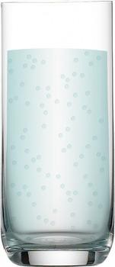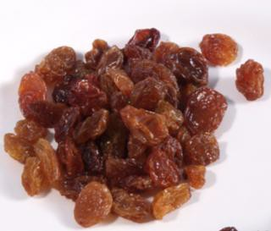

## Bread making

### What I need

|  |
| --- |
| Bread mix |
| Water  Raisins  You may choose not to include these |
| Sesame seeds  You may choose not to include these |

### What do I do?

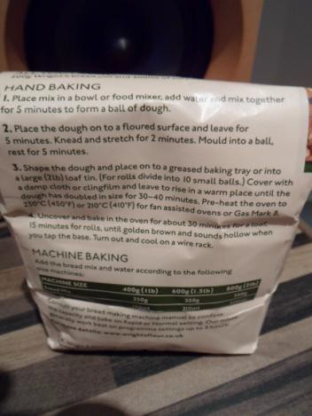

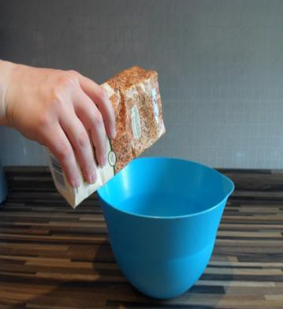

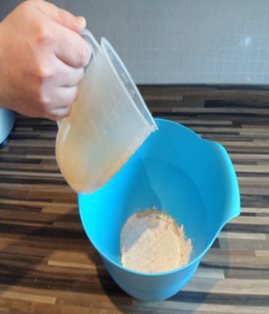

#### Follow the instructions for making bread on the back of the bread mix packet

Empty bread mix into a large mixing bowl

Use a measuring jug to pour the correct amount of water into the bread mix

The bread mix packet will tell you how much to add

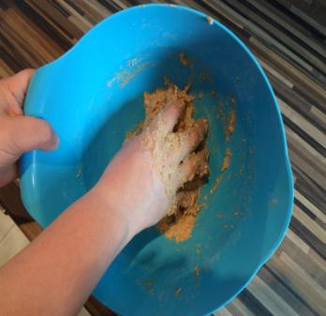Mix the bread mix and water together Do this until it looks like a ball of dough

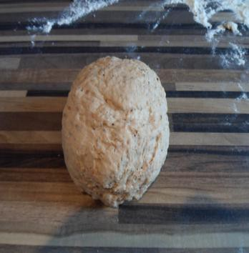Place the dough on a floured surface

Leave for the amount of time shown in the instructions on the back of the bread mix packet

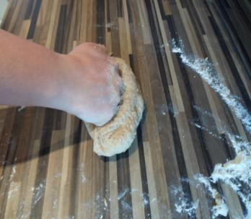Knead the dough using a punching motion

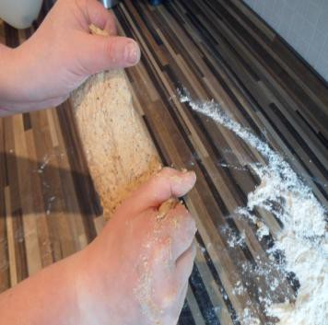Stretch the dough

Continue to knead and stretch the dough for as long as the instructions say. It should become smooth and stretchy

Leave the dough to rest for as long as the instructions say

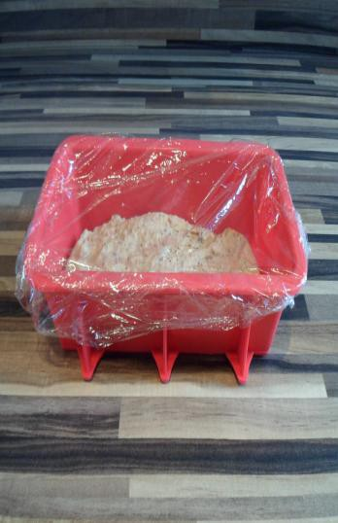Shape the dough into a large loaf tin (2lb)

Or shape into small balls and place on a greased baking tray to make rolls

Cover with a damp cloth or cling film

Leave in a warm place until the dough has got a lot bigger

Check the instructions on the bread mix packet for times

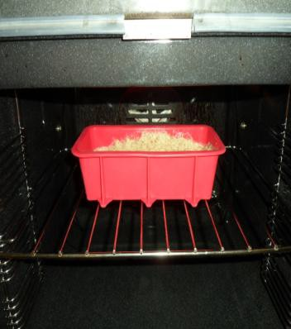Place in a pre-heated oven

Check the instructions on the back of the bread mix packet for temperature and time

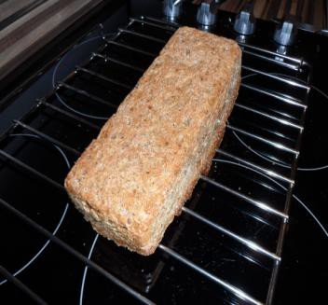Turn out the loaf from the tin and leave to cool on a wire rack

Enjoy!

## Say yes to fibre quiz

Tick or circle the correct answers

1. What problems can we have if our body does not get enough fibre?

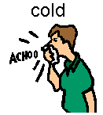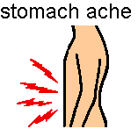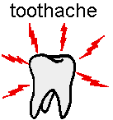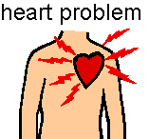

1. What else do we need for fibre to work well?

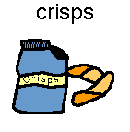



How many drinks should we drink each day?



1 glass 2 glasses 10 glasses

1. Which type of bread has more fibre?

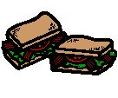

White bread Brown bread

1. Which is the breakfast with most fibre?



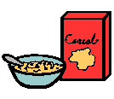

Fried breakfast Cereal and fruit juice

### Question Answer

|  |  |
| --- | --- |
| Q1 | If we do not eat enough fibre we can get constipation. This means a sore tummy and not being able to go to the toilet easily.  It is also good for the heart to eat fibre. |
| Q2 | We need to drink fluids like water so that fibre can soak it up inside our bodies. This helps us go to the toilet easily. |
| Q3 | Brown (wholemeal) bread has more fibre and is better for you. Ask group if they eat brown bread. |
| Q4 | Cereal and fruit juice have more fibre than a fried breakfast. Ask group how they could get more fibre at breakfast time. |

**Fibre**



**Fibre**

# Regular



# Healthy heart

**Fibre**



Foods low in fibre

Foods high in fibre

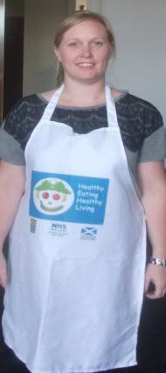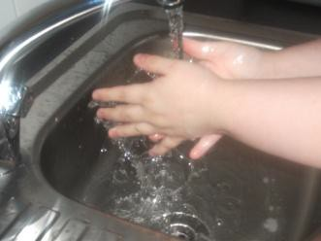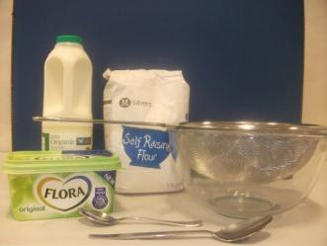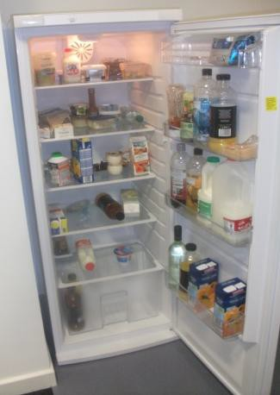

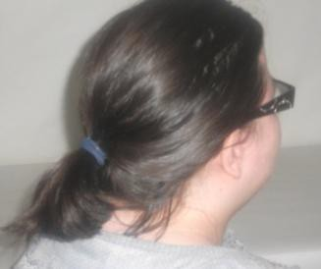**Cook’s rules**

|  |
| --- |
| Tie your hair back |
| Wear an apron |
| Wash your hands with soap and dry them before you start |
| Get everything out that you will need before you start |
| Keep milk, meat, cheese and yogurt in the fridge until you are ready to use them |

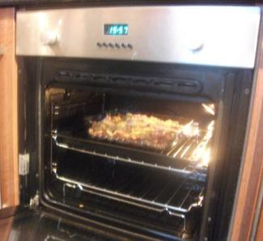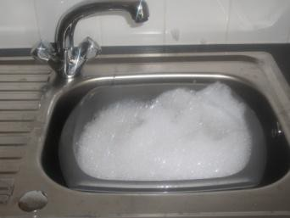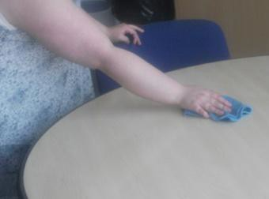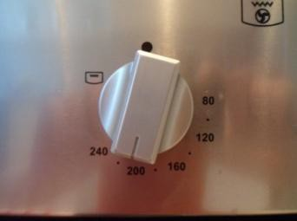

|  |
| --- |
| If you need help putting things in and taking things out of the oven, ask your support worker |
| Remember to switch off the oven when you are finished |
| Wash up using hot soapy water |
| Wipe worktops with a clean cloth and hot soapy water |
| Enjoy your food! |