Session 2: Fat and shopping

Learning outcomes:
At the end of the session the group should:
  - know where to buy foods low in fat
  - be able to choose ingredients for one recipe
  - have tasted low-fat foods.

Activities and resources

Activity | Preparation | Resources
Supermarket visit | - Contact supermarket manager for permission to take photographs  - Arrange transport  - Visit supermarket to be aware of where to find ingredients  - Consider high and low fat alternatives and where to find them  - Consider cost | - Pictorial shopping list for low fat fruity bacon (page 167) and or fish and chips (page 168)  - Petty cash for food tasters
Tasting | - Identify preparation area and hand washing facilities  - Check risk assessment for food allergies/ preferences | - Plates or cups depending on what low fat foods you buy to taste

Session 2: Fat and shopping

Supermarket visit

The purpose of this exercise is to:
  - know where to buy low fat foods
  - buy low-fat foods for the tasting session
  - be able to choose ingredients for low fat fruity bacon and or fish and chips.

At the visit with the group:

1. Find foods that exist in two forms - low fat or high in fat.

For example: full fat milk (blue label) and low fat milk (green or red label)
- Ask the group which food they should choose and why

Answer: Low fat foods because they are better for your heart and do not make you fat.
Repeat the activity with other products. For example:
  - Butter and low fat margarine
  - Full fat cheese and cottage cheese
  - Chocolate pudding and yogurt

You can choose other items that are low fat to look at and / or buy too.
- Visit the butcher or meat section and see meat with fat and without fat. Explain to the group that if they want they can ask the butcher to cut the fat from the meat they want to buy. This is called lean meat

For example:
  - Chicken with the skin removed
  - Bacon with the fat cut off
  - Lean mince

4. Visit the fish section and remind the group that fish is good for us because it has less fat than meat. Even oily fish like tuna and salmon are good for us.
5. Visit the snack section. Look for fruity crisps and potato crisps. Check to see if they have any baked crisps.
6. Ask the group to choose some low fat foods they haven’t tried before for tasting later.
7. Buy the foods that you will use for the cooking session next week. You will need to decide if you are going to cook the fruity bacon or fish and chips. (There is an option as some learners may not eat bacon)

Tasting what we bought

The purpose of this exercise is to:
  - have tasted alternative low fat foods to high-fat foods.

When you return to the learning base prepare for the tasting exercise.
Make sure the group wash their hands and then taste the things that you bought at the supermarket.

Discuss:
  - How things taste.
  - Which unhealthy foods you could replace with these healthier alternatives.
  - Your experience at the supermarket.

Try to reinforce messages discussed in previous sessions such as:

  - Why fat is bad for us.
  - The benefits of foods those are low in fat.
  - Alternative foods to try.
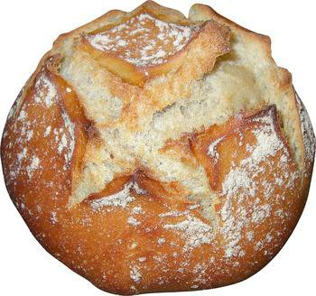
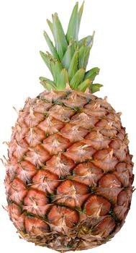
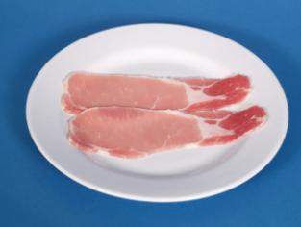

Shopping list for fruity bacon
Bacon
Bread Rolls
Tinned or fresh pineapple (optional)
Banana
Tomatoes

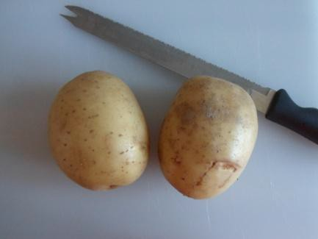
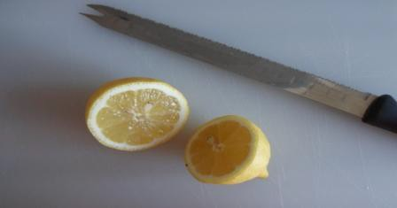
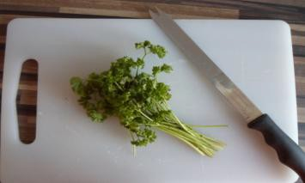
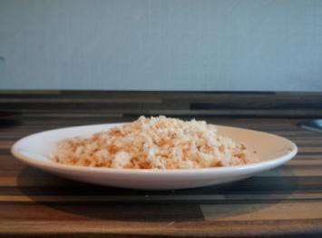
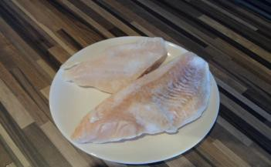
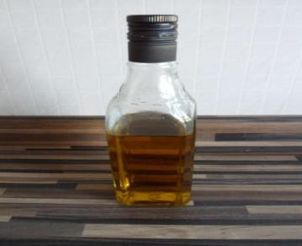

Shopping list for fish and chips
2 large baking potatoes
Juice and zest of 1 lemon
Small bunch of parsley
40g of fresh breadcrumbs

2 white fish fillets

Rapeseed or olive oil for drizzling

