Session 4: Fruit and vegetables and cooking

Learning outcomes:

At the end of the session the group should:
be aware of basic food safety guidelines have increased their practical cooking skills
have experienced the process of raw foods to cooked know the task sequence
have experienced tasting the foods they cooked.


Activities and resources:

Activity | Preparation | Resources
Preparation for cooking | Buy aprons and hats (if using), disposable ones are available  Print off or photocopy cook’s rules in colour if possible. It is best to laminate these so they can be used again. Matt laminate is recommended | Aprons  Hats (optional) Cook’s rules (page  148-149)
Cooking | Check risk assessment to help you choose group leaders  Print off or photocopy recipe (you may choose to laminate these) |   Recipe sheets (page 109-117)  Ingredients  Cooking and serving utensils
Tasting | Identify preparation area and hand washing facilities  Check risk assessment for food allergies/preferences | Plates or cups depending on what you are tasting

Preparation for cooking
The purpose of this part of the session is to:
be aware of basic food safety guidelines.

Today you will make one (or more if applicable) of the following: carrot and coriander soup
baked apple
quick pizza.
Hand out and read through, explaining as you go the cook’s rules. Ask everyone to wash their hands and put on their aprons and hats (if using).

Cooking
The purpose of this part of the session is to:

increase their practical cooking skills
experience the process of raw foods to cooked foods
be able to follow a task sequence
experience tasting the foods they cooked
Lay out the ingredients on the table along with the equipment that is required.
You should have previously identified group leaders. Encourage them to perform the cooking tasks and those who may be less able can perform simple and safe activities such as:

putting the ingredients into bowls cutting up the ingredients
mixing the ingredients.
Split the group into smaller teams with at least one group leader in each.
Hand out the recipe cards. Depending on your group you may decide to go through the recipe step by step as one big group or leave the small teams to work their way through the recipe. Make sure you keep checking in with each group to ensure they are on track and know what they are doing.

Important notice: Please follow the cooking rules to avoid problems with food safety. Everything used has to be clean and safe.

Tasting
The purpose of this part of the session is to:
experience the process of raw foods to cooked foods experience tasting the foods they cooked.
Make sure that everyone has washed their hands, sit down and enjoy your food!
Ask the group:
Do you like them?
What unhealthy foods could you replace in your diet with your recipes?
Would you make them at home? Who could help you?

Optional exercise
Depending on the size of your group and the cooking facilities that you have, you might want to do the tasting along the lines of the television programme ‘Come Dine with Me’ with groups giving marks out of 10 for each dish
Starter – carrot and coriander soup Main course – pizza
Dessert - Baked apple
You might want to give the cook’s rules, shopping list and recipe cards as handouts so that members of the group can take them home and make them again.

Carrot and coriander soup

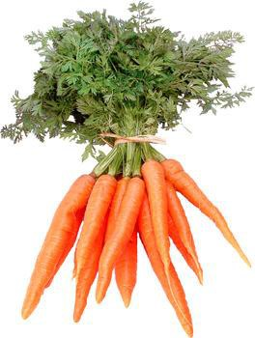
What I need:

 | 225 grams or 4 small carrots
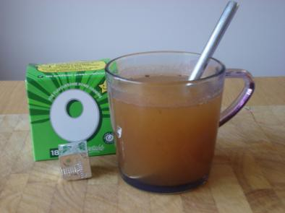 | 1 cup of vegetable stock
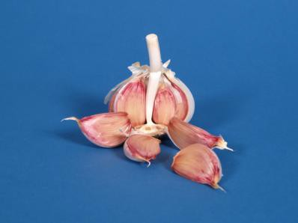 | ½ a clove of garlic
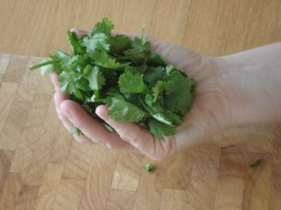 | 1 teaspoon dried coriander  Or 1 big handful fresh coriander

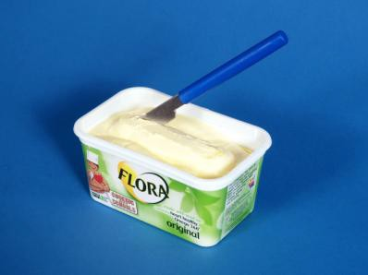 | 25 grams or 2 teaspoons of margarine
 | Salt and pepper

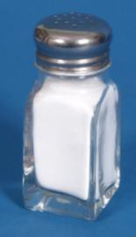

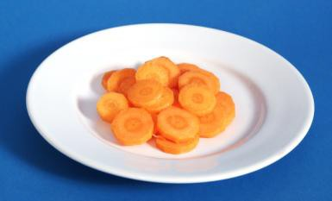
What do I do?

 | Peel and chop carrot into small chunks
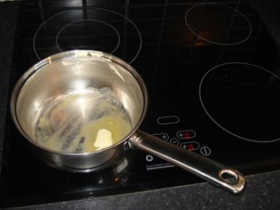 | Put the margarine into a large pan.  Put the pan on the hob and turn the heat to medium.
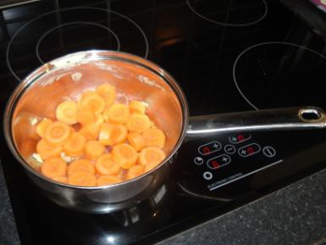 | Add carrot and garlic to pan  Cook for about 5 minutes until the carrots are softer

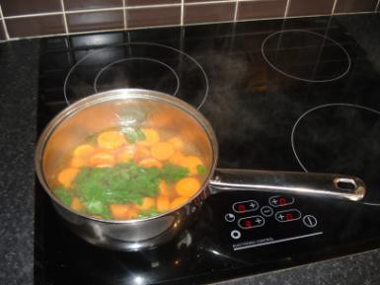

Pour in the stock
Simmer for 20 minutes Then add coriander
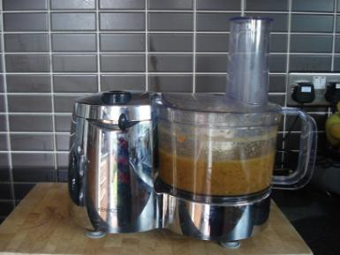 | Put the soup into a blender. Blend until smooth.


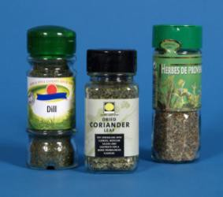
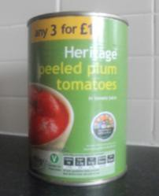

Quick pizza
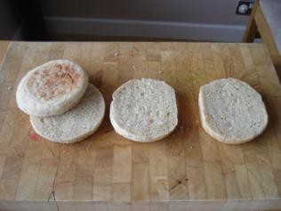
What I need:

 | 2 bread rolls cut in ½ Or 4 English muffins
 | ½ Tin of tomatoes
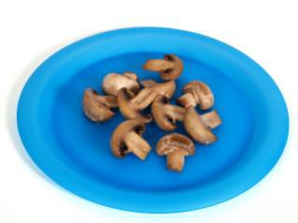 | 4 Mushrooms  or 1/2 pepper or vegetables of your choice or 1 small tin of pineapple or other fruit
 | 85grams ½ fat cheese
 | ½ teaspoon of dried herbs

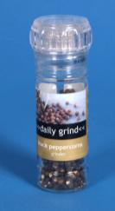
Pinch of pepper

What do I do?

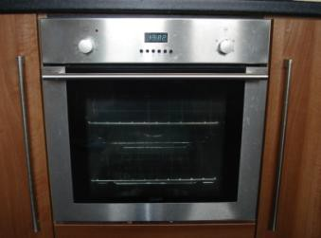 | Put the grill onto medium
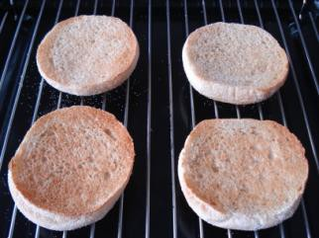 | Toast the bread rolls or English muffins
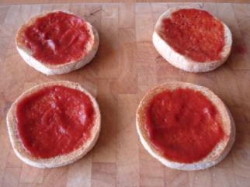 | Spread the tomatoes over the toasted rolls or muffins
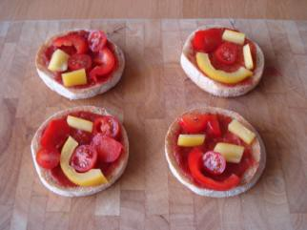 | Put mushrooms, peppers and or pineapples on top of the 4 quick pizzas

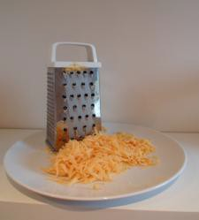

 | Grate cheese
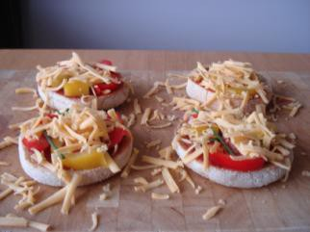 | Add grated cheese to the quick pizzas
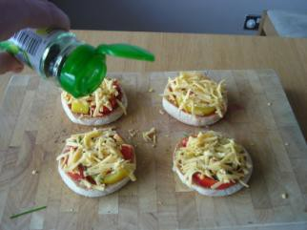 | Sprinkle with herbs and pepper
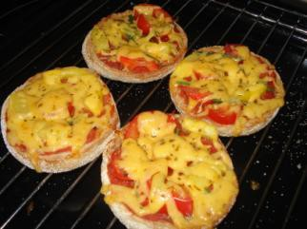 | Place under the grill until cheese bubbles

Baked apple

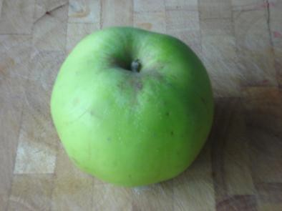
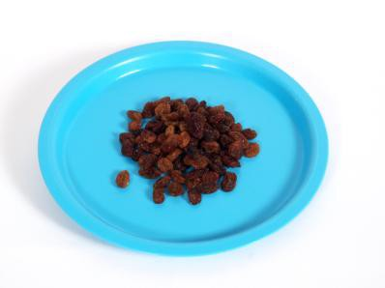
What I need:

 | 1 cooking apple
 | 1 handful of raisins
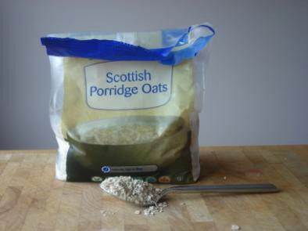 | 1 dessert spoon of porridge oats
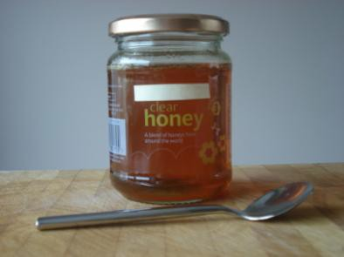 | 1 teaspoon of runny honey

Oven temperature: 190˚C
Time to cook: 40 minutes

What do I do?

 | Set the oven to 190 (gas mark 5)
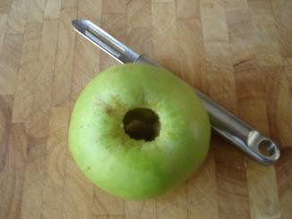 | Remove apple core  (if you don’t have an apple corer you can use a potato peeler or sharp knife)
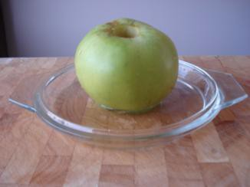 | Put the cored apple in an oven proof dish  Add enough cold water to cover the bottom of the oven proof dish
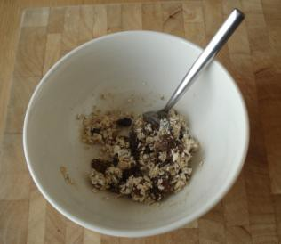 | Put the raisins in a bowl Add the porridge oats Add the honey  Mix together



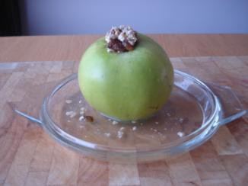 | Fill the middle of the apple with the raisin mix
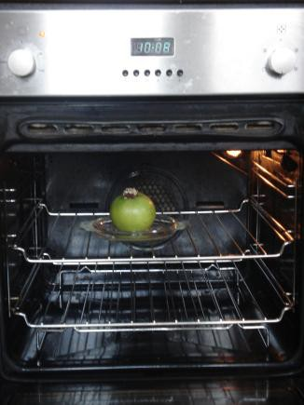 | Bake in the middle of the oven for 40 minutes
 | Remove from the oven and enjoy You could serve with low-fat yoghurt

