Session 3: Fruit and vegetables and shopping

Learning outcomes
At the end of the session the group should:
be able to recall the previous session
know where to buy fresh, dried, frozen, tinned fruit and vegetables be able to choose ingredients for one recipe
have tasted new/exotic fruit and vegetables.

Activities and resources

Activity | Preparation | Resources
Recap fruit and vegetables | Consider how you will review the previous session
Supermarket visit | Visit the supermarket before to be aware of where the sections you want to visit are  See where you can buy fresh, dried, tinned and frozen fruit and veg  Be aware of difference in cost  Choose ingredients for carrot and coriander soup or pizzas or baked apple | Pictorial shopping list for recipe (page 102-104)  Petty cash for food tasters
Tasting |  | Knife  Chopping board Plates  Fruits and vegetables from the supermarket

Session 3: Fruit and vegetables and shopping

Recap fruit and vegetables
The purpose of this exercise is to:
discuss what they did during the second session.

Suggestion: Consider questions from session two Fruit and Vegetables in your meals to recall the information.

Supermarket visit

The purpose of this exercise is to:
know where to buy fresh, dried, frozen, tinned fruit and vegetables be able to choose ingredients for one recipe

Before you visit the supermarket ask the group to choose which recipe they will make (you may decide to make more than one depending on your group).
- Carrot and coriander soup
- Baked apple
- Quick pizza

At the visit with the group:

- Find fruit and vegetables that exist in different forms – fresh, dried, tinned or frozen.

For example:
fresh banana and dried banana fresh apples and dried apples fresh apricots and dried apricots
fresh pineapple and tinned pineapple tinned fruit salad
fresh peas and tinned peas and frozen peas fresh broccoli and frozen broccoli florets frozen mixed vegetables.

Ask the group:

- What fruit and vegetables do you see?
Repeat the question each time you see different forms of fruit and vegetables.

- Which fruit and vegetables are your favourite?

- Can you choose some fruit and vegetables to try later?
Encourage them to opt for ones they’ve not tried before.
For example: avocado, passion fruit (fresh), cranberries, bananas (dried), mango (tinned or fresh), cherry tomatoes, celery.

- Buy the foods that you will use for the cooking session (see shopping list for recipe).

Tasting what we bought

The purpose of this exercise is to:
have tasted new/exotic fruit and vegetables.

When you return to the learning base prepare for the tasting exercise. Make sure the group wash their hands and then taste the things that you bought at the supermarket.

Discuss:

how things taste
all the different colours of fruit and vegetables and why this is good for us
which unhealthy foods you could replace with these healthier alternatives
our experience at the supermarket

Try to reinforce messages discussed in previous sessions such as: Why it is good to eat fruit and vegetables
How many portions you should have a day
Alternative foods to try
What a portion is

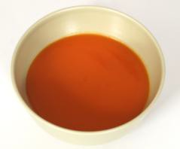
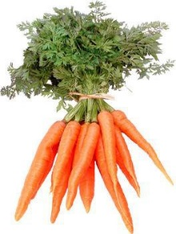
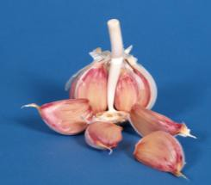

 | Shopping list for carrot and coriander soup
 | Carrots
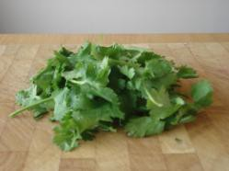 | Coriander dried or fresh
 | Garlic
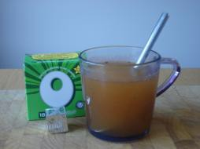 | Vegetable stock
 | Margarine
 | Salt and pepper

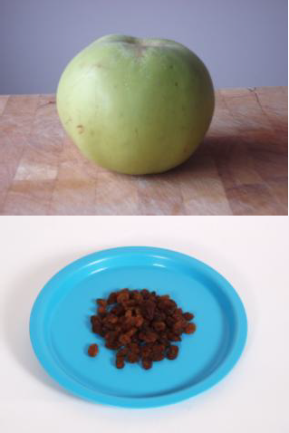

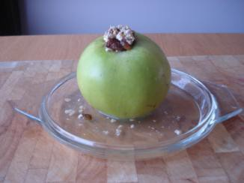 | Shopping list for baked apples
 | Cooking apples
 | Raisins
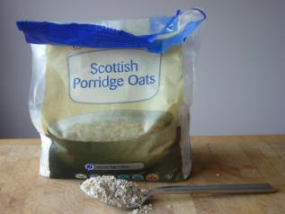 | Porridge oats
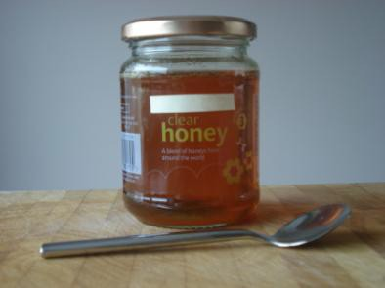 | Honey
 | Low-fat yoghurt

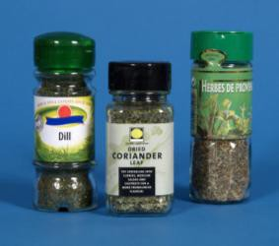
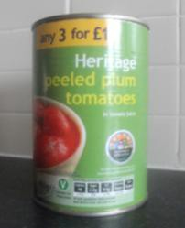
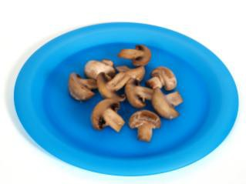
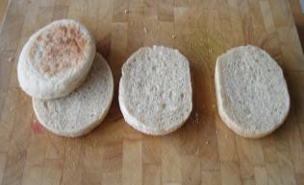

Shopping list for quick pizza
Bread rolls or English muffins
Tinned tomatoes
Mushrooms or peppers or pineapple You can choose any vegetable or fruit
½ fat cheese
Dried herbs
Pepper

