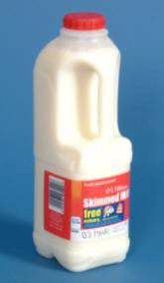
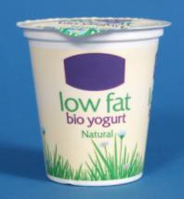
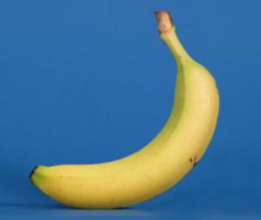
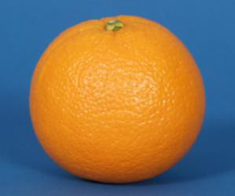
Fruit smoothies

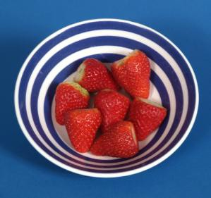
What I need:

6 strawberries
1 banana
1 tablespoon yoghurt
You could use 150ml of milk instead of yoghurt
Juice from 1 orange

What do I do? Fruit smoothies

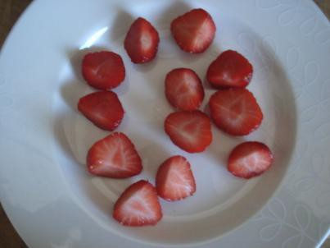 | Wash strawberries  Take stems off strawberries  Cut each strawberry into 2 pieces
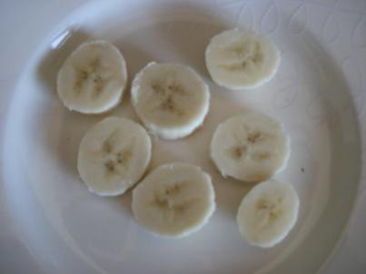 | Peel the banana. Cut banana into pieces
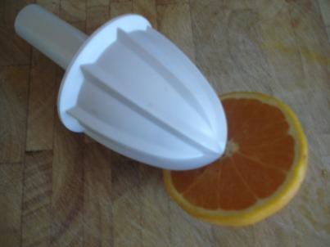 | Juice the orange
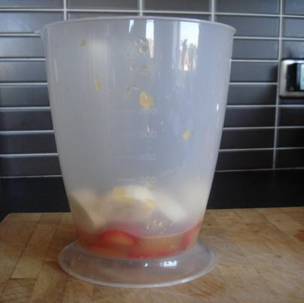 | Add all fruit to blender bowl
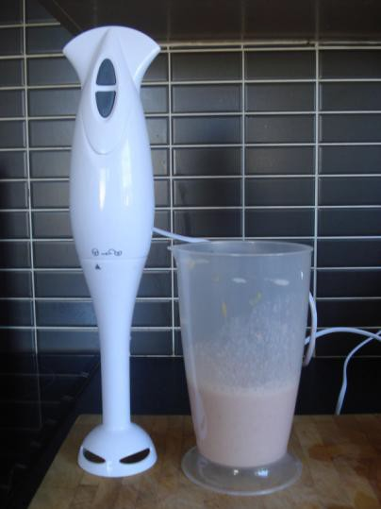 | Add yoghurt or milk to blender bowl  Blend until smooth  Pour into glass and enjoy!

