Session 2: Fruit and Vegetables in your meals

Learning outcomes
At the end of the session the group should:

be able to recall the previous session
know what counts as a portion of fruit and vegetables know how to choose 5 or more portions each day have taken part in making fruit smoothies
have made a choice of what to cook have taken part in physical activity.

Activities and resources

Activity | Preparation | Resources
Pictorial recall | Print off pictures of fresh, tinned, dried and frozen fruit and vegetables  Make sure you are familiar with the health benefits of eating fruit and vegetables  Print off board maker pictures | - Eatwell floor mat or guide  - Real or pictures of fresh, tinned, dried, frozen fruit and veg  - Boardmaker picture of heart problems  - Boardmaker picture of a healthy heart with happy face and thumbs up  - Boardmaker picture of a person sneezing  - Boardmaker picture of a person in pain on the toilet  - Boardmaker picture of a smiling person on the toilet  - Boardmaker picture of a person ill in bed  (Page 131-136)

Activity | Preparation | Resources
What is a portion? |  | - An orange  - An apple  - 4 strawberries  - A handful of raisins  - A bowl of tinned fruit in fruit juice  - A bowl of fruit salad in fruit juice  - A bowl of vegetable salad  - 3 heaped tablespoons of beans or sweet corn or peas.
How can we have 5 portions a day? |  | - Flip chart/paper and pens  - Pictures of:  - Bowl of cereal  - Sandwich  - Steak  - Glass of fruit juice  - A handful of dried fruit  - Oranges  - Apples  - Bananas  - Grapes  - Salad  - Vegetable soup  - Broccoli  - Carrots  - Peas  - Yoghurt

Activity | Preparation | Resources
Taste and try |  | Smoothies recipe card A chopping board  A knife to cut fruit A blender  Fresh fruit or tinned with juice  Milk or yoghurt Plastic cups to serve smoothies
Physical activity | Check the risk assessment sheets to make sure that groups can do the exercise that is suggested  Plan out a walk to do with the group. | ‘You can do it’ (SCLD) from http://vimeo.com/21292 481

Session 2: Fruit and vegetables in
your meals

Recap fruit and vegetables are good for you!
The purpose of this exercise is to:
be able to recall the previous session.

Try and get an answer from each group member and ask the group: Why should we eat fruit and vegetables?
Use the Eatwell guide (or activity mat) to remind them where the fruit and vegetables go. Each group member should choose a food and put it on the mat.

Answer
It is important to eat fruit and vegetables for good health. It keeps our bodies healthy, keeps us regular and can protect us from heart disease, heart attacks, strokes and some cancers. It can protect us from other illness such as catching colds.

It is also important to eat as many different coloured fruit and vegetables as possible, as fruit or vegetable gives us different vitamins.

You can use the Boardmaker pictures (page 131-136) to recap with the group.

Remind the group that fruit and vegetables can be fresh, tinned, dried, frozen.

- Fresh (show a picture of fresh fruit or actual fresh fruit).
- Tinned (show a picture of tinned fruit or an actual tin of fruit in fruit juice).
- Dried (show a picture of dried fruit or an actual handful of dried fruit.
- Frozen (show a picture of frozen vegetables or an actual packet of frozen vegetables).

What is a portion?

The purpose of this exercise is to:
- know what counts as a portion of fruit and vegetables.
Ask the group if they know what a portion of fruit and vegetables is. A portion is:
any fruit and vegetable that fits in your hand
3 heaped tablespoons of vegetables, beans or pulses a dessert bowl of fruit or vegetable salad.

Examples
An orange, an apple, 4 strawberries, a bowl of tinned fruit, a bowl of fruit salad in fruit juice, a bowl of vegetable salad, 3 heaped tablespoons of beans, sweetcorn or peas.

Try to give examples of fresh, dried, tinned and frozen fruit and veg. It is preferable to show an actual portion fitting in your hand rather than pictures.

Ask someone from the group to hold a portion. Ask them if there is more space in their hand for more fruit or veg.

Ask the group:
Do you know how many portions of fruit and vegetables you should eat each day?

We all should eat 5 portions of fruit and veg. Remind the group that potatoes do not count as a portion of fruit and vegetables.

You can only count a glass of fruit juice and peas/beans once a day because they don’t have the same goodness in them that other fruit and vegetables have.

How can we have 5 portions of fruit and vegetables a day?

The purpose of this exercise is to:
recognise what counts as a portion
know how to choose 5 or more portions each day.

It is very easy to have 5 portions of fruit and vegetables in a day. By using a flipchart and pictures of foods build a healthy menu.
Put a picture of breakfast cereals as a breakfast on the flipchart. Ask the group:
1. Which foods they can add so they can start counting their portions of fruit and vegetables a day (let them choose from the pictures)
any fruit in the bowl of cereals (1st portion)
a glass of fruit juice (2nd portion) remember only counts once in the day
2. Which food they might have as a snack after breakfast (let them choose from the pictures)
- a fruit or a handful of dried fruit (3rd portion)

Put a picture of a sandwich as lunch on the flipchart.
3. Which foods they can add to make it healthier (let them choose from the pictures)
a salad (4th portion)
vegetable soup (5th portion)
4. Which food they might have as a snack after lunch (let them choose from the pictures)
yoghurt with added fruit in it (6th portion)
Put a picture of a steak as dinner on the flipchart

5. Which foods they can add to make it healthier (let them choose from the pictures)
broccoli, cauliflower, carrots and peas (7th portion)
a tin of fruit salad in fruit juice as a dessert (8th portion)

Look through the flip chart and see how many different colours of fruit and vegetables there are.

Taste and try

The purpose of this exercise is to:
have taken part in making fruit smoothies
have made a choice in creating a healthy smoothie
Lay out the ingredients on the table along with the equipment that is required.
You should have previously identified group leaders. Encourage them to perform the cooking tasks and those who may be less able can perform simple and safe activities such as:
washing the fruit
putting the ingredients into bowls cutting up ingredients
using the blender.
Split the group into smaller teams with at least one group leader in each.
Hand out the recipe cards. Depending on your group you may decide to go through the recipe step by step as one big group or leave the small teams to work their way through the recipe. Make sure you keep checking in with each group to ensure they are on track and know what they are doing.

Important notice: Please follow the cooking rules to avoid problems with food safety. Everything used has to be clean and safe.

Serve the smoothies in the plastic cups.

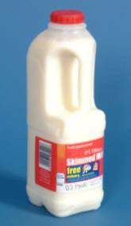
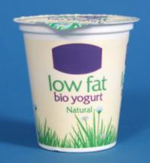
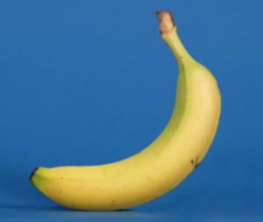
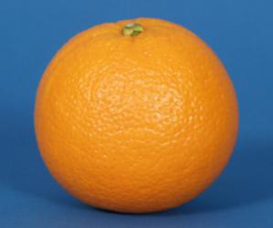
Fruit smoothies

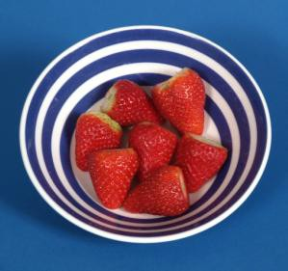
What I need:

6 strawberries
1 banana
1 tablespoon yoghurt
You could use 150ml of milk instead of yoghurt
Juice from 1 orange

What do I do?

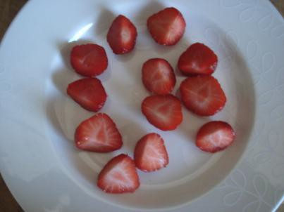 | Wash strawberries  Take stems off strawberries  Cut each strawberry into 2 pieces
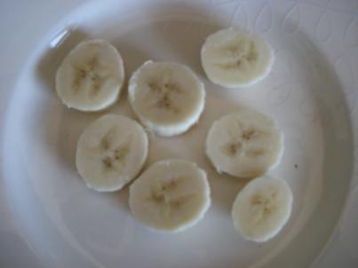 | Peel the banana. Cut banana into pieces
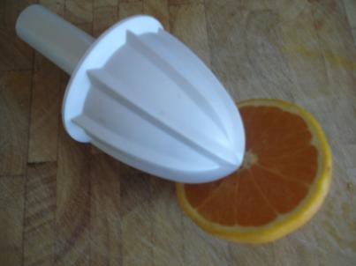 | Juice the orange
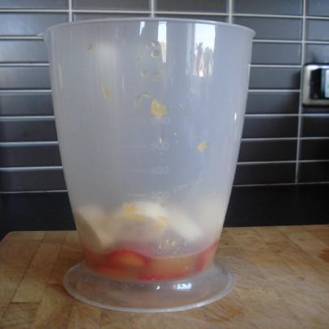 | Add all fruit to blender bowl
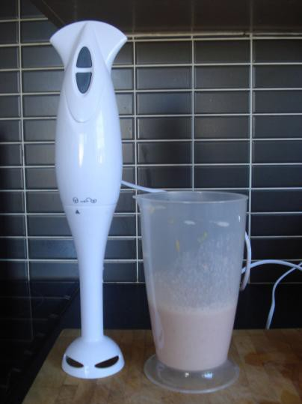 | Add yoghurt or milk to blender bowl  Blend until smooth  Pour into glass and enjoy!

Physical activity

The purpose of this exercise is to:
have taken part in physical activity.

Encourage the group do some exercise. You could:
- go for a walk.

Suggestion:
Why not ask the group what they would like to do for next time? If you have time you could watch the ‘You can do it’ SCLD video – (http://vimeo.com/21292481) to get some ideas or talk to your local authority to find out if they run accessible physical activities.

