Background information for course leader

Fruit and vegetables are good sources of lots of different vitamins and minerals. Fruit and vegetables are very low in fat and are a great source of fibre. People who eat lots of fruit and vegetables get the vitamins and minerals to feel healthy.

Eating plenty of fruit and vegetables: Helps fight off infection Prevents heart disease Prevents some cancers
Maintains normal healthy bowel function, this can help prevent constipation
Prevent obesity, by making us feel fuller for longer Which fruit and vegetables give us which vitamin?
Vitamin | Benefit to body | Fruit and/or vegetable
A | For growth, healthy skin and hair, helps immune system | Bananas, blackberries, avocados, melons, oranges, carrots
B | Cell repair, digestion, production of energy, immune system, healthy blood | Asparagus, broccoli, spinach, bananas, dried fruit
C | For growth, healthy body tissue, wound repair, healthy immune system, helps iron absorption | Strawberries, oranges, mangos, lemon, red pepper, spinach
E | Healthy heart, blood and circulation | Tomatoes, brussel sprouts, spinach, tropical fruits
K | Helps in blood clotting and for strong bones | Apple, banana, kiwi fruit most vegetables

You should eat at least five portions of fruit and vegetables every day. You can choose from fresh, frozen, tinned, dried or juiced. Choose a variety of different colours to get the most health benefits. Steam or microwave rather than boil to maintain as much goodness as possible. If you do boil, do so for the shortest time and in the least amount of water possible.
Remember potatoes do not count because they are a starchy food. 1 portion = 80g of fruit or vegetables
Sources (1 portion):
1 apple, banana, pear, orange or other similar sized fruit 2 plums or similar sized fruit
½ a grapefruit or avocado
1 slice of large fruit, such as melon or pineapple
3 heaped tablespoons of vegetables (raw, cooked, frozen or tinned)
3 heaped tablespoons of fruit salad (fresh or tinned in fruit juice) or stewed fruit
3 heaped tablespoons of beans and pulses*
1 heaped tablespoon of dried fruit (such as raisins and apricots) 1 handful of grapes, cherries or berries
1 dessert bowl of salad
1 glass (150ml) of fruit juice**

* However much you eat, beans and pulses count as a maximum of one portion a day
** However much you drink, fruit juice counts as a maximum of one portion a day

Reference Intakes (RIs):

The average adult of normal weight and average activity levels needs:
Each day | women | men
Portions of 80g | 5 portions or more | 5 portions or more

How to increase our intake:
eat at least one portion of vegetables with each meal have fruit or raw vegetables for snacks.

Breakfast options:
add a portion of fresh fruit (banana) or a tablespoon of dried fruit (raisins) to your cereal or porridge
have a banana sandwich
drink a glass of fruit juice – diluting juice or a fruit drink are NOT counted as a portion.

Lunch options:
bowl of vegetable soup bowl of salad
portion of vegetables with main course try the vegetarian option.

Evening meal options:
have two portions of vegetables with your meal try the vegetarian meal option
fresh fruit or tinned fruit in juice as pudding.

There is a dedicated section about fruit and vegetables on the Healthy Eating Healthy Living video on the SCLD website to go with this pack. It may be useful to show this to the group to aid learning or to give you ideas about what activities to do.

Session 1: Fruit and vegetables and health

Learning outcomes:
At the end of the session the group should:
        - Know that you should eat plenty of fruit and vegetables
        - Be able to list the types – fresh, dried, frozen, tinned Be aware of the health benefits of fruit and vegetables
        - Know what counts as a portion
        - Have fun experiencing new fruit and vegetables by touch, taste and smell
        - Have taken part in physical activity

Activities and resources:

Activity | Preparation | Resources
Questions assessing knowledge about fruit and vegetables | - Print off copies or photocopy Fun with Fruit and Vegetables quiz sheets | Fun with fruit and vegetables quiz (page 127-129)  Pens
Eatwell guide (or activity mat) | Buy fruit and vegetable items or collect wrappers and containers to use in exercise  Alternatively print off food photographs from the SCLD website | - Eatwell guide (or activity mat)  - Tinned fruit in juice  - Tinned sweet corn  - Bananas  - Beans  - Strawberries  - Grapes  - Potatoes  - Orange  - Dried raisins  - Chips  - Frozen mixed vegetables  - Fruit juice carton

Activity | Preparation | Resources
Fresh, tinned, dried, frozen | Print off pictures of fresh, dried, tinned and frozen fruit and vegetables if necessary | - Eatwell guide (or activity mat)  - Real or pictures of fresh, tinned, dried, frozen fruit and vegetables
Fruit and vegetables are good for you! | Boardmaker pictures | A Boardmaker picture of heart problems  A Boardmaker picture of a healthy heart with happy face and thumbs up  A Boardmaker picture of a person sneezing  A Boardmaker picture of a person in pain on the toilet  A Boardmaker picture of a smiling person on the toilet  A person ill in bed (pages 131-136)

Activity | Preparation | Resources
Guess the fruit and vegetables by touch smell and taste | Touch  Shred some paper to fill the box  Add a pineapple, kiwi fruit and head of broccoli  Smell  Peel and top 2 cloves of garlic and place in disposable cup covered with foil  Taste  Wash cherry tomatoes  Pour out small unsweetened fruit juice  Place small portion of dried fruit e.g. raisins, cranberries in cups  Store all food tasters in the fridge until needed | A table cover Tray  Cocktail sticks Disposable plastic cups Napkins  A box filled with shredded paper Garlic  Lemon Pineapple Kiwi Broccoli  Cherry tomatoes Fruit juice  Dried fruit Prize
Physical activity | Check the risk assessment sheets to make sure that groups can do the exercise that is suggested  Plan out a walk to do with the group. | ‘You can do it’ (SCLD) from http://vimeo.com/21292 481

Session 1: Fruit and vegetables and health questions

Assessing knowledge about fruit and vegetables

The purpose of this exercise is to:
find out the group’s existing knowledge about fruit and vegetables.

Hand out the ‘Fun with fruit and vegetables’ quiz (page 127-129) and a pen to each group member.

Ask the group one question at a time.
Ask the group to tick beside the picture/s they think are the answers.
Collect in their answer sheets, to be used again at the end of the fruit and vegetables topic to find out if they have learned from the sessions.

Eatwell guide (or activity mat)

The purpose of this exercise is to:
introduce the group to fruit and vegetables
be able to list the vegetable types – fresh, dried, frozen, tinned. Try and get an answer from each group member and ask:
- Which fruit and vegetables do you like?
- Do you think we should eat a lot or a little fruit and vegetables?

Lay out the fruit and vegetables (or wrappers/containers/photographs) on a table.
For example:
tinned fruit in juice tinned sweetcorn bananas
beans strawberries grapes potatoes orange
dried raisins chips
frozen mixed vegetables
- fruit juice carton.

Invite each learner to choose a food and place it on the Eatwell guide (or activity mat). Ask them to think about which section of the mat it should go onto. If they are not sure ask the rest of the group to help them.

The foods should go into the green section, fruit and vegetables. Potatoes and chips do not belong in the fruit and vegetable section. They go in the yellow section, starchy foods.

Explain that you should have at least 5 portions of fruit and vegetables every day.

Fresh, tinned, dried, frozen

The purpose of this exercise is to:
be able to list the types – fresh, dried, frozen, tinned.

Fruit and vegetables can be:
fresh (show a picture of fresh fruit or actual fresh fruit)
tinned (show a picture of tinned fruit or an actual tin of fruit in fruit juice)
dried (show a picture of dried fruit or an actual handful of dried fruit)
frozen (show a picture of frozen vegetables or an actual packet of frozen vegetables).

Fruit and vegetables are good for you!

The purpose of this exercise is to:
know that you should eat plenty of fruit and vegetables be aware of the health benefits of fruit and vegetables.

Ask the group:

- do you know why fruit and vegetables are good for you?

It is important to eat fruit and vegetables for good health. It keeps our bodies healthy, keeps us regular and can protect us from heart disease, heart attacks, strokes and some cancers. It can protect us from other illness such as catching colds.

Use the Boardmaker pictures to talk through your answers (pages 131-- 136):
a heart in pain a healthy heart
a person sneezing
a person in pain on a toilea smiling person on a toilet a person ill in bed.

Guess the fruit and vegetables by touch, smell and taste!

The purpose of this exercise is to:
have fun and experience of touching, smelling and tasting fruit and veg.

Split into three groups. Ask each group to decide on a name for their group. Each group will work on either touch, smell or taste at any one time.

Touch
The following foods should be placed in a colourful box filled with shredded paper so that the group members can touch the fruit and vegetables without seeing it:
pineapple kiwi broccoli.

Ask if anyone recognises the fruit and vegetables they feel. When the group has finished the game, they should move to the next game. Note down the answers of each group for each game.

Smell
Bring through the following foods from the fridge on trays, in covered cups/beakers with a small opening on top to smell:
garlic lemon.

Ensure the group cannot see the items.

Ask if anyone can name the fruit and vegetables they smell. Note down the answers of each group for each game.

Taste
Bring through the following foods from the fridge on trays: cherry tomatoes
fruit juice dried fruit.

Ask if anyone can name the fruit and vegetables they taste. Note down the answers of each group for each game.

You may wish to give a fruity prize for the winning team, e.g. a mango or pineapple.

Physical activity

The purpose of this exercise is to:
- have taken part in physical activity.

Encourage the group do some exercise. You could:
- go for a walk.

Suggestion:
Why not ask the group what they would like to do for next time? If you have time you could watch the ‘You can do it’ video (SCLD) to get some ideas.

Session 2: Fruit and Vegetables in your meals

Learning outcomes
At the end of the session the group should:

be able to recall the previous session
know what counts as a portion of fruit and vegetables know how to choose 5 or more portions each day have taken part in making fruit smoothies
have made a choice of what to cook have taken part in physical activity.

Activities and resources

Activity | Preparation | Resources
Pictorial recall | Print off pictures of fresh, tinned, dried and frozen fruit and vegetables  Make sure you are familiar with the health benefits of eating fruit and vegetables  Print off board maker pictures | - Eatwell floor mat or guide  - Real or pictures of fresh, tinned, dried, frozen fruit and veg  - Boardmaker picture of heart problems  - Boardmaker picture of a healthy heart with happy face and thumbs up  - Boardmaker picture of a person sneezing  - Boardmaker picture of a person in pain on the toilet  - Boardmaker picture of a smiling person on the toilet  - Boardmaker picture of a person ill in bed  (Page 131-136)

Activity | Preparation | Resources
What is a portion? |  | - An orange  - An apple  - 4 strawberries  - A handful of raisins  - A bowl of tinned fruit in fruit juice  - A bowl of fruit salad in fruit juice  - A bowl of vegetable salad  - 3 heaped tablespoons of beans or sweet corn or peas.
How can we have 5 portions a day? |  | - Flip chart/paper and pens  - Pictures of:  - Bowl of cereal  - Sandwich  - Steak  - Glass of fruit juice  - A handful of dried fruit  - Oranges  - Apples  - Bananas  - Grapes  - Salad  - Vegetable soup  - Broccoli  - Carrots  - Peas  - Yoghurt

Activity | Preparation | Resources
Taste and try |  | Smoothies recipe card A chopping board  A knife to cut fruit A blender  Fresh fruit or tinned with juice  Milk or yoghurt Plastic cups to serve smoothies
Physical activity | Check the risk assessment sheets to make sure that groups can do the exercise that is suggested  Plan out a walk to do with the group. | ‘You can do it’ (SCLD) from http://vimeo.com/21292 481

Session 2: Fruit and vegetables in
your meals

Recap fruit and vegetables are good for you!
The purpose of this exercise is to:
be able to recall the previous session.

Try and get an answer from each group member and ask the group: Why should we eat fruit and vegetables?
Use the Eatwell guide (or activity mat) to remind them where the fruit and vegetables go. Each group member should choose a food and put it on the mat.

Answer
It is important to eat fruit and vegetables for good health. It keeps our bodies healthy, keeps us regular and can protect us from heart disease, heart attacks, strokes and some cancers. It can protect us from other illness such as catching colds.

It is also important to eat as many different coloured fruit and vegetables as possible, as fruit or vegetable gives us different vitamins.

You can use the Boardmaker pictures (page 131-136) to recap with the group.

Remind the group that fruit and vegetables can be fresh, tinned, dried, frozen.

- Fresh (show a picture of fresh fruit or actual fresh fruit).
- Tinned (show a picture of tinned fruit or an actual tin of fruit in fruit juice).
- Dried (show a picture of dried fruit or an actual handful of dried fruit.
- Frozen (show a picture of frozen vegetables or an actual packet of frozen vegetables).

What is a portion?

The purpose of this exercise is to:
- know what counts as a portion of fruit and vegetables.
Ask the group if they know what a portion of fruit and vegetables is. A portion is:
any fruit and vegetable that fits in your hand
3 heaped tablespoons of vegetables, beans or pulses a dessert bowl of fruit or vegetable salad.

Examples
An orange, an apple, 4 strawberries, a bowl of tinned fruit, a bowl of fruit salad in fruit juice, a bowl of vegetable salad, 3 heaped tablespoons of beans, sweetcorn or peas.

Try to give examples of fresh, dried, tinned and frozen fruit and veg. It is preferable to show an actual portion fitting in your hand rather than pictures.

Ask someone from the group to hold a portion. Ask them if there is more space in their hand for more fruit or veg.

Ask the group:
Do you know how many portions of fruit and vegetables you should eat each day?

We all should eat 5 portions of fruit and veg. Remind the group that potatoes do not count as a portion of fruit and vegetables.

You can only count a glass of fruit juice and peas/beans once a day because they don’t have the same goodness in them that other fruit and vegetables have.

How can we have 5 portions of fruit and vegetables a day?

The purpose of this exercise is to:
recognise what counts as a portion
know how to choose 5 or more portions each day.

It is very easy to have 5 portions of fruit and vegetables in a day. By using a flipchart and pictures of foods build a healthy menu.
Put a picture of breakfast cereals as a breakfast on the flipchart. Ask the group:
1. Which foods they can add so they can start counting their portions of fruit and vegetables a day (let them choose from the pictures)
any fruit in the bowl of cereals (1st portion)
a glass of fruit juice (2nd portion) remember only counts once in the day
2. Which food they might have as a snack after breakfast (let them choose from the pictures)
- a fruit or a handful of dried fruit (3rd portion)

Put a picture of a sandwich as lunch on the flipchart.
3. Which foods they can add to make it healthier (let them choose from the pictures)
a salad (4th portion)
vegetable soup (5th portion)
4. Which food they might have as a snack after lunch (let them choose from the pictures)
yoghurt with added fruit in it (6th portion)
Put a picture of a steak as dinner on the flipchart

5. Which foods they can add to make it healthier (let them choose from the pictures)
broccoli, cauliflower, carrots and peas (7th portion)
a tin of fruit salad in fruit juice as a dessert (8th portion)

Look through the flip chart and see how many different colours of fruit and vegetables there are.

Taste and try

The purpose of this exercise is to:
have taken part in making fruit smoothies
have made a choice in creating a healthy smoothie
Lay out the ingredients on the table along with the equipment that is required.
You should have previously identified group leaders. Encourage them to perform the cooking tasks and those who may be less able can perform simple and safe activities such as:
washing the fruit
putting the ingredients into bowls cutting up ingredients
using the blender.
Split the group into smaller teams with at least one group leader in each.
Hand out the recipe cards. Depending on your group you may decide to go through the recipe step by step as one big group or leave the small teams to work their way through the recipe. Make sure you keep checking in with each group to ensure they are on track and know what they are doing.

Important notice: Please follow the cooking rules to avoid problems with food safety. Everything used has to be clean and safe.

Serve the smoothies in the plastic cups.

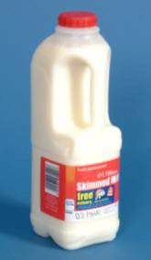
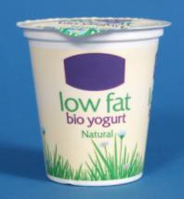
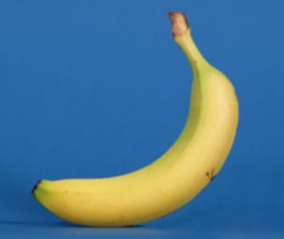
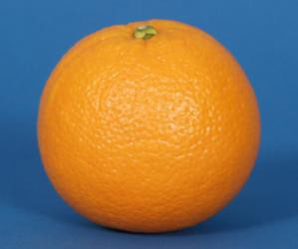
Fruit smoothies

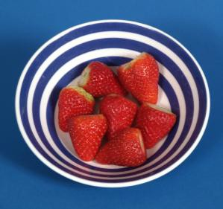
What I need:

6 strawberries
1 banana
1 tablespoon yoghurt
You could use 150ml of milk instead of yoghurt
Juice from 1 orange

What do I do?

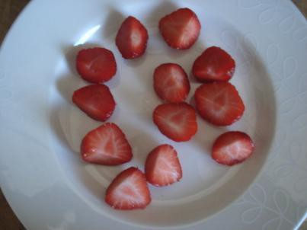 | Wash strawberries  Take stems off strawberries  Cut each strawberry into 2 pieces
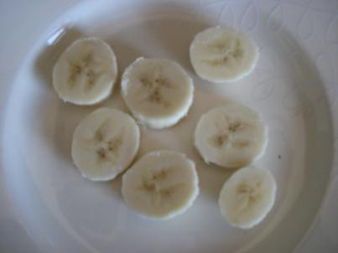 | Peel the banana. Cut banana into pieces
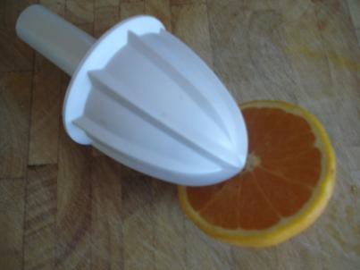 | Juice the orange
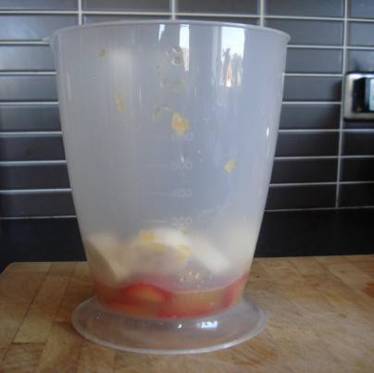 | Add all fruit to blender bowl
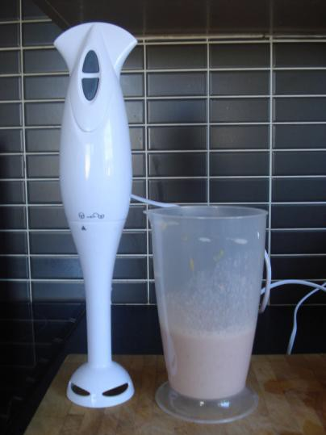 | Add yoghurt or milk to blender bowl  Blend until smooth  Pour into glass and enjoy!

Physical activity

The purpose of this exercise is to:
have taken part in physical activity.

Encourage the group do some exercise. You could:
- go for a walk.

Suggestion:
Why not ask the group what they would like to do for next time? If you have time you could watch the ‘You can do it’ SCLD video – (http://vimeo.com/21292481) to get some ideas or talk to your local authority to find out if they run accessible physical activities.

Session 3: Fruit and vegetables and shopping

Learning outcomes
At the end of the session the group should:
be able to recall the previous session
know where to buy fresh, dried, frozen, tinned fruit and vegetables be able to choose ingredients for one recipe
have tasted new/exotic fruit and vegetables.

Activities and resources

Activity | Preparation | Resources
Recap fruit and vegetables | Consider how you will review the previous session
Supermarket visit | Visit the supermarket before to be aware of where the sections you want to visit are  See where you can buy fresh, dried, tinned and frozen fruit and veg  Be aware of difference in cost  Choose ingredients for carrot and coriander soup or pizzas or baked apple | Pictorial shopping list for recipe (page 102-104)  Petty cash for food tasters
Tasting |  | Knife  Chopping board Plates  Fruits and vegetables from the supermarket

Session 3: Fruit and vegetables and shopping

Recap fruit and vegetables
The purpose of this exercise is to:
discuss what they did during the second session.

Suggestion: Consider questions from session two Fruit and Vegetables in your meals to recall the information.

Supermarket visit

The purpose of this exercise is to:
know where to buy fresh, dried, frozen, tinned fruit and vegetables be able to choose ingredients for one recipe

Before you visit the supermarket ask the group to choose which recipe they will make (you may decide to make more than one depending on your group).
- Carrot and coriander soup
- Baked apple
- Quick pizza

At the visit with the group:

- Find fruit and vegetables that exist in different forms – fresh, dried, tinned or frozen.

For example:
fresh banana and dried banana fresh apples and dried apples fresh apricots and dried apricots
fresh pineapple and tinned pineapple tinned fruit salad
fresh peas and tinned peas and frozen peas fresh broccoli and frozen broccoli florets frozen mixed vegetables.

Ask the group:

- What fruit and vegetables do you see?
Repeat the question each time you see different forms of fruit and vegetables.

- Which fruit and vegetables are your favourite?

- Can you choose some fruit and vegetables to try later?
Encourage them to opt for ones they’ve not tried before.
For example: avocado, passion fruit (fresh), cranberries, bananas (dried), mango (tinned or fresh), cherry tomatoes, celery.

- Buy the foods that you will use for the cooking session (see shopping list for recipe).

Tasting what we bought

The purpose of this exercise is to:
have tasted new/exotic fruit and vegetables.

When you return to the learning base prepare for the tasting exercise. Make sure the group wash their hands and then taste the things that you bought at the supermarket.

Discuss:

how things taste
all the different colours of fruit and vegetables and why this is good for us
which unhealthy foods you could replace with these healthier alternatives
our experience at the supermarket

Try to reinforce messages discussed in previous sessions such as: Why it is good to eat fruit and vegetables
How many portions you should have a day
Alternative foods to try
What a portion is

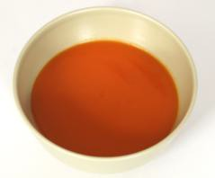
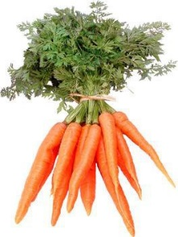
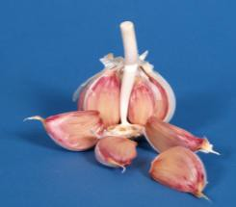
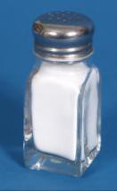
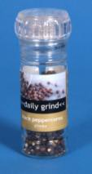

 | Shopping list for carrot and coriander soup
 | Carrots
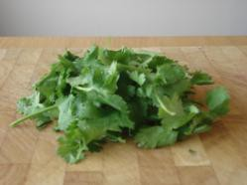 | Coriander dried or fresh
 | Garlic
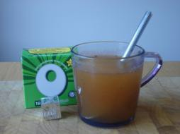 | Vegetable stock
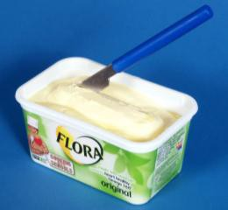 | Margarine
 | Salt and pepper

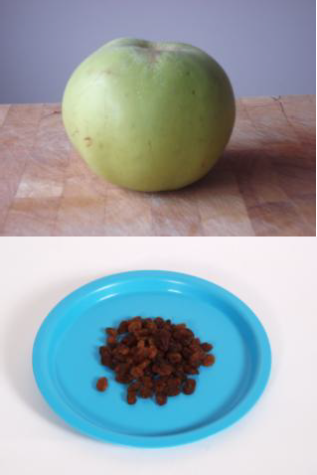

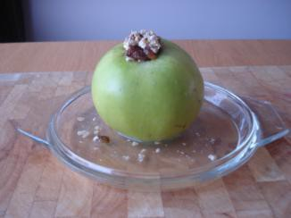 | Shopping list for baked apples
 | Cooking apples
 | Raisins
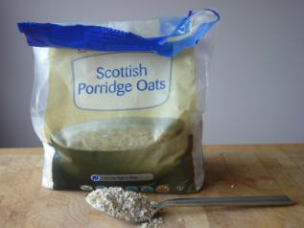 | Porridge oats
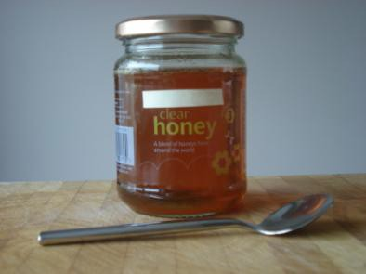 | Honey
 | Low-fat yoghurt

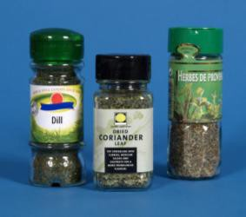
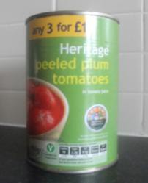
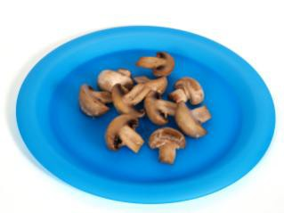
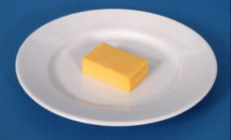
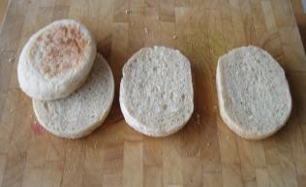

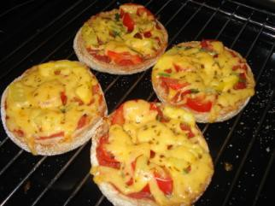 | Shopping list for quick pizza
 | Bread rolls or English muffins
 | Tinned tomatoes
 | Mushrooms or peppers or pineapple You can choose any vegetable or fruit
 | ½ fat cheese
 | Dried herbs
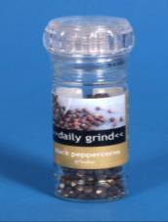 | Pepper

Session 4: Fruit and vegetables and cooking

Learning outcomes:
At the end of the session the group should:
be aware of basic food safety guidelines have increased their practical cooking skills
have experienced the process of raw foods to cooked know the task sequence
have experienced tasting the foods they cooked.

Activities and resources:

Activity | Preparation | Resources
Preparation for cooking | Buy aprons and hats (if using), disposable ones are available  Print off or photocopy cook’s rules in colour if possible. It is best to laminate these so they can be used again. Matt laminate is recommended | Aprons  Hats (optional) Cook’s rules (page  148-149)
Cooking | Check risk assessment to help you choose group leaders  Print off or photocopy recipe (you may choose to laminate these) | Recipe sheets (page 109-117)  Ingredients  Cooking and serving utensils
Tasting | Identify preparation area and hand washing facilities  Check risk assessment for food allergies/preferences | Plates or cups depending on what you are tasting

Preparation for cooking
The purpose of this part of the session is to:
be aware of basic food safety guidelines.
Today you will make one (or more if applicable) of the following: carrot and coriander soup
baked apple
quick pizza.
Hand out and read through, explaining as you go the cook’s rules. Ask everyone to wash their hands and put on their aprons and hats (if using).

Cooking
The purpose of this part of the session is to:
increase their practical cooking skills
experience the process of raw foods to cooked foods
be able to follow a task sequence
experience tasting the foods they cooked
Lay out the ingredients on the table along with the equipment that is required.
You should have previously identified group leaders. Encourage them to perform the cooking tasks and those who may be less able can perform simple and safe activities such as:
putting the ingredients into bowls cutting up the ingredients
mixing the ingredients.
Split the group into smaller teams with at least one group leader in each.
Hand out the recipe cards. Depending on your group you may decide to go through the recipe step by step as one big group or leave the small teams to work their way through the recipe. Make sure you keep checking in with each group to ensure they are on track and know what they are doing.

Important notice: Please follow the cooking rules to avoid problems with food safety. Everything used has to be clean and safe.

Tasting
The purpose of this part of the session is to:
experience the process of raw foods to cooked foods experience tasting the foods they cooked.
Make sure that everyone has washed their hands, sit down and enjoy your food!
Ask the group:
Do you like them?
What unhealthy foods could you replace in your diet with your recipes?
Would you make them at home? Who could help you?

Optional exercise
Depending on the size of your group and the cooking facilities that you have, you might want to do the tasting along the lines of the television programme ‘Come Dine with Me’ with groups giving marks out of 10 for each dish
Starter – carrot and coriander soup Main course – pizza
Dessert - Baked apple
You might want to give the cook’s rules, shopping list and recipe cards as handouts so that members of the group can take them home and make them again.

Carrot and coriander soup

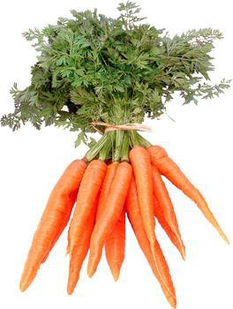
What I need:

 | 225 grams or 4 small carrots
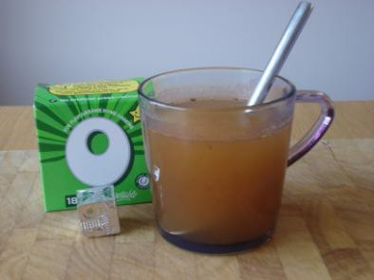 | 1 cup of vegetable stock
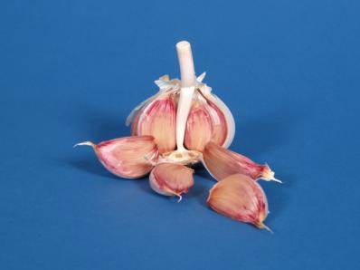 | ½ a clove of garlic
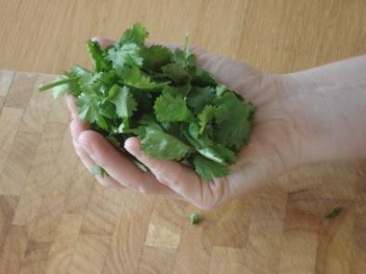 | 1 teaspoon dried coriander  Or 1 big handful fresh coriander

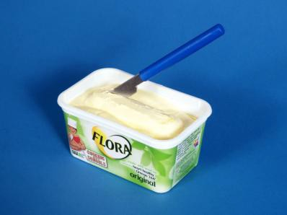 | 25 grams or 2 teaspoons of margarine
 | Salt and pepper

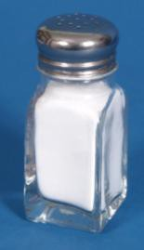
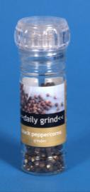
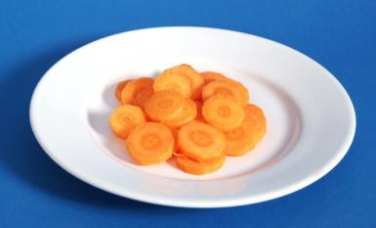
What do I do?

 | Peel and chop carrot into small chunks
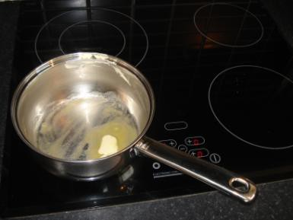 | Put the margarine into a large pan.  Put the pan on the hob and turn the heat to medium.
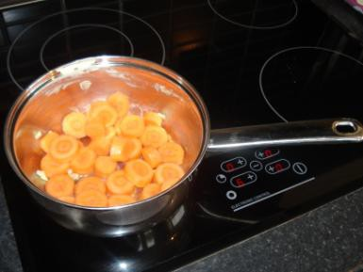 | Add carrot and garlic to pan  Cook for about 5 minutes until the carrots are softer

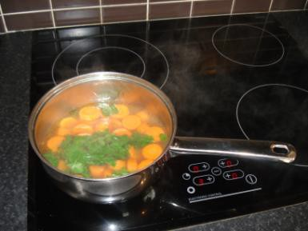

Pour in the stock
Simmer for 20 minutes Then add coriander
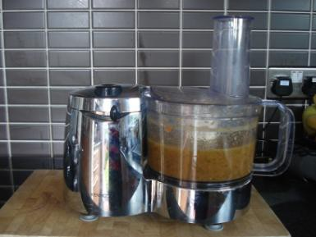 | Put the soup into a blender. Blend until smooth.

Quick pizza
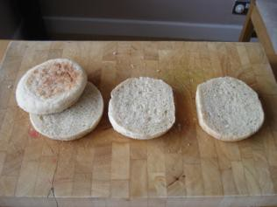
What I need:

2 bread rolls cut in ½ Or 4 English muffins
½ Tin of tomatoes
4 Mushrooms

or 1/2 pepper or vegetables of your choice or 1 small tin of pineapple or other fruit
85grams ½ fat cheese
½ teaspoon of dried herbs

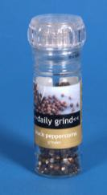
Pinch of pepper

What do I do?

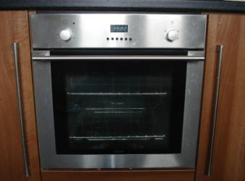 | Put the grill onto medium
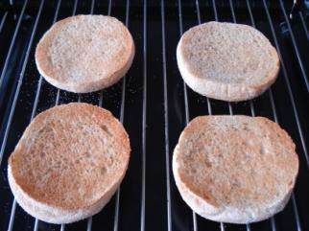 | Toast the bread rolls or English muffins
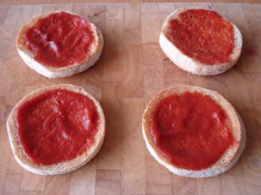 | Spread the tomatoes over the toasted rolls or muffins
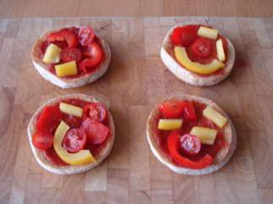 | Put mushrooms, peppers and or pineapples on top of the 4 quick pizzas

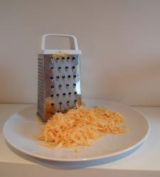

 | Grate cheese
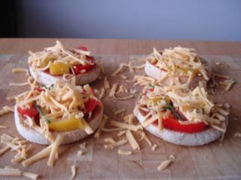 | Add grated cheese to the quick pizzas
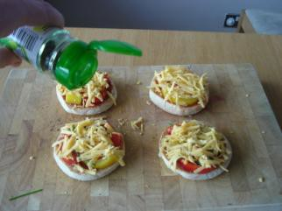 | Sprinkle with herbs and pepper
 | Place under the grill until cheese bubbles

Baked apple

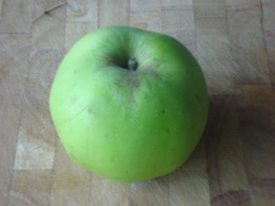
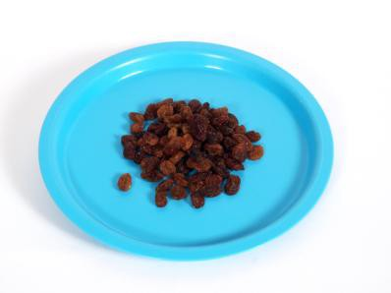
What I need:

 | 1 cooking apple
 | 1 handful of raisins
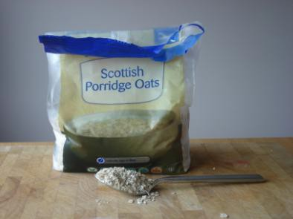 | 1 dessert spoon of porridge oats
 | 1 teaspoon of runny honey

Oven temperature: 190˚C
Time to cook: 40 minutes

What do I do?

 | Set the oven to 190 (gas mark 5)
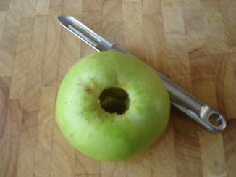 | Remove apple core  (if you don’t have an apple corer you can use a potato peeler or sharp knife)
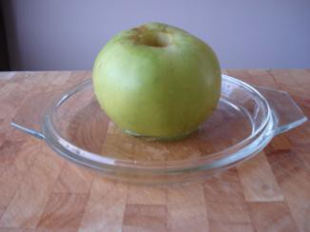 | Put the cored apple in an oven proof dish  Add enough cold water to cover the bottom of the oven proof dish
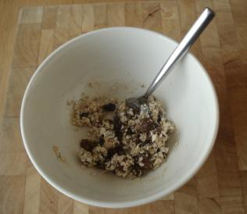 | Put the raisins in a bowl Add the porridge oats Add the honey  Mix together

 | Fill the middle of the apple with the raisin mix
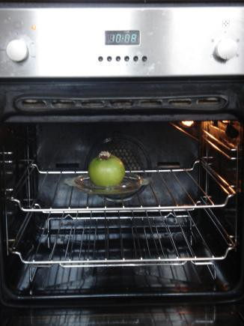 | Bake in the middle of the oven for 40 minutes
 | Remove from the oven and enjoy You could serve with low-fat yoghurt

Session 5: Fruit and vegetables recap

Learning outcomes:
At the end of the session the group should:
be able to recall the main messages from the previous sessions have some fun playing fruit and vegetable bingo
have taken part in physical activity .

Activity | Preparation | Resources
Recap | Buy fruit and vegetable items or collect wrappers and containers to use in exercise  Alternatively print off food photographs from the SCLD website | Boardmaker pictures (pages 131-136) Eatwell guide (or activity mat)  Tinned fruit in juice  Tinned sweetcorn Bananas  Beans Strawberries Grapes Potatoes Orange Dried raisins Chips  Frozen mixed vegetables  - Fruit juice carton  Fruit juice carton
What is a portion? | Buy fruit and vegetable items or collect wrappers and containers to use in exercise  Alternatively you could select some photos to use | An orange An apple  4 strawberries  A handful of raisins A bowl of tinned fruit  A bowl of fruit salad in fruit juice  A bowl of salad  3 heaped tablespoons of beans or corn or peas

Activity | Preparation | Resources
Fruit and vegetables during the day | Print off pictures in colour and matt laminate if possible | A flip chart and flip paper  A black marker pen Pictures of the following:  Bananas Oranges Broccoli Cauliflower Carrots Peas Salad Sweetcorn  A picture of the following: Bran cereals or Weetabix White bread sandwich Brown bread sandwich White rice  Brown rice  A picture of the following Milk  Water Tea Coffee Juice
Fruit and vegetable bingo | Print off in colour the bingo cards  Print off the pictures for bingo and cut pages in half  If you laminate these they can be re-used. Matt laminate is preferable  Buy a prize for the winner | Bingo cards (pages 137- 142)  Pictures of each fruit and vegetable (143-147) Black marker pens  Prize for bingo winner, e.g. a fresh pineapple

Activity | Preparation | Resources
Learning check | Look out the answer sheets from session 1 to see difference in knowledge around fruit and vegetables | Fun with fruit and veg quiz sheets (page 127-129)
Physical activity | Check the risk assessment sheets to make sure that groups can do the exercise that is suggested  Plan a walk to do with the group. | ‘You can do it’ from http://vimeo.com/21292 481  Find out if your local authority has activities or facilities that you can access

Session 5: Fruit and vegetables recap

The purpose of this exercise is to:
be able to recall the main messages from the previous sessions.

Ask the group:
Why should we eat fruit and vegetables?

It is important to eat fruit and vegetables for good health. It keeps our bodies healthy. Keeps us regular and can protect us from heart disease, heart attacks, strokes and some cancers. It can protect us from other illness such as catching colds.

Use the Boardmaker pictures (pages 131-136) to talk through your answers: a heart in pain
a healthy heart
a person sneezing
a person in pain on a toilet a smiling person on a toilet a person ill in bed.

Remind the group that fruit and vegetables can be fresh, tinned, dried and frozen.

Lay out the fruit and vegetables (or wrappers/containers) on a table. For example:

Tinned pears in juice Tinned sweetcorn Bananas
Beans Strawberries Grapes Potatoes Orange Dried raisins
Frozen mixed vegetables
Fruit juice carton Chips

Invite each learner to choose a food and place it on the Eatwell guide (or activity mat). Ask them to think about which section of the mat it should go onto. If they are not sure ask the rest of the group to help them.

The foods should go into the green section, fruit and vegetables. Potatoes and chips do not belong in the fruit and vegetable section. They go in the yellow section, starchy foods.

What is a portion?

The purpose of this exercise is to:
be able to recall the main messages from the previous sessions Ask the group if they know what a portion of fruit and vegetables is.
A portion is:
any fruit and vegetables that fits in your hand
3 heaped tablespoons of vegetables, beans or pulses a dessert bowl of fruit or vegetable salad.

Examples:

An orange, an apple, 4 strawberries, a bowl of tinned fruit, a bowl of fruit salad in fruit juice, a bowl of salad, 3 heaped tablespoons of beans, sweetcorn or peas.

Try to give examples of fresh, dried, tinned and frozen fruit and veg. It is preferable to show an actual portion fitting in your hand rather than pictures.

Ask someone from the group to hold a portion. Ask them if there is more space in their hand for more fruit or veg.

Ask the group:
Do you know how many portions of fruit and vegetables you should eat each day?

We all should eat 5 portions of fruit and vegetables a day. The more colours we eat the better as different colours provide different vitamins. Remind the group that potatoes do not count as a portion of fruit and vegetables.

Fruit and vegetables during the day

The purpose of this exercise is to:
be able to recall the main messages from the previous sessions.

It is very easy to have five portions of fruit and vegetables in a day. By using a flipchart and pictures of foods build a healthy menu.

Put a picture of breakfast cereals as a breakfast on the flipchart. Ask the group:
1. Which foods they can add so they can start counting their portions of fruit and vegetables a day. (Let them choose from the pictures)
Any fruit in the bowl of cereals (1st portion) A glass of fruit juice (2nd portion)
2. Which food they might have as a snack after breakfast (let them choose from the pictures)
A fruit or a handful of dried fruit (3rd portion)

Put a picture of a sandwich as lunch on the flipchart.
3. Which foods they can add to make it healthier (let them choose from the pictures)
A salad (4th portion) Vegetable soup (5th portion)
4. Which food they might have as a snack after lunch (let them choose from the pictures)
Yoghurt with added fruit in it (6th portion)

Put a picture of a steak/chicken/fish as dinner on the flipchart
5. Which foods they can add to make it healthier (let them choose from the pictures)
- Broccoli, cauliflower, carrots and peas (7th portion)
- A tin of fruit salad in fruit juice as a dessert (8th portion)

Look through the flip chart and see how many different colours of fruit and vegetables there are.

Fruit and vegetable bingo

The purpose of this exercise is to:
have some fun playing fruit and vegetable bingo. We are going to play fruit and vegetable bingo!
Hand out bingo cards (page 137-142) and black markers to each learner. Make sure you only give out 1 winning card (the winning card has a bowl of strawberries at the bottom right).

Explain to the group:
I will pick out pictures of fruit and vegetables (page 143-147) one at a time.
You tell me what the fruit or vegetable is.
Then cross of the picture if you have it on your card.
The first person to cross off all the pictures on their card is the winner.
When you get all the pictures remember to shout bingo!

Learning check
The purpose of this exercise is to:
be able to recall the main messages from the previous sessions.

Use the “Fun with fruit and vegetables” quiz sheets (page 127-129) completed in session 1. Do the quiz a second time and see if the group still tick the same answers.

Physical activity

The purpose of this exercise is to:
have taken part in physical activity.

Encourage the group do some exercise. You could:
- go for a walk.

Suggestion:
Why not ask the group what they would like to do for next time? If you have time you could watch the ‘You can do it’ SCLD video. (http://vimeo.com/21292481) to get some ideas or talk to your local authority to find out if they run accessible physical activities.

Fun with fruit and vegetables quiz

- Can you recognize the food and drinks below? Tick the fruit and vegetables.

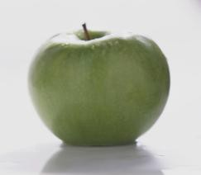
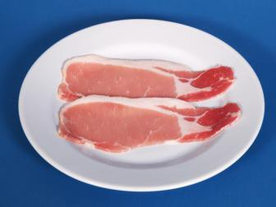
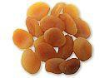
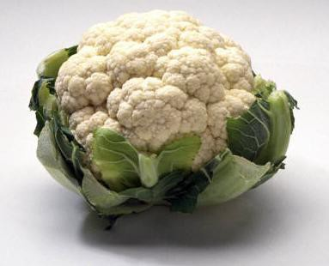

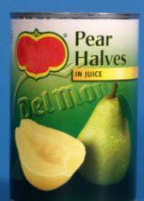
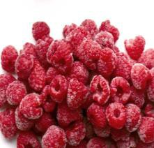
- Tick the fruit and vegetables that are good for us
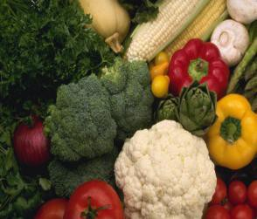
a) fresh fruit | fresh vegetables

b) frozen fruit | frozen vegetables

c) dried fruit | dried vegetables | 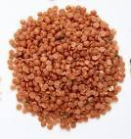

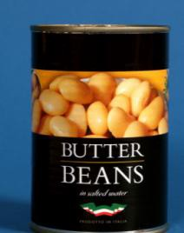
- tinned fruit  - All of them | tinned vegetables

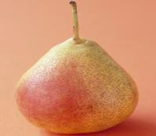
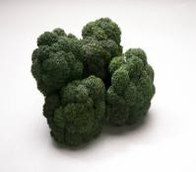
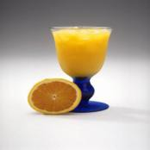
- Tick how many fruit and vegetables we should eat each day? a)

b)

c)

d)

- Tick the correct way to measure a portion
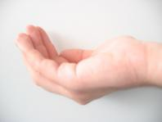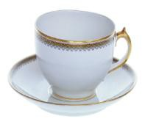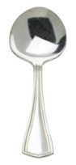
A handful a cup a spoon

- Tick the healthy snack

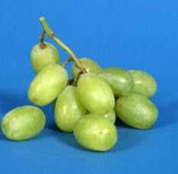
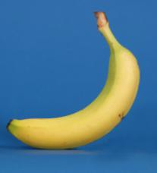

Fruit and vegetables

Fun with fruit and vegetables quiz

Answers

  - Apple, dried apricots, carrots and cauliflower.

  - All of them.

  - We should eat at least 5 portions of fruit and vegetables every day. We should try to have as many different colours as possible too.
  - A portion is approximately a handful.
  - The grapes and banana are the healthy snack.
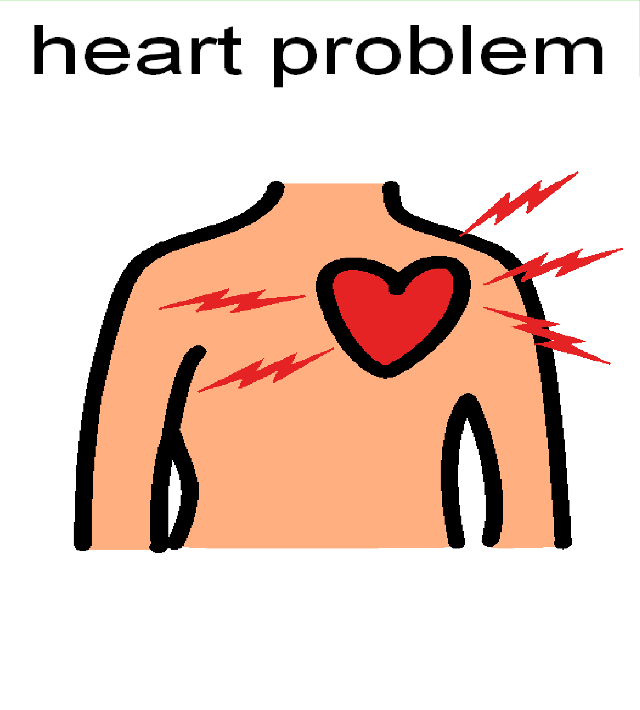
Fruit and vegetables

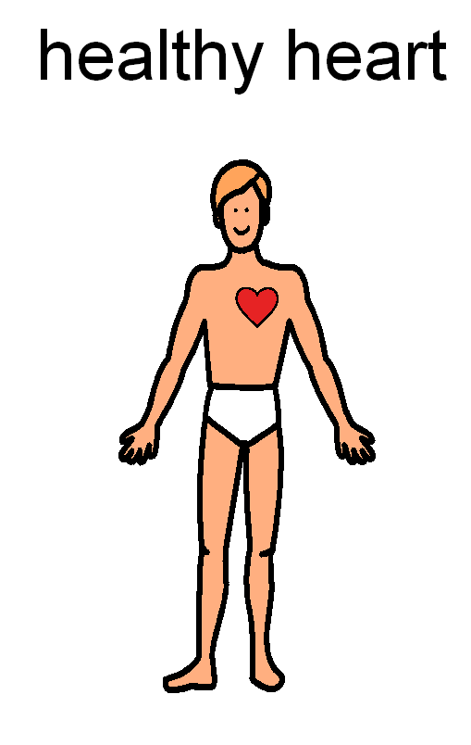
Fruit and vegetabl
es

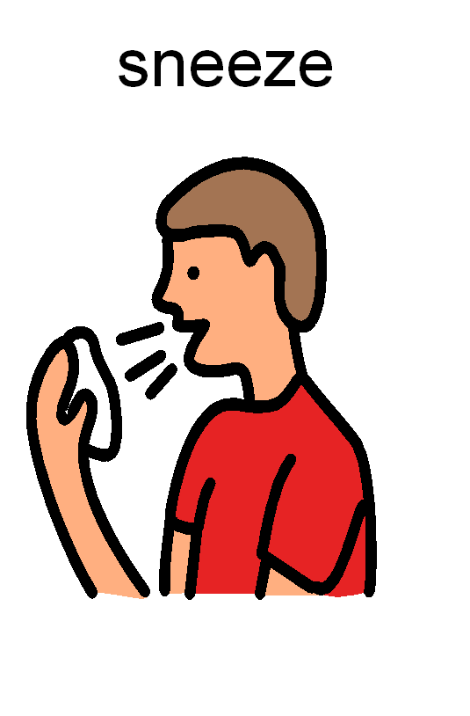
Fruit and vegetable
s

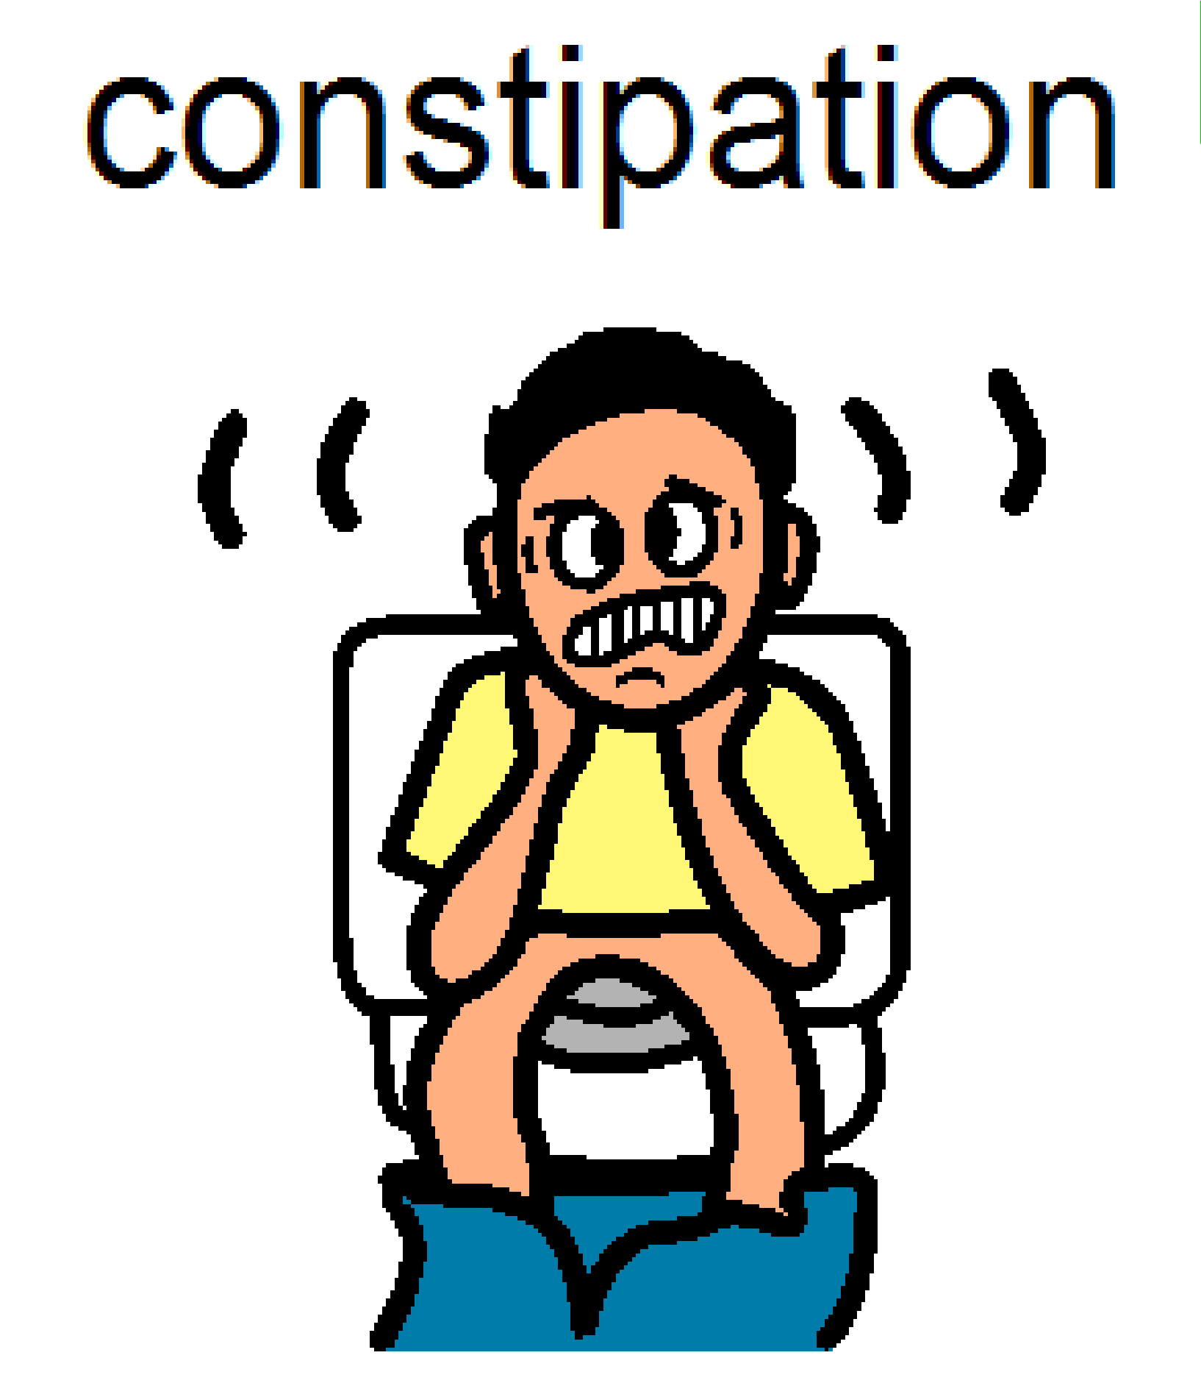
Fruit and vegetables

Fruit and vegetables

regular

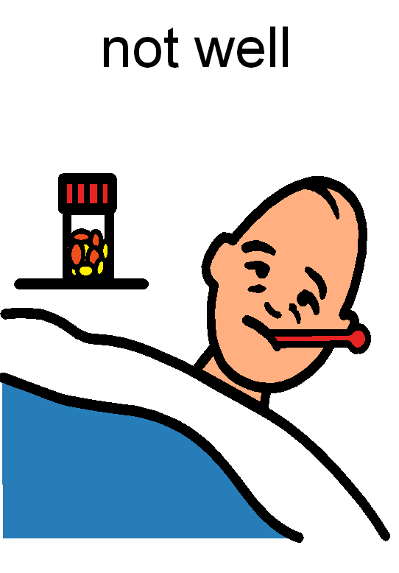
Fruit and vegetable
s

Fruit and vegetables

Bingo
 | 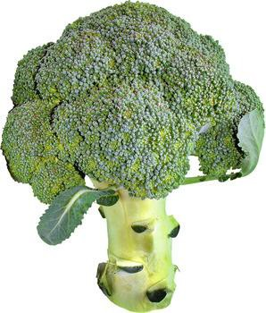 | 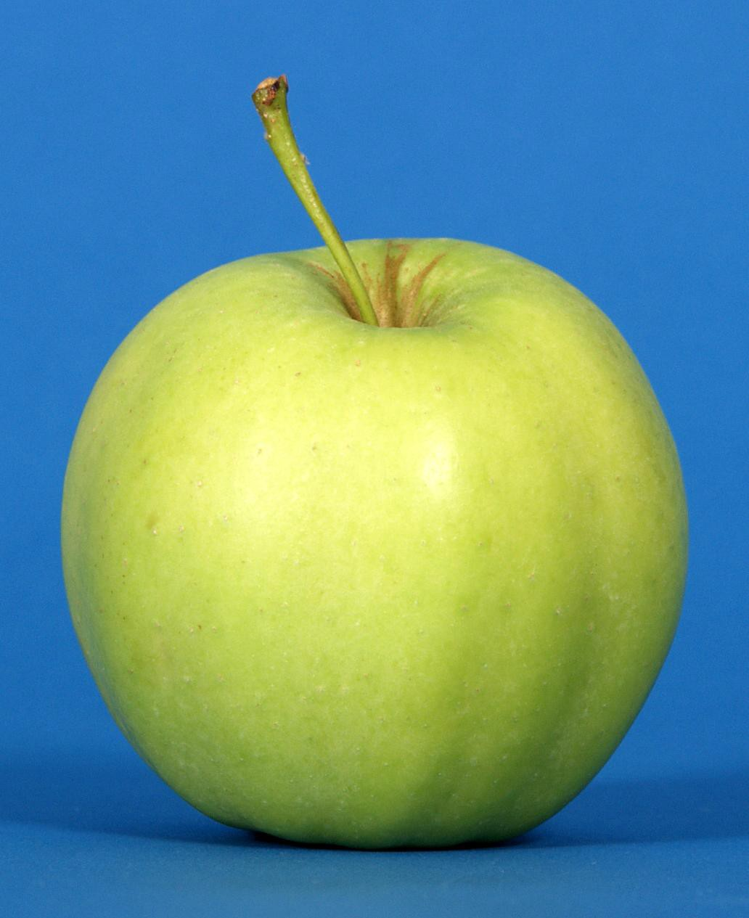
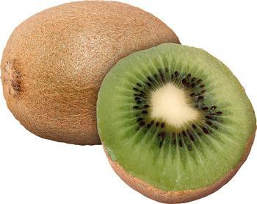 |  | 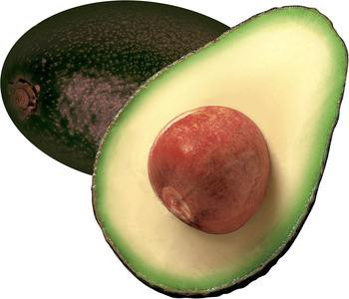
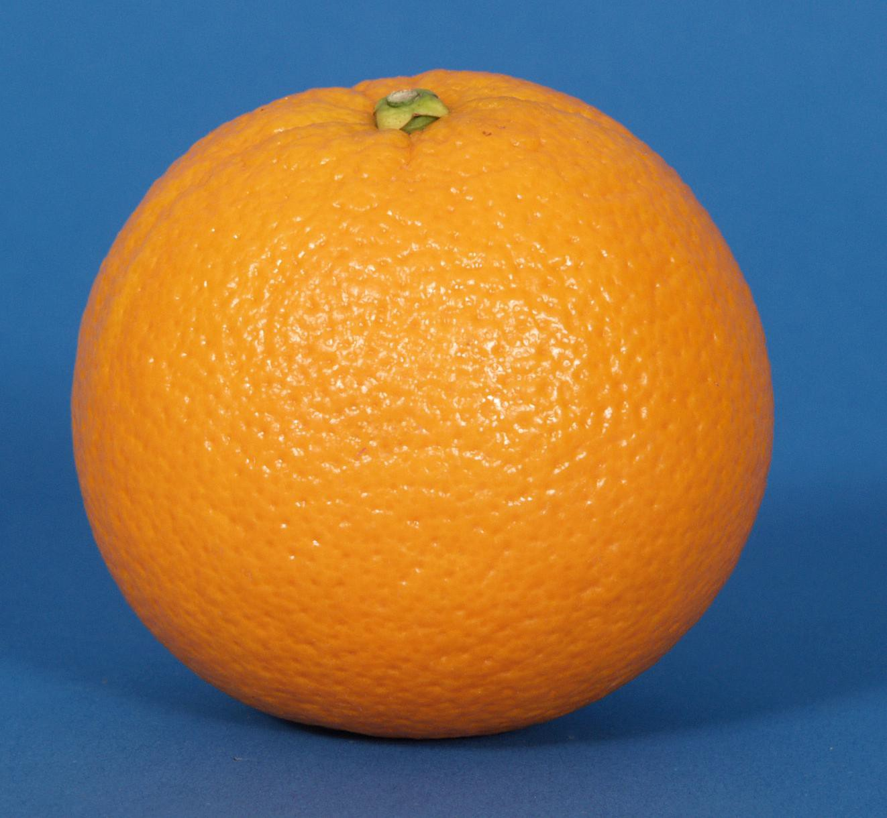 | 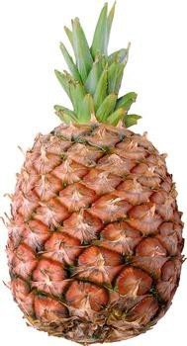 | 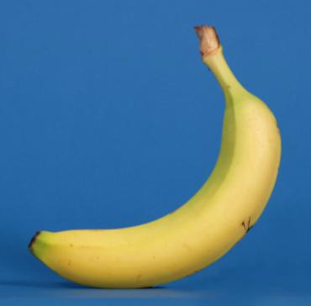

Fruit and vegetables

Bingo

Fruit and vegetables

Bingo

Fruit and vegetables

Bingo

Fruit and vegetables

Bingo

Fruit and vegetables

Bingo
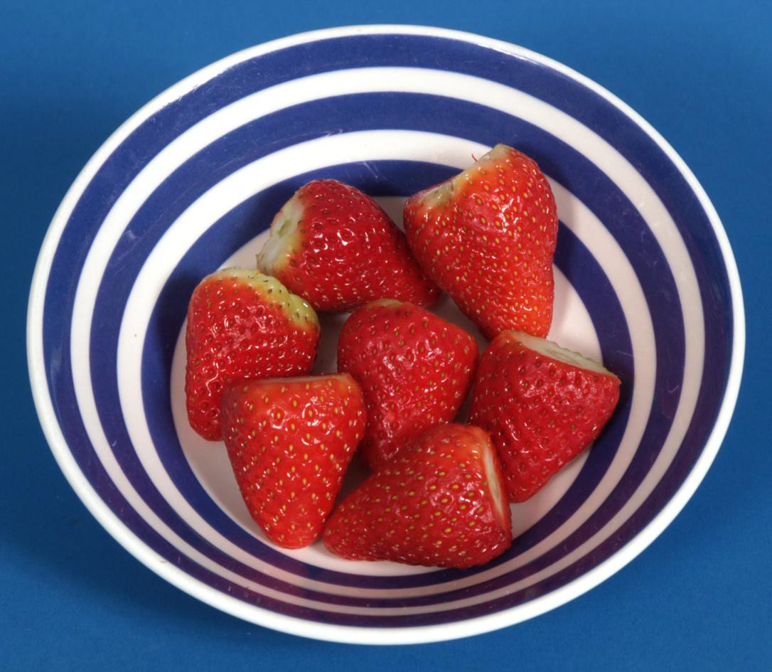

Fruit and vegetables

Fruit and vegetables

144

Fruit and vegetables

145
Fruit and vegetables

Fruit and vegetables

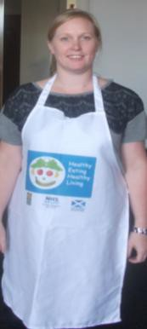
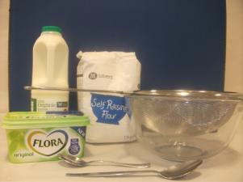

Fruit and vegetables

Cook’s rules

Tie your hair back
Wear an apron
Wash your hands with soap and dry them before you start
Get everything out that you will need before you start

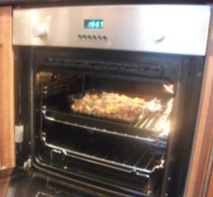
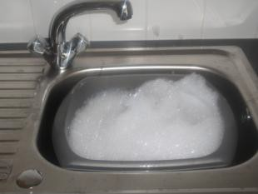
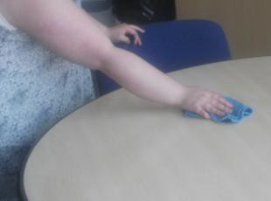
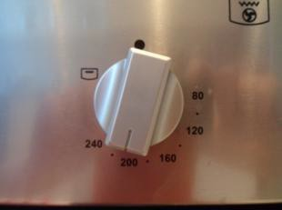

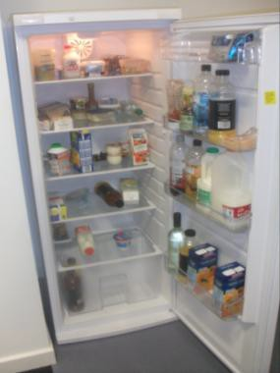
Fruit and vegetables

Keep milk, meat, cheese, and yogurt in the fridge until you are ready to use them
If you need help putting things in and taking things out of the oven, ask your support worker
Remember to switch off the oven when you are finished
Wash up using hot soapy water
Wipe worktops with a clean cloth and hot soapy water
Enjoy your food!

