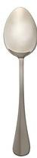

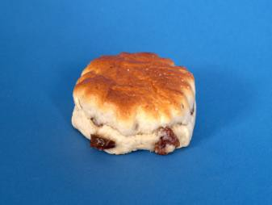 | Fruit scones

What I need:
7 heaped tablespoons of self raising flour
¼ teaspoon baking powder
40g or 3 rounded teaspoons of margarine

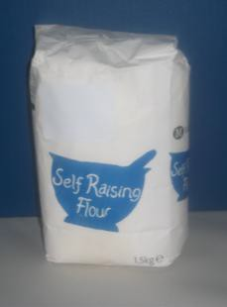
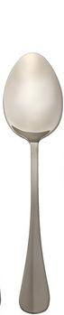

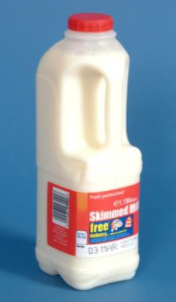
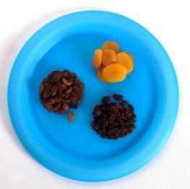

150ml or 5 tablespoons of milk
A small handful of dried fruit. You can choose from: Raisins
Cherries Dates
Or any other dried fruit
¼ teaspoon of mixed spice

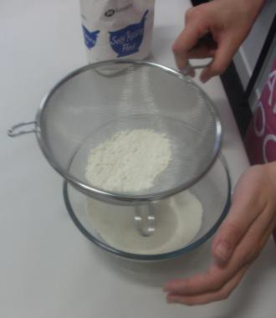
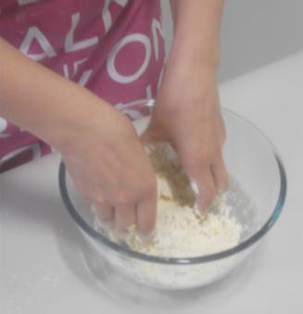
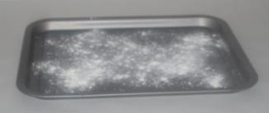

Oven temperature: 240˚C Time to cook: 10-12 minutes

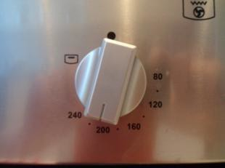
What do I do?

Set oven at 240˚C
Lightly flour baking tray
Sieve the flour and the baking powder into a large mixing bowl
Rub the margarine into the flour using your fingertips

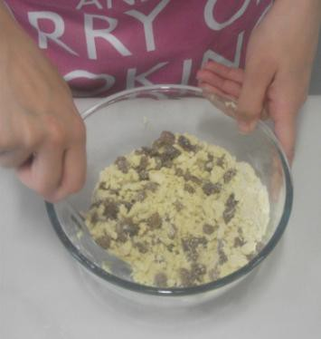
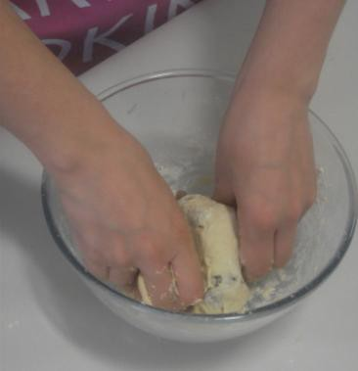
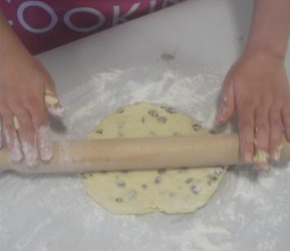

Stir in dried fruit and mixed spice if using them
Add enough milk to make soft dough
Knead lightly on floured surface
Roll out to the thickness of your thumb

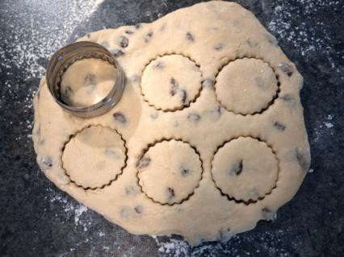 | Using a small cutter, cut the mixture into approximately 6 scones
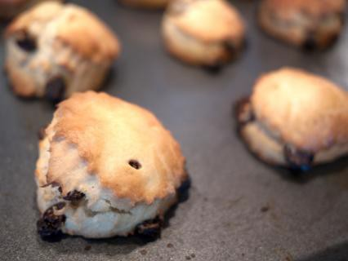 | Bake for 10-12 minutes till well risen and golden brown

