#### Session 2: Sugar and shopping

#### Learning Outcomes:

At the end of the session the group should:

Know where to buy foods low in sugar

Be able to choose ingredients for one recipe Have tasted alternative foods to high-sugar foods

#### Activities and resources

|  |  |  |
| --- | --- | --- |
| **Activity** | **Preparation** | **Resources** |
| Supermarket visit | * Contact supermarket manager for permission to take photographs * Arrange transport Visit supermarket to * be aware of where to * find ingredients Consider high and low sugar alternatives and where to find them * Consider cost | Pictorial shopping list for low sugar scones (pages 34-35)  Petty Cash for food tasters |
| Tasting | Identify preparation area and hand washing facilities  Check risk assessment for food allergies / preferences | Plates or cups depending on what you buy to taste |

Session 2: Sugar and shopping

**Supermarket visit**

The purpose of this exercise is to:

Know where to buy foods low in sugar

Buy alternative foods to high sugar foods for the tasting session Be able to choose ingredients for low sugar scones

At the visit with the group:

1. Find foods that exist in two forms-low sugar or high in sugar.

For example: Sugar free jelly and normal jelly.

1. Ask the group which food they should choose and why?

Answer: Low sugar foods because they do not cause teeth problems and make you fat.

Repeat the activity with other products. For example:

Sugar and sweeteners

Fruit Juice with no added sugar or with sugar Tinned Fruit in fruit juice instead of syrup

Breakfast cereals with sugar (coco pops) or with no added sugar (bran flakes with dried fruit)

Dried fruit instead of hard boiled sweets

Low fat yogurts instead of chocolate pudding

Fruit scones instead of biscuits and chocolate bars

You can choose other items that have no sugar or no added sugar to look at and / or buy too.

1. Ask if the group can name the foods that you select from the supermarket shelves.
2. Ask the group to choose some foods that are low in sugar to try later e.g. tinned fruit salad in fruit juice. Buy Weetabix or Branflakes and add banana when tasting instead of chocolate or sugar coated cereal.
3. Buy the foods that you will use for the cooking session next week.

#### Tasting what we bought

The purpose of this exercise is to:

Have tasted alternative foods to high sugar foods

When you return to the learning base prepare for the tasting exercise. Make sure the group wash their hands and then taste the things that you bought at the supermarket.

Discuss:





How things taste

Which unhealthy foods you could replace with these healthier alternatives

Your experience at the supermarket

Try to reinforce messages discussed in previous sessions such as:

Why sugar is bad for us

The benefits of foods that are low in sugar Alternative foods to try.

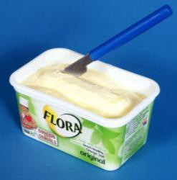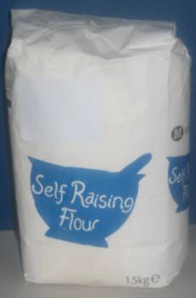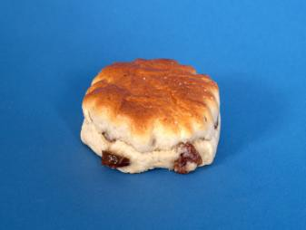

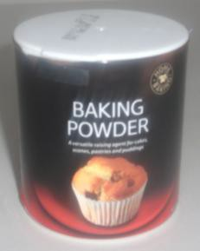

|  |
| --- |
| **Shopping List for fruit scones** |
| Self raising flour |
| Baking Powder  Margarine |

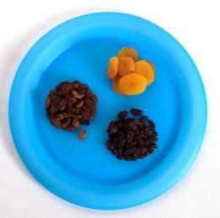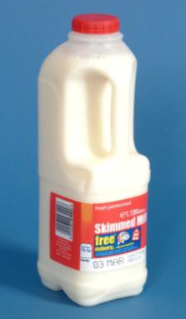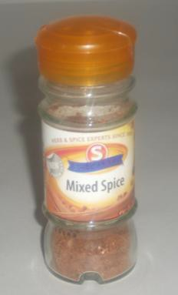

|  |
| --- |
| Milk  Mixed spice |
| Dried fruit (you could use sultanas, cherries, dates or any other dried fruit that the group likes) |