Background information for course leader

Sugar occurs naturally in some foods such as fruit, milk, cereals, grains, nuts and even vegetables. Generally, we do not need to worry about these sugars. The foods which have sugars added, or where natural sugars have been released during processes such as juicing or blending, are the ones we need to cut down – these are called ‘free sugars'. Free sugars include:

- Any sugars added to our food or drinks, including sugar in biscuits, chocolate, flavoured yoghurts, sugary breakfast cereals, fizzy drinks, jams, pastries, ice cream and sweeties.
- Sugars in honey, syrups (such as maple or golden syrup) and coconut sugar or blossom.
- Unsweetened fruit juices and smoothies. Please note, although the sugars in these foods are found naturally in the fruits and vegetables, they are classified as free sugars. This is because the fruit and vegetables have been processed (blended or juiced) so the sugar is no longer held within the structure of the food, and therefore is more easily absorbed. They are very easy to drink in large quantities (which can result in lots of unnecessary calories) and can also cause a large increase in blood sugar levels.

Too much free sugar is bad for our bodies, it can cause:

- obesity – due to the amount of calories (kcals) in sugar
- teeth and gum problems
- heart disease – due to the risks of obesity
- diabetes – eating sugar does not cause diabetes, being overweight due to eating too many high calorie foods such as sugar is the cause.

It can sometimes be difficult to know if a food product contains free sugar. Look out for the items below on an ingredient list – if they are added to food as an ingredient they are classified as a free sugar.

Sucrose (table sugar) | Cane sugar | Glucose
Fructose | Maltose | Invert sugar
Concentrated fruit juice | Sugars in fruit purees | Sugars in jam
Demerara (brown) sugar | Coconut sugar
Honey | Molasses | Treacle
Caramel | Malt syrup | Dextrose
Golden syrup | Agave syrup | Glucose syrup
Rice malt syrup | Coconut blossom syrup | Maple syrup
Fruit syrup | Date nectar | Corn syrup
Also lactose, hydrolysed lactose and galactose ADDED as an ingredient

What’s not classified as free sugar?

- Lactose naturally present in milk and dairy products.
- Sugar naturally present in whole pieces of fruit, including dried, canned and stewed (and have not been juiced or made into a smoothie).
- Sugar naturally present in whole pieces of vegetables (and that have not been juiced or made into a smoothie)
- Sugar naturally present in grains and cereals.

Generally we don’t have to cut down on these but it’s always important to keep an eye on portion sizes to stop unnecessary weight gain. The diagram below shows what counts as free sugars and what doesn’t.

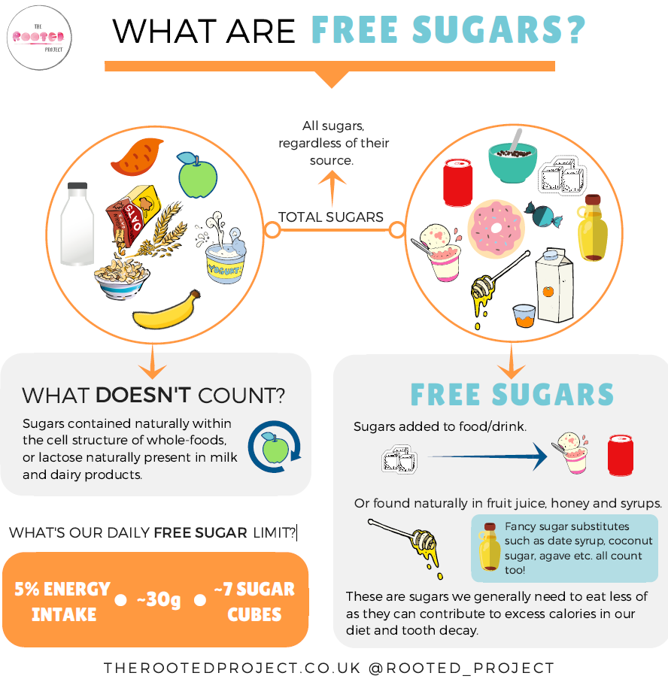

How much sugar can I eat?

Reference Intakes (RIs):
This is the maximum amount of sugar required by average adults of normal weight and average activity levels
Free Sugars only | Total Sugar (including free sugars and also those found naturally in milk, whole fruit, vegetables, cereals & grains.)
30g per day (approximately 7 teaspoons of sugar) | 90g per day

Please note low calorie sweeteners can be used as a replacement for sugar. However, many have a laxative effect, so should be used in moderation.

