**Parents’ Report**

**Name of child:**

**Date of birth:**



**Name of parent:**



1. **What do you think of where your child is staying?**

|  |
| --- |
|  |



1. **Have you met the foster carer to talk about your child’s care?**

**Yes No**

**Do want to say anything about your child’s placement?**

|  |
| --- |
|  |

1. **Is there anything you want to say about your child’s health?**

|  |
| --- |
|  |

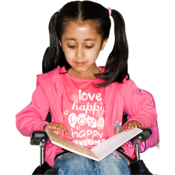

1. **Is there anything you want to say about your child’s education?**

|  |
| --- |
|  |

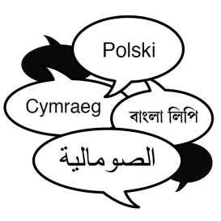

1. **Is there anything about your child’s religion, language or culture that you would like to discuss?**

**Please tell us about this**

|  |
| --- |
|  |

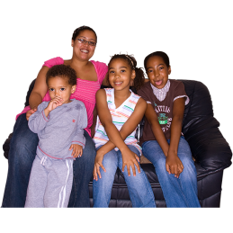

1. **Please tell us about any important changes for your family?**

|  |
| --- |
|  |

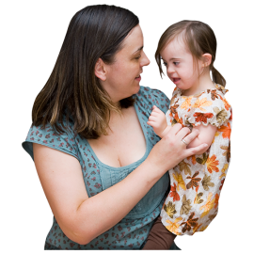

1. **Who does your child have contact with? How is this going?**

|  |
| --- |
|  |

1. **Do you think your child is safe?**

**Yes No**

|  |
| --- |
|  |

1. **Have you had a copy of:**

**An assessment? Yes No**

**A care plan? Yes No**

**Minutes of LAAC reviews? Yes No**

1. **Would you like any changes to the plan?**

|  |
| --- |
|  |

1. **Are there any other decisions you think we should make?**

|  |
| --- |
|  |



1. **Anything else?**

|  |
| --- |
|  |

**Signed: Date:**

**Name:**

**Name:**