An Easy Read guide to…
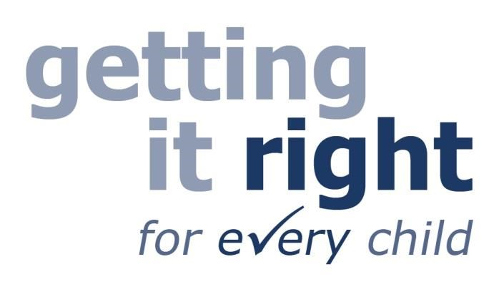

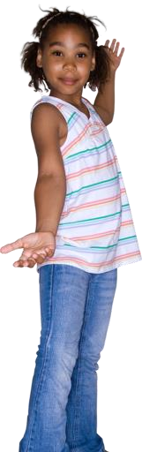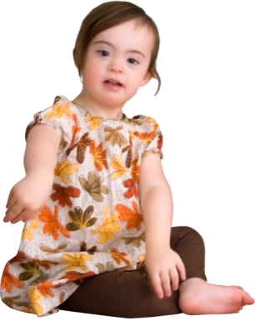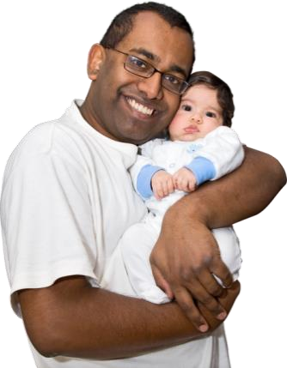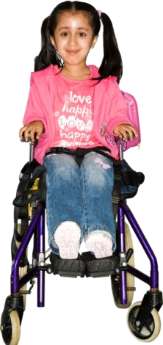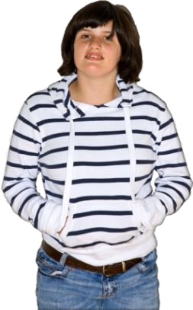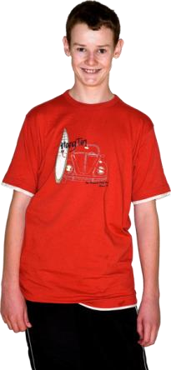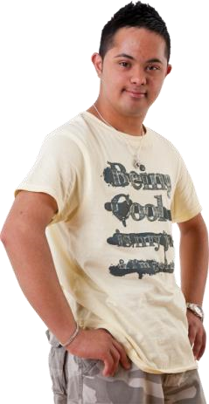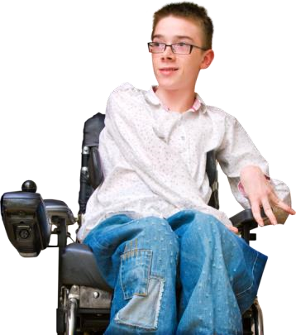
What is Getting it right for every child?
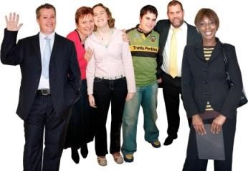
There is a way of working for people who work with children.

You might not have heard of this way of working before.

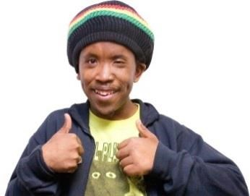
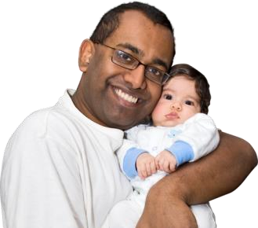
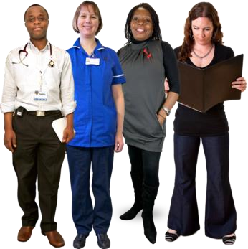
The new way of working has been brought in to help every child in Scotland have a good life.

It does not change how you should look after your child.

But it does change how people who work with your child look after them.

People who work with your child are people like… • doctors
- nurses
- teachers • social workers.

When these people talk to you about your child they will probably talk about the new way of working.

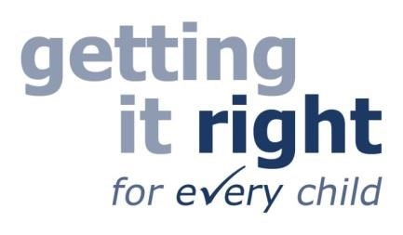
The new way of working is called Getting it right for every child.

Getting it right for every child is sometimes shortened to GIRFEC.

It comes from the first letter of each word in Getting It Right For Every Child.
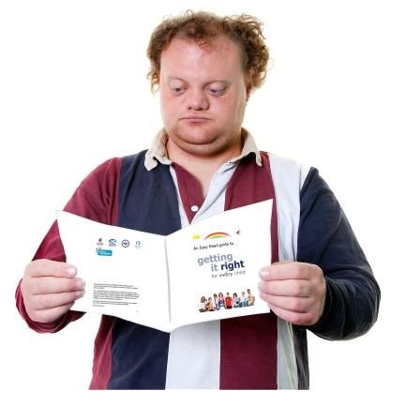
This guide is about what
Getting it right for every child means for you and your child.

There are lots of parts to
Getting it right for every child.

The 2 main parts are…
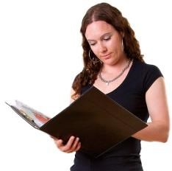
People who work with children
will check every child has what they need to have a good life.

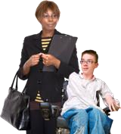
Every child will have 1 person who looks out for them and their family if they need help.

On the next few pages there is more information about what these parts mean for you and your child.

When people like doctors and teachers talk to you about Getting it right for every child they might use jargon words.

It is important to know about these words and what they mean.
When we have used the jargon words in this guide they are written in blue.
There is a list of these words and what they mean at the back of this guide.

People who work with children
will check every child has what they need to have a good life.

What this means for you and your child
As a parent, you are usually the main person who cares for your child.

Through your child’s life, lots of other people will play a part in caring for them too.

This is people like…
- doctors
- nurses
- teachers
- social workers.

Part of their job is to help every child have a good life.

Getting it right for every child says there are 8 things that every child needs to have a good life.

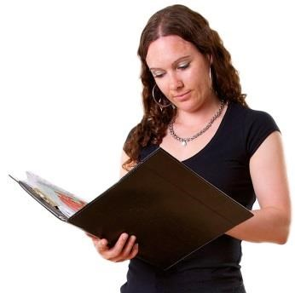
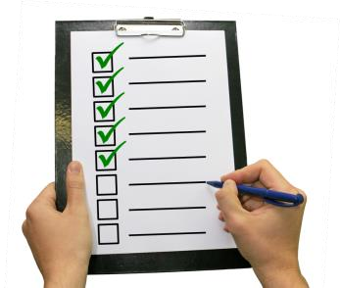
So people who work with your child will check your child has these 8 things.

The 8 things every child needs to have a good life are to be…

- safe
- healthy
- achieving
- nurtured
- active
- respected
- responsible
- included.

You can read about what these words mean on the next pages.

7

Every child needs to be Safe Being safe means things like…
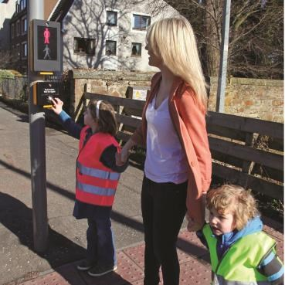
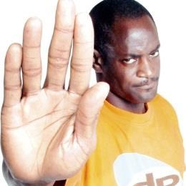
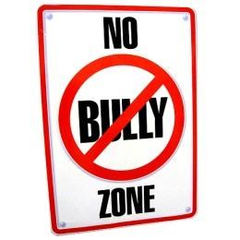
Your child is kept away from dangerous things like fire and traffic

Your child has a safe place to live

Your child is protected from abuse

Your child is not bullied

safe.

Every child needs to be Healthy
Being healthy means things like…
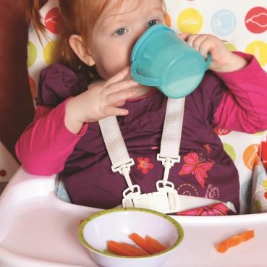
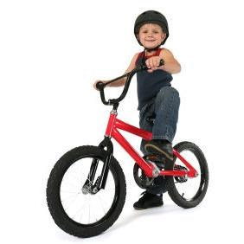
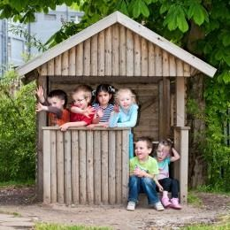
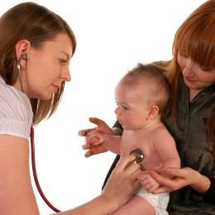
Your child eats healthy food

Your child gets enough exercise

Your child is happy and feels good

Your child goes to the doctor and dentist when they need to

healthy.

Every child needs to be Achieving
Achieving means things like…
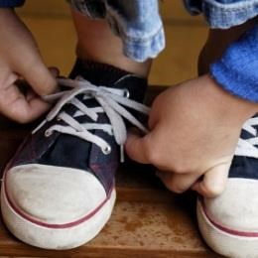
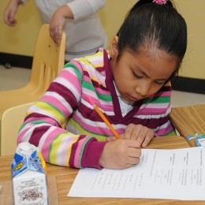
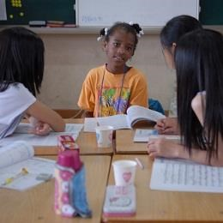
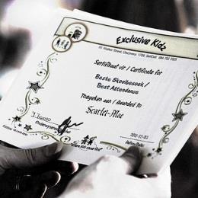
Your child learns new things

Your child wants to work hard at school

Your child feels confident

Your child gets praise when they do well

achieving.

Every child needs to be Nurtured
Being nurtured means things like…
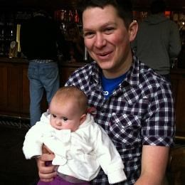
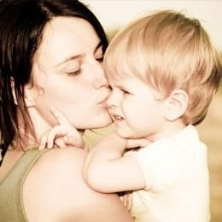
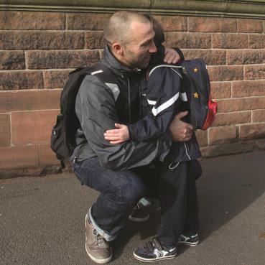
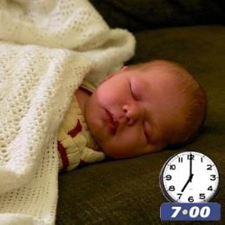
Your child is cared for

Your child knows they are loved by their family

Your child has someone to turn to when they are upset

Your child has daily routines for eating, sleeping and personal care

nurtured.

Every child needs to be Active
Being active means things like…
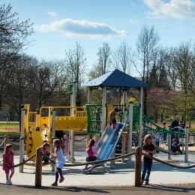
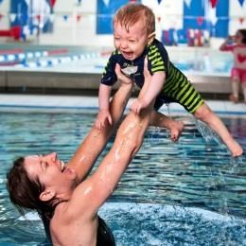
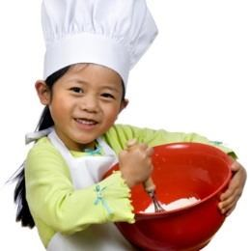
Your child plays at home

Your child plays outdoors, for example rides a bike or plays in a park

Your child does fun things with the family

Your child does activities they like to do

active.

Every child needs to be Respected
Being respected means things like…

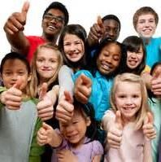
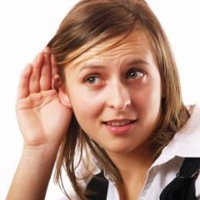
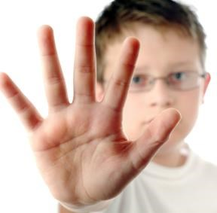
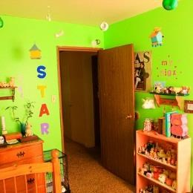
Your child is treated as an individual

Your child is listened to and taken seriously

Your child can keep things private if they want

Your child gets a say in things like how their room is decorated and what to watch on TV

People who work with your child will check your child is respected.
Every child needs to be Responsible Being responsible means things like…
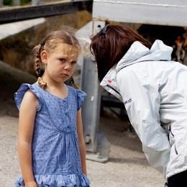
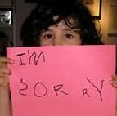
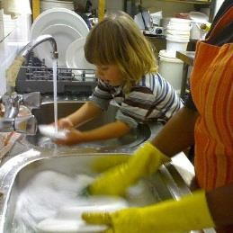
Your child knows about right and wrong

Your child says sorry when they do something wrong

Your child has the right level of responsibility for their age – they tidy their room or do the dishes

You trust your child to do the right thing

People who work with your child will check your child is responsible.
Every child needs to be Included Being included means things like…
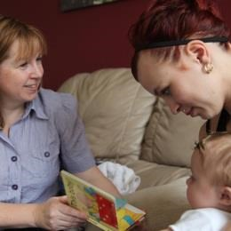
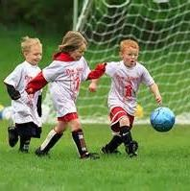
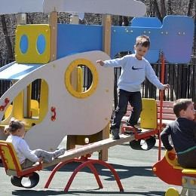
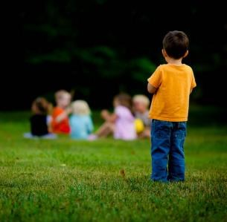
You and your child get the support you need

Your child can be part of a group like Scouts, Brownies or a football group if they want to

Your child joins in with their friends and other children at school

Your child is not left out

People who work with your child will check your child is included.
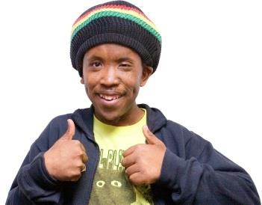
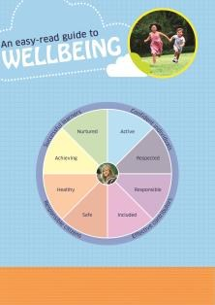
These 8 things that every child needs to have a good life are called Wellbeing Indicators.

Wellbeing is another word for how happy you are.

If you want more examples of what these words mean you can read a booklet called
An easy-read guide to Wellbeing.

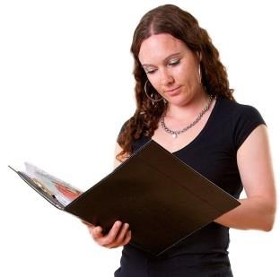
Getting it right for every child says people who work with your child will check your child has what they need to have a good life.

When they do this they will think about your child’s whole environment.

This means…
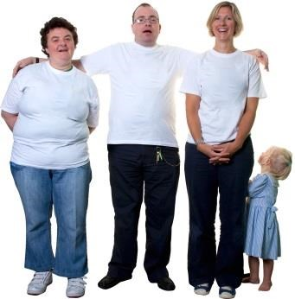
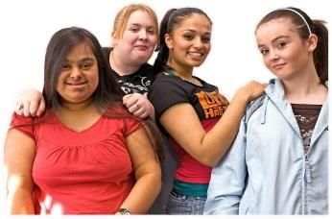
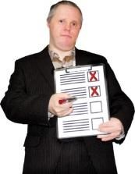
- people who are around your child

- where your child lives
- what is going on in your child’s life.

They will think about what is good about your child’s environment.

And they will think about what could be better.

If they are worried about anything they will do something to help.
Every child will have 1 person who looks out for them and their family if they need help.

What this means for your and your child
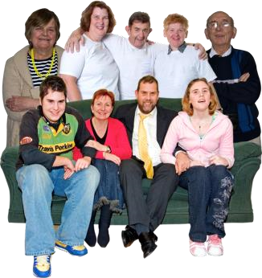
Most children get everything they need to have a good life from…

- their parents
- grandparents, aunts and uncles
- brothers and sisters
- other people around them.

But some children might need
extra help.

Getting it right for every child says…
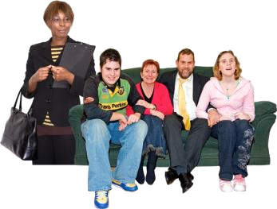
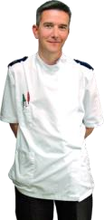
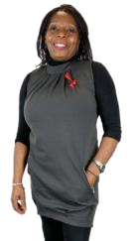
- every child should have 1 person to look out for them and their family if they need help

- this person should be someone from outside the child’s family
- this person should be someone like a nurse or a teacher.

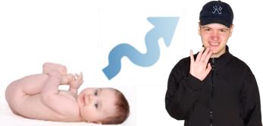
This person is called a Named Person.

Every child in Scotland now has a Named Person.
Every child has a Named Person from when they are born until they are 18.

What does the Named Person do?
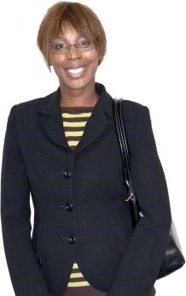
Your child’s Named Person does not take over from you as a parent.

The Named Person is there to help you and your child if you need it.

How the Named Person can help your child
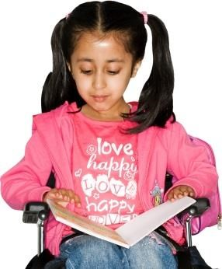
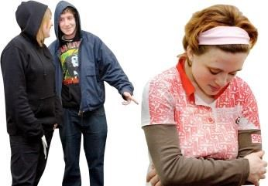
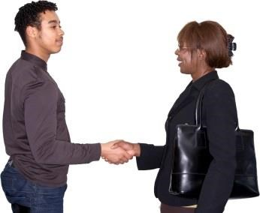
The Named Person looks out for your child.

If the Named Person is worried about anything it is their job to try to make things better.
For example…
They might be worried that your child is not doing as well at school as they should be.
Or they might be worried that your child is being bullied.

The Named Person will work with you and your child to make things better.

They might get other people or organisations to help too.

How the Named Person can help you
You and your child can ask the Named Person for help and advice if you want it.

Having a Named Person means you will know who to go to for help and advice.

Who is my child’s Named Person?
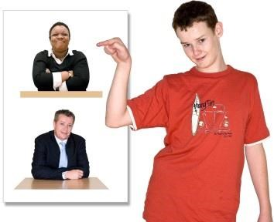
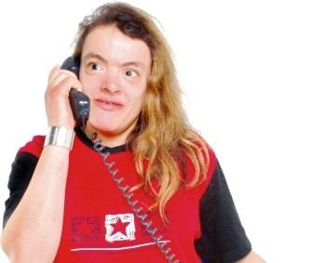
You might have been told who your child’s Named Person is.

If you don’t know, you can find out by contacting your health visitor or your child’s school.

Your child’s Named Person will change as they get older.
Most children will have 3 different Named Persons as they grow up.
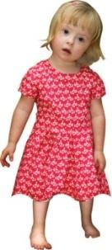
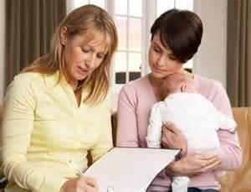
Between birth and when your child starts primary school…

their Named Person will usually be
the health visitor.

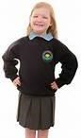
When your child is at

primary school…

their Named Person will usually be the Head Teacher or Deputy Head.

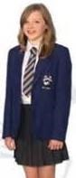
When your child is at high school…

their Named Person will usually be the Head Teacher or
a guidance teacher.

What else is in Getting it right for every child?
This guide is about the 2 main parts of Getting it right for every child.
These 2 main parts are…
People who work with children
will check every child has what they need to have a good life.

Every child will have 1 person who looks out for them and their family if they need help.

These 2 parts are the same for every child in Scotland.
There are 2 more parts of Getting it right for every child that are only for some children.
These parts are for children who need extra support.
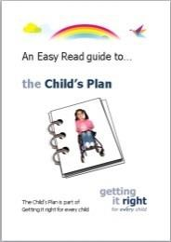
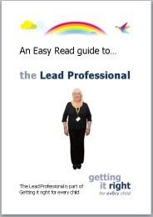
These parts are called…

- Child’s Plan
- Lead Professional

You can read about these parts in 2 more guides.

What the words mean

Getting it right for every child
The name of a way of working for people who work with children.
The way of working has been brought in to help every child in Scotland have a good life.

GIRFEC
The short name for Getting it right for every child.

Wellbeing Indicators
The 8 things every child needs to have a good life.
Every child needs to be…
- safe
- healthy
- achieving
- nurtured
- active
- respected
- responsible • included.
You can read about what these words mean on pages 8 to 15.

SHANARRI
A word people sometimes use instead of Wellbeing Indicators.
It comes from the first letter of each of the
Wellbeing Indicators…
Safe
Healthy
Achieving
Nurtured
Active
Respected
Responsible Included.

Named Person (NP)
A person who looks out for you and your child if you need help.
You can read more about the Named Person on pages 18 to 22.

25
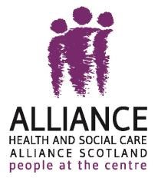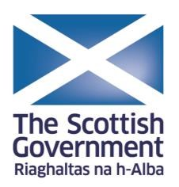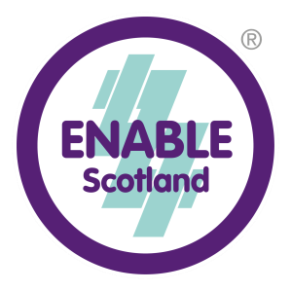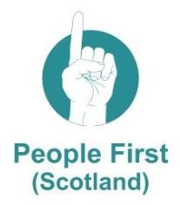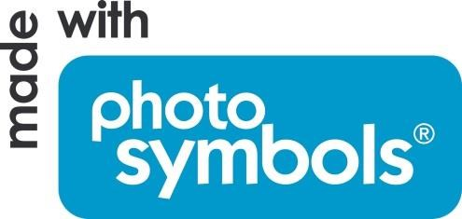

This guide was produced by ENABLE Scotland on behalf of the Health and Social Care Alliance Scotland (the ALLIANCE). The Wellbeing section of the guide built on the excellent work of the People First (Scotland) Parents’ Group.
The ALLIANCE has been funded by the Scottish Government to run a project to help parents, carers and children understand Getting it right for every child. The project is called “Getting to Know GIRFEC: what Getting It Right For Every Child means for children and young people who are disabled or who live with long term conditions”.
This Easy Read guide forms part of the project and has been designed to be accessible to parents who have learning difficulties.
© November 2014

www.alliance-scotland.org.uk

26

