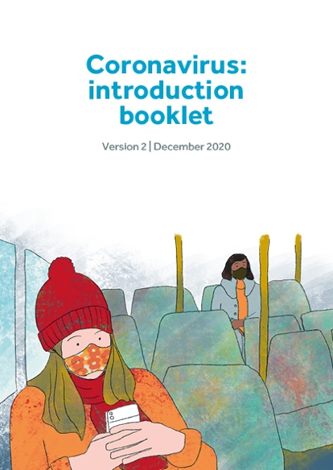**Guidance Sheet**

Introductory Booklet

How to use the booklet

Who is this booklet for?

This booklet introduces guided self-help materials for people with learning disabilities who might be struggling to cope with the coronavirus pandemic and restrictions.

The coronavirus has had a big impact on everyone’s lives. Not being able to do our usual activities or see friends and family can have an emotional impact, leading to feelings of boredom and isolation. People may also be worried about the virus.

What is the booklet for?

The aim of this booklet is to introduce the materials that are available and to find out what the person might find most helpful. There are booklets about understanding and coping with feeling down and feeling anxious. The other booklets are about important ways of staying well. They cover a good night’s sleep, staying active and problem solving. There is also an online film of a relaxation exercise that some people might find helpful.

Who can help talk through these booklets with people with learning disabilities and how do they to do it?

This guide is for people who can help talk through the booklets with the person with learning disabilities. These can be family members, friends, or support staff. The booklets are also suitable for social care staff and health professionals and have been developed and tried out in a national research project. Although the booklets were designed to be accessible, many individuals with learning disabilities will have few, if any, literacy skills. Even if individuals do have literacy skills, the idea of all of these booklets is to give the person a chance to talk through their feelings with someone else. This means that the support person has a key role.

This introductory booklet can be talked through in a number of ways depending on the individual circumstances of the person with learning disabilities. You can meet face-to-face if social distancing restrictions allow, or by phone, using a printed or online copy. You can also use online video links such as zoom or skype or mobile phone apps, if you and the person with learning disabilities have internet or enough mobile data.

How do you use the booklet to find out what the person’s feeling and what materials they might find helpful?

Give the person a chance to tell you about the difficulties they have been having in their life and the good things that have been happening. There is a section at the end, which goes through the different jargon that’s being used about the coronavirus and the restrictions that are in place. This may give a chance for people to talk about what’s been happening. Don’t rush through the booklet, stop and talk about the different points the person brings up. Pause and check the person’s understanding after completing each section of the booklet.

Building a trusting relationship with the person makes a real difference to how they feel. So it is crucial to listen carefully to what they are telling you and to try to understand their point of view.

If the person becomes upset

Some people might be feeling a bit upset or may be struggling emotionally. So it’s understandable if they become upset when talking about their feelings. However, if there are serious concerns about someone’s mental health or if they are at serious risk of harming themselves or others then their GP should be contacted.

Other booklets and resources

You will find the booklets and the relaxation film at the Scottish Commission for People with Learning Disabilities <http://scld.org.uk> and at NES Scotland <https://www.nes.scot.nhs.uk>

The set of booklets you are introducing have been adapted from StepUp, a guided self-help intervention for people with learning disabilities and depression. You can look at the online training for StepUp which includes video clips.

Online modules and the manual on StepUp can be found at NES, Scotland, <https://learn.nes.nhs.scot/15095/learning-disabilities/talking-therapies-for-depression-step-up>

and NHS Education England.

<https://www.e-lfh.org.uk/programmes/intellectual-disability-and-depression-talking-therapies/>

Feedback

If you have any feedback or thoughts about the booklets then we would really like to hear from you. You can contact

[ihw-cope@glasgow.ac.uk](mailto:ihw-cope@glasgow.ac.uk)

