My home,
my community
The third report from the How’s life? survey
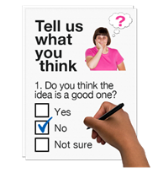 | In 2019, SCLD and partner organisations made the ‘How’s life?’ survey.
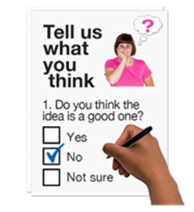 | The survey asked people with learning disabilities how they felt about different aspects of their lives.
 | The survey was designed to be completed by people with learning disabilities.
 | If people needed help from someone that was fine.
 | The help might be from a family member, advocate, or paid supporter.
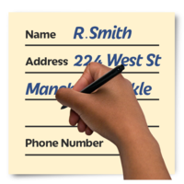 | 1232 people sent back the survey with their answers filled in.
 | This Easy Read is a summary of what we found in the survey.
 | A summary means it is just the most important parts.
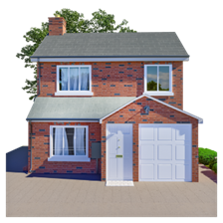 | It is about the houses people live in and the support they get to live in them.
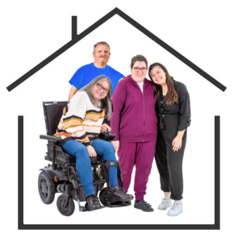 | It is also about the areas that people live in and how safe and happy people feel living there.
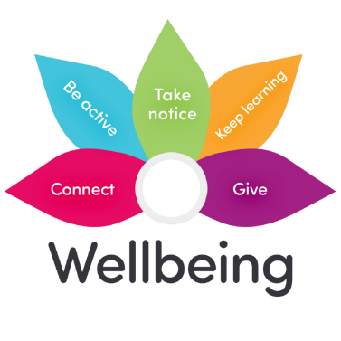 | The survey showed that these things are important for people’s wellbeing.
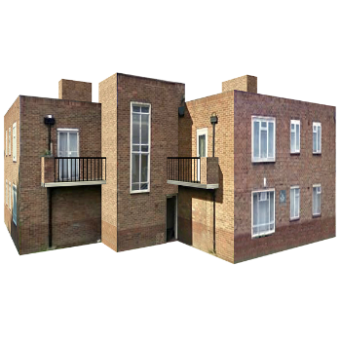 | Most people that answered the survey lived in mainstream housing.
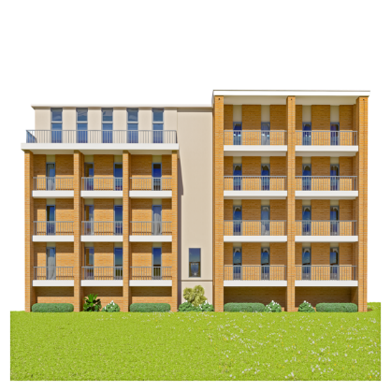 | This means houses or flats that they or their family rent or own.
 | Around 1 person in 3 lived on their own.
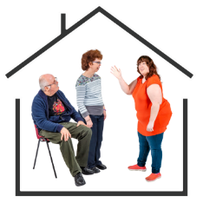 | Around 1 in 2 young adults with learning disabilities still lived with their parents.
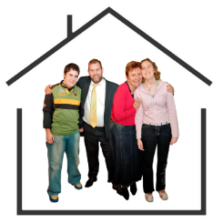 | Around 1 in 4 young people in the rest of the population still lived with their parents.
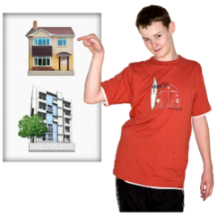 | Around 1 person in 3 did not get to choose where they lived.
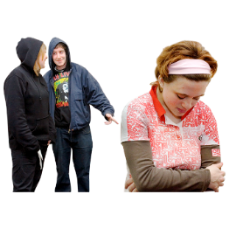 | Around 1 person in 3 did not feel safe in the local area.

Here are four things about people who are happy where they live
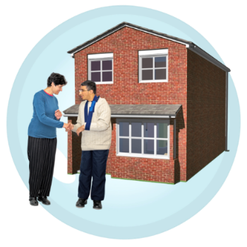 | People are happier when they live in supported accommodation.
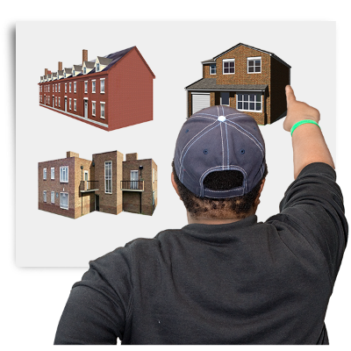 | People are happier when they chose where to live.
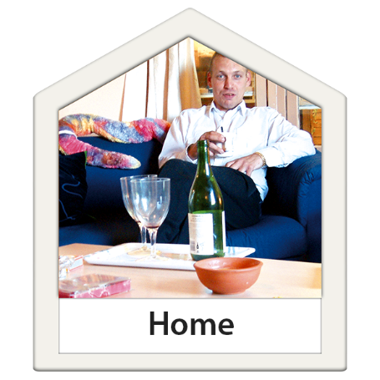 | People are happier when they have enough support to live independently.
 | People are happier when they are treated with respect by people that support them.

Here are five things about people with a higher level of wellbeing
 | People say they have better wellbeing when they always feel safe.
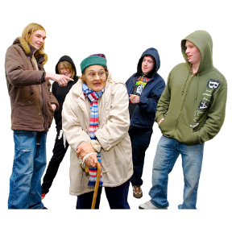 | People say they have better wellbeing when they are not picked on when they were out and about.
 | People say they have better wellbeing when they are happy with the transport that was available where they lived.
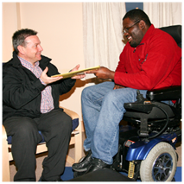 | Most people who were happy with their home had a high level of wellbeing.
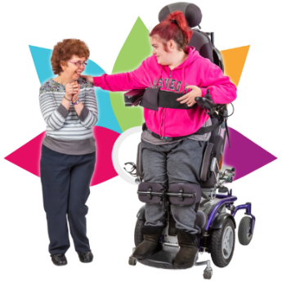 | Most people who were happy with their local area had a high level of wellbeing.

Here is a list of 7 things that SCLD thinks will help to make things better.
Number 1.
 | We need to get better information about the kind of housing people with learning disabilities are living in.
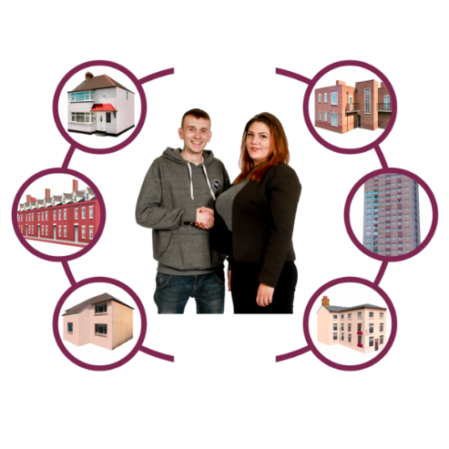 | Then we will know how many people with learning disabilities cannot get the houses they need.
 | Scottish Government and local authorities need to do this.

Number 2
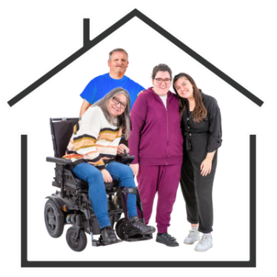 | Local authorities (councils) and people with learning disabilities and their families need to work together better to plan what houses and support people will need.
Number 3
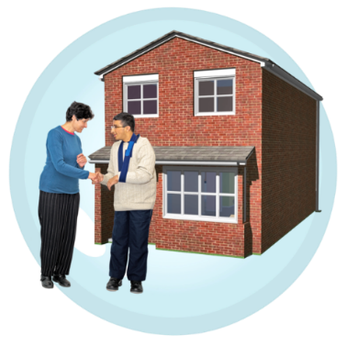 | Local authorities (councils) must give people more support to find the right house and to make good choices.
Number 4
 | The Scottish Government have made a fund called the Community Living Change Fund.
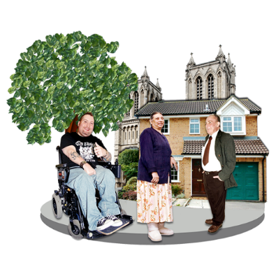 | This fund will give money to Health and Social Care Partnerships (HSCPs) to use to help to provide good housing options for the people who need it.
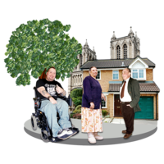 | This should help people to stay in their local communities or move back if they have had to move away to find housing that meets their needs.
Number 5
 | Public transport must be made more accessible to people with learning disabilities.
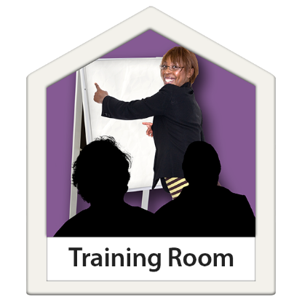 | This includes learning disability awareness training for staff of transport companies.
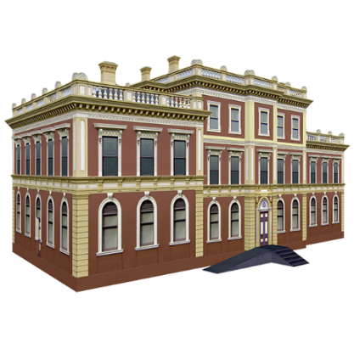 | This is a task for transport companies and local authorities.

Number 6
 | Housing providers and support organisations must make sure that people with learning disabilities know how to report a hate crime.
 | Staff that work for these organisations must know how to support anyone that reports a hate crime.
Number 7
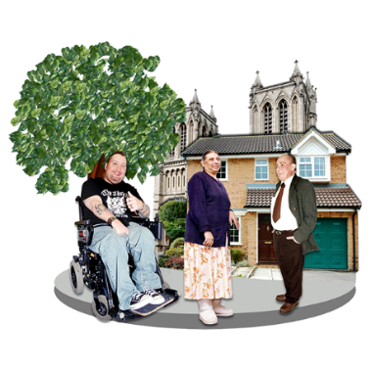 | Local authorities should invest in making communities more inclusive.
 | They should make more jobs for people to do this.
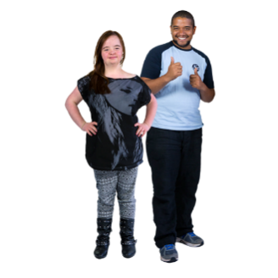 | Support workers should spend more of their time doing this.
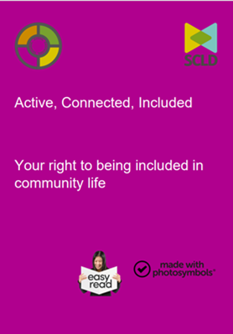 | There are resources to help with this like which you can find on the SCLD website by following this link Active, Connected and Included

