The fourth report from the How’s life? survey
My time, my choice
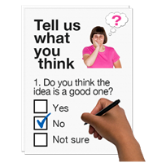 | In 2019, SCLD and partner organisations made the ‘How’s life?’ survey.
 | The survey asked people with learning disabilities how they felt about different parts of their lives.
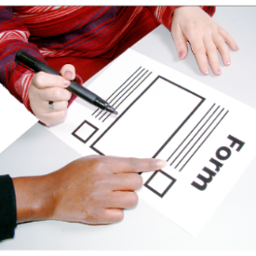 | The survey was designed to be completed by people with learning disabilities.
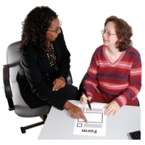 | They could have help from a family member or advocate or paid supporter if they wanted.
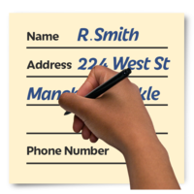 | 1232 responses were received.
 | We did this survey before Covid.
 | This report shows how people with learning disabilities spent their time before lockdown and other Covid restrictions
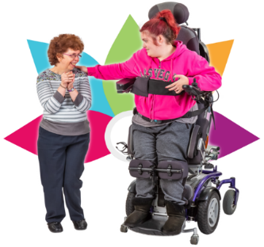 | How people spend their time is connected to how good their wellbeing is.
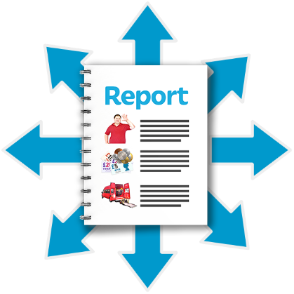 | This is a summary of what we found in the survey.

Here are things that people with learning disabilities did less than other people.
 | 75 out of every 100 people did paid work.
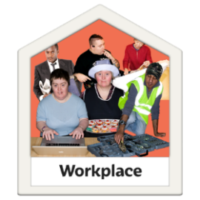 | Only 14 out of every 100 people with learning disabilities did any kind of paid work.
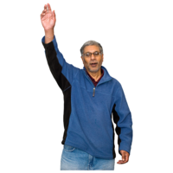 | 48 out of every 100 people volunteered
 | 38 out of every 100 people with learning disabilities volunteered.

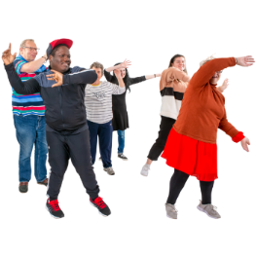 | 80 out of every 100 people did exercise in the last few weeks.
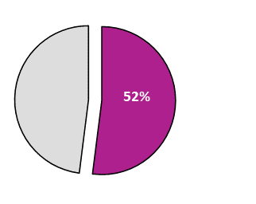  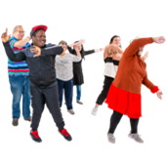 | 52 out of every 100 people with learning disabilities did exercise in the last few weeks.
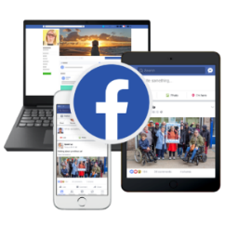 | 62 out of every 100 people used social media in the last few weeks.
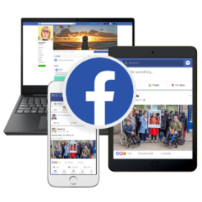 | 33 out of every 100 people with learning disabilities used social media in the last few weeks.
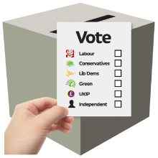 | 71 out of every 100 people voted in the last few years.
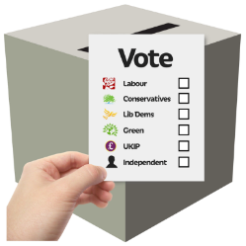 | 51 out of every 100 people with learning disabilities voted in the last few years

Here are things that people with learning disabilities did as often as other people
 | 17 out of every 100 people with learning disabilities had written to their MSP.
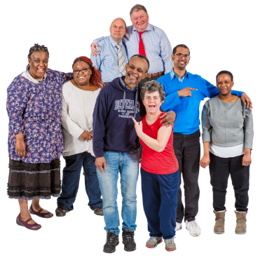 | Meeting friends was another thing that happened just as often.
 | Going to the pictures and going to concerts and going to the library happened just as often.

Here are the things that people with learning disabilities did more often than other people

 | 16 out of every 100 people had been to a public meeting.
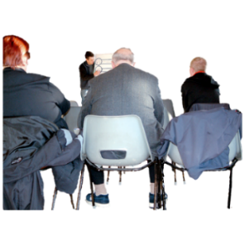 | 21 out of every 100 people with learning disabilities had been to a public meeting.
Here are other things that people with learning disabilities spent their time doing
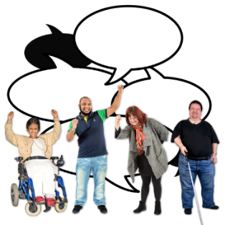  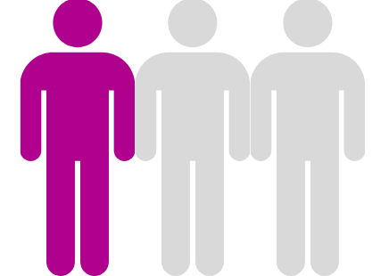 | 1 person in 3 had taken part in self-advocacy in the last year.
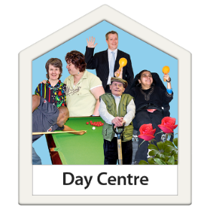 | 1 person in 3 went to a day centre.

How support helps people to make choices about their time.
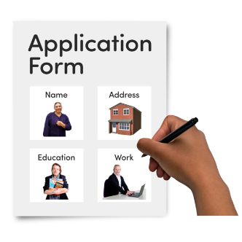 | People who did not need support were more likely to have a job
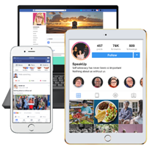 | People who did not need support use social media more than people that did need support
 | People that got the support they needed were less likely to vote.
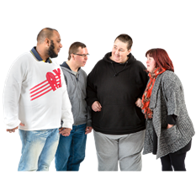 | People that got the support they needed were less likely to take part in self-advocacy than people that did not get the support they needed.
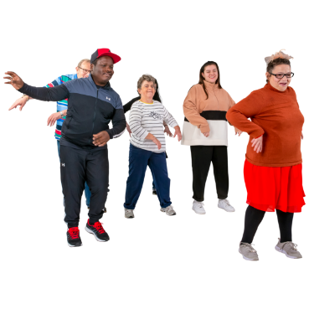 | People that got the support they needed were more likely to exercise than people that did not get the support they needed
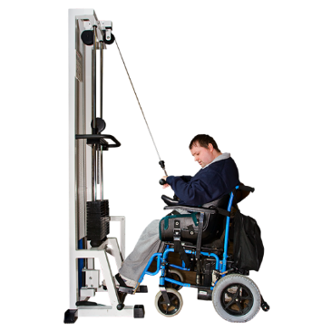 | People that got the support they needed were more likely to exercise than people that did not need support.
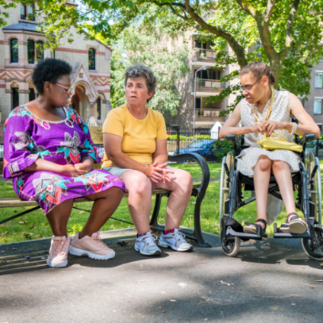 | People with complex needs found it hard to find things to do in their communities.

Things that should be discussed more.
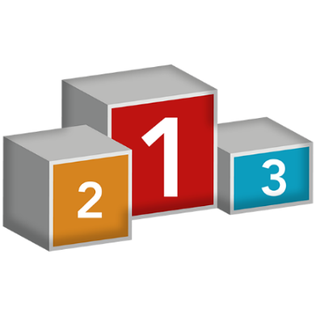 | SCLD thinks that what people said is very important.
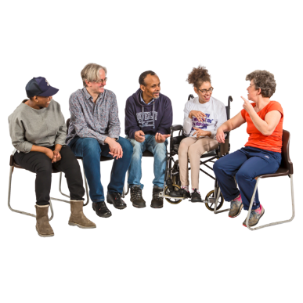 | There should be discussions about what these things mean.
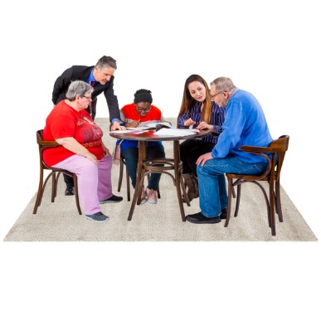 | There should be discussions about what to do next
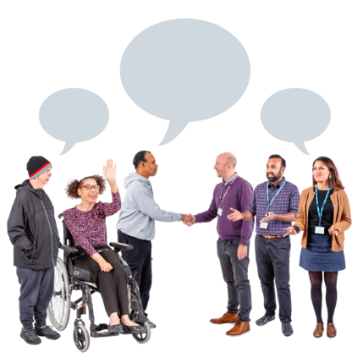 | People with learning disabilities and their families should be involved in these discussions as well as professionals.

SCLD thinks these questions should be discussed
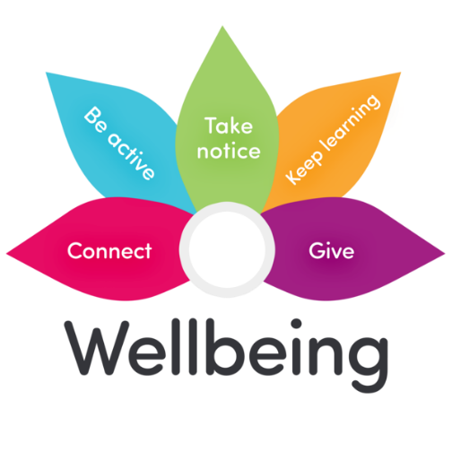 | How do we make sure that people with learning disabilities can choose to do more things that will improve their wellbeing?
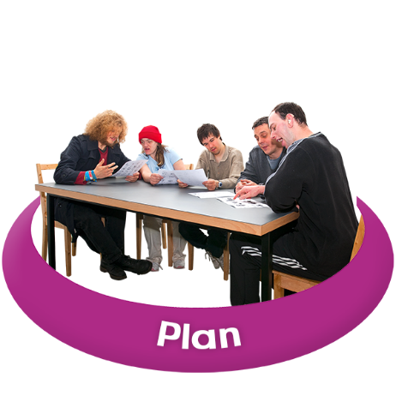 | What can be done to make sure that person-centred plans include how people want to spend their time?
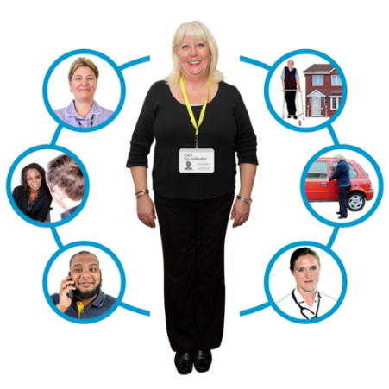 | How do we make sure that family members and support workers help people decide for themselves what they want to do?
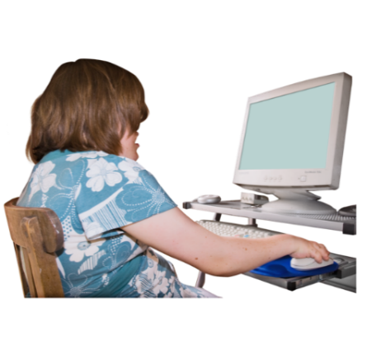 | How do we make sure that as many people as possible are able to use and enjoy technology?
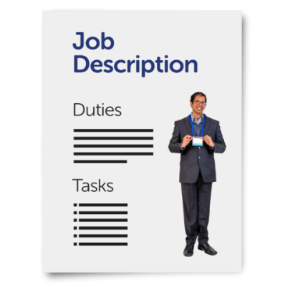 | How do we make sure that everyone with a learning disability that wants to work gets the support they need to find a job?
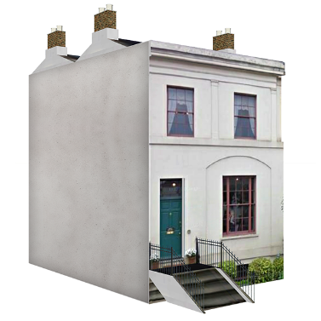 | How do we make sure that there are toilets and other basic facilities available in the community so that people with complex needs are able to get out of the house and do what they want to do?

