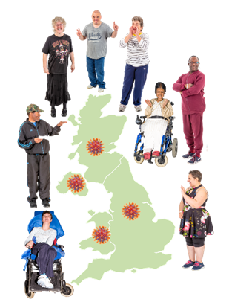
Coronavirus and People with Learning Disabilities - a study of the lives of people learning disabilities through the coronavirus pandemic
Do you want to take part in a research project?
We are university researchers. Researchers ask people questions to find out new information.
The Covid-19 pandemic has meant a lot of changes for everybody.

We want to ask people with learning disabilities about these changes.

Some adults with learning disabilities will not be able to talk to researchers. We want to speak to family members or care workers/paid support staff of these adults.

We want to talk to people three times over the next year to see if anything changes.

If you live in Scotland and you would like to find out more, please speak to Roseann Maguire. You can telephone or text on 0141 211 3902 or email at roseann.maguire@glasgow.ac.uk

www.covid19learningdisabilities.co.uk
CoronavirusLearningDisability | @coronavirusLD | @coronavirusLD | Covid-19 and learning disabilities survey

