SELF DIRECTED SUPPORT
SELF ASSESSMENT TOOLBOX
Guidance Notes

Progress in Personalisation
A self-assessment tool for support providers
Guidance Notes

Contents
Introduction | 2
Self-Assessment Process | 3
Self-Assessment Tool Guidance Notes | 9
Introduction | 10
The Main Dashboard | 10
Administration Toolbox | 11
Self-Assessment Form | 11
Reports | 13
Action Plans | 16

Introduction
The Scottish Government are determined that self-directed support should help individuals and their families gain more control over their lives and exercise real choices about the support they are given. Provider organisations are making changes in the way they support people in order both to comply with SDS legislation and to work in a more personalised way. This resource aims to help providers make that transition towards effective personalised support.
One way of measuring these positive changes is through self-assessment; this document sets out a framework for organisations to check their progress, measure what has been achieved in the development of self-directed support and what remains to be done.
This self-assessment tool was developed as part of a Scottish Government-funded programme called Changing Support Changing Lives. A group of people who use self-directed support, including a number of carers, played a vital role in its development, identifying the key outcomes that provider organisations should be achieving when individuals are effectively directing their own support. They also identified four areas of a provider organisation’s activity to which these outcomes apply:
- Dignity, Integrity and Accountability
- Flexibility, Creativity and Innovation
- Meaningful Choice and Control
- Working Together, Collaboration and Participation in the Community
It is hoped that support providers will see this tool as a way of helping them to improve continuously, and make small but significant differences to how self-directed support is progressing within their organisations.
It aims to offer a pragmatic and detailed template to measure progress and capture quality practice, in order to facilitate improved performance.
It has been piloted across a number of organisations, large and small, to make sure it is fairly easy to use actually helps to make a difference. It is intended to be a live document that can help shape how services move individuals and their families from passively receiving services to actively determining how those services are designed and delivered. It is also intended to assess how far providers have come in supporting the people who use their services to become active citizens with an enhanced and sustained quality of life.
This self-assessment framework has been developed by The Scottish Consortium for Learning Disability (SCLD), Heartfelt Limited and Integratis Consultancy Services. We hope it is a useful way of signposting where you are, where you want to be and your strategy for getting there.
It is the lived experience of the individuals who helped shape this resource that places them in a unique position to determine what exactly can make self-directed support a success and what matters most to individuals and their families. As one member of this group said:
“We need to make sure everybody gets this right. Not just fancy talk but really trying to hand over power and authority to individuals and their families”.
Self-Assessment Process
What is Self-Assessment?
Self-Assessment is simply a comprehensive, systematic, regular review of the progress of the organisation against recognised principles of excellence, carried out by people involved in the organisation, resulting in plans for improvement.

Self-Assessment is recognised worldwide as a key organisational and partnership tool and is the
“direction of travel” for local authorities and others involved in the delivery of public services. Self-Assessment establishes an agreed, comprehensive picture of the organisation’s current and future health. The simple goal is to reach consensus agreement on strengths and areas for improvement in relation to agreed excellence criteria. This is then used as the basis for creating and implementing plans for improvement. If more than one organisation is involved in providing the services within a formal partnership, the Self-Assessment (and improvement planning) should be carried out jointly.

Effective Self-Assessment provides:

• Identification of the organisation’s strengths
• Identification of the organisation’s areas for improvement
• Effective measurement of the organisation’s progress
• A basis improvement in the way the organisation works

The process of carrying out Self-Assessment can also improve:

• Staff awareness of the organisation
• Staff ownership of improvements
• Values and habits of continuous improvement, synergy, trust and teamwork
• Understanding of what is required to improve the service
• Improvements in partnership relationships
“Self-Assessment is a key tool in the drive for continuous improvement. Continuous improvement is the challenge facing all organisations in the public or private sectors. Pressure on resources, increased expectations from customers and service users, technological advances and the increasing availability of comparative information mean that organisations are required to deliver more and better services to meet customer needs and maintain customer satisfaction.”

Continuous improvement requires a shift in culture and approach within organisations. Self-assessment can help deliver this because it creates new opportunities for involvement and ownership. It is also often less threatening for managers to identify and rectify organisational weaknesses themselves than have a third party to do it for them. This can shorten the time between recognising a problem or opportunity and acting on it.

The Assessment Process

- Engage Stakeholders

Involving key stakeholders at an early stage of the self-assessment process is critical to develop understanding, commitment and involvement, enabling participants to contribute, using the process as a learning opportunity. It should also facilitate the self-assessment becoming integrated into existing planning and review frameworks. This stage should include communication on:

- What the assessment is for.
- Who is involved and why.
- What is expected.
- Timescales.

- Plan The Assessment

Outcomes
What are the differences or changes that you are trying to make through our activities and services?

Indicators
What indicators will help you to determine whether you have made the difference that you hoped to make i.e. the Outcomes? What would the outcomes look like? There can be 3 types of Outcome Indicators:

individual indicators that help you to assess the progress of individuals you are working with
target or user group indicators that help you to measure the progress of the group of people you are working with.
whole community or population indicators that help you to measure things for the wider community or population.

Once you have set out the indicators which will help you determine to what extent you are achieving the outcomes, you need to consider the most effective methods to gather information relating to these indicators. Some indicators will be objective and will simply require you to gather numerical information. Some indicators will be softer and more subjective and may benefit from a more imaginative approach. This could involve questionnaires, surveys, interviews or other appropriate ways of gathering information.

Accountability and Timescales
Who is going to be responsible for gathering the information and over what time period? Careful consideration needs to be given at this stage, ensuring the appropriate resources are in place.

To help organisations measure progress under these themes, we have looked at how organisations may do things operationally and would suggest that the following departments measure individually, and then the organisation collectively, how self-directed support is being developed:
Finance and Administration
Human Resources, Staff Development and Training
Information and Communication
Management, Strategy and Organising Supports
Not every organisation or service provider may have all these departments or staff who have a designated training role for example. However, no matter the size of the organisation or service provider, if that organisation is involved in offering self-directed support packages, then it will need to examine how budgets are organised, how much say people have in choosing their own staff, how individuals are informed about self-directed support, how support is managed, planned and organised and how staff are trained to do their jobs properly.
Train the Participants

There may be aspects of the self-assessment process that require staff to be trained or developed in some way. This may create some time pressures in the short term however the more competent and comfortable staff are with the processes involved in Self-Assessment, the more successful the outcomes will be.

Conduct the Assessment
This is likely to take some time to complete, involving a range of stakeholders and a number of different activities.

Evidence
Before you start to analyse your evidence, think about what you need to know about the work you’ve done and the difference you hope you’ve made. You need to gather the key bits of information, decide who is going to analyse the information and set aside analysis time.

It’s important that in gathering evidence, the focus should be on evidencing of Outcomes, and not inputs and outputs. The Self-assessment is focused on looking at the difference your resources and services are making for service users.

Your evidence can come in a variety of forms and may include spreadsheets, reports and pictures. Even if one person has the main responsibility it is good to involve others in analysing information, including service users or volunteers (bearing in mind confidentiality). Getting other people involved:
- increases their ownership of the assessment process
- helps them to understand how you will use the evidence they provide or gather and why you need to collect it in the first place
- gives different perspectives
- increases understanding of what evidence needs to be collected

Analysing your Evidence
- When you analyse evidence, you do not just read it or look at it, you need to critically review what it tells you. To do this you need to be clear what you are looking for. So you need to sort and assess the information you have collected to check:
- what difference you made (your outcomes)
- whether these were planned or unintended outcomes
- what you did to deliver your outcomes
- which activities or processes were most effective or important
- whether things worked in the way you expected

Scoring your Evidence
When allocating a score, take into account both
- The quality of your organisation’s delivery (as far as you can ascertain it)
- The strength of evidence you have for this quality
When assessing the strength of the evidence please take into account how comprehensive the evidence is e.g. is it anecdotal or does it relate to everyone you support.
Also take into account whether the evidence relates to outcomes i.e. the difference your support makes to the lives of the people you support, or simply your organisational process or outputs. Evidence of good processes or outputs does not equate to good outcomes being achieved.

Here is a guide to scoring your organisation’s performance:
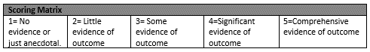

Sources of Evidence
There are many ways your service can produce evidence to demonstrate how well it is delivering a personalised service. Some sources of evidence e.g. staff manual, can show that policies and procedures support a personalised approach. However, on their own these sources of evidence are incomplete because they do not show that the policies have made a positive difference in the lives of those you support. Other sources of evidence that demonstrate outcomes are needed, for example a questionnaire completed by the individuals you support.
The following list gives examples of sources of evidence, both of service processes/outputs, and of outcomes. NB this list is not exhaustive or prescriptive.
- Service user questionnaire
- Support plans
- Updated support plans that show when outcomes are achieved
- Staff handbook
- Policies and procedures
- Accounting systems that show disaggregated budgets
- Annual conferences for people you support where they comment on their service
- Service user reviews
- External evaluations

- Agree Priorities for Improvement

What did you learn?
What is learning about?
- Practice - the way you work
- Products - the achievements, outputs and outcomes
- Policy - the legal context and wider issues affected
- Programme - the overall strategy or approach to an issue
- Knowledge - research or intelligence
- Culture - the values and behaviours that apply
- Process/system - the nuts and bolts of how things are done or administered
- People - how they feel, know or experience

Who is the learning useful to and why?
- Service users – will benefit from improved services
- Staff and volunteers – to plan their work
- Managers – to manage work and assess progress
- Sector - other organisations in your field can learn from your work
- Policy makers – your learning can feed into policy decisions
- Funders – to decide who to fund and how to invest
- Society - of interest or benefit to the wider public

You can use what you have learnt to:

- Identify and prioritise the areas where improvements and changes are required in order to become more effective at achieving the outcomes.
- get better at what you do – like improve services or motivate your staff
- involve and engage service users
- get more funding
- lobby for change – in government policy or local authority practice
- improve wider understanding of what works and why

- Develop an Action Plan

Having analysed the evidence that has been gathered, identified and prioritised the key issues and learning points, an action plan should be developed. The action plan should identify the improvements that are to be implemented, by whom and over what timescales.

- Monitor Progress

Ideally this activity should be integrated in to the existing planning and performance review framework within your organisation, ensuring alignment between strategy plans and performance and accountability.

SELF ASSESSMENT TOOLBOX - Guidance Notes
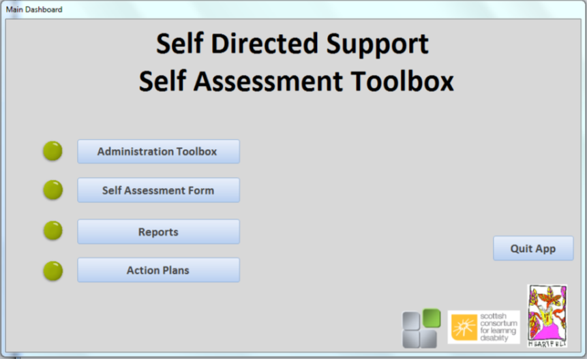

Introduction
The following guidance notes will give you a brief introduction to the Self-Assessment Toolbox, and guide you through the processes that will allow you to complete, record and report on your Assessments.
- The Main Dashboard
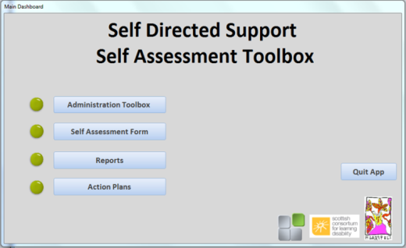
The Main Dashboard give’s you access to the following sections, by clicking on the relevant buttons:
- Administration Toolbox
- Self-Assessment Forms
- Reports
- Action Plans

- Administration Toolbox
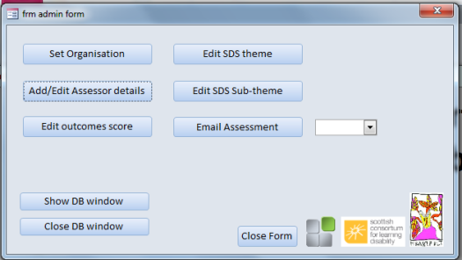
Access to the administration toolbox requires the entering of a password when prompted. This password is ”PASSWORD”

The Toolbox gives you access to 5 maintenance tables to enter/edit standard information within your toolbox:

- Organisation Details
- Assessor/User Details
- Outcome Scoring
- SDS Themes
- SDS Subthemes
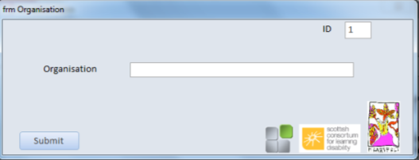
Enter your organisations name and click submit

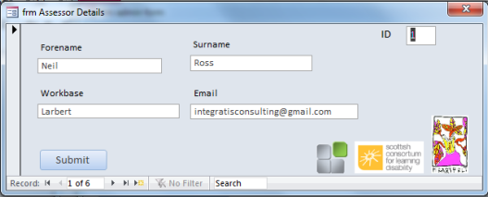
Enter your employees details here, including all employees who will be completing assessments and/or be responsible for action plan tasks. Click Submit when complete. Staff can be edited by using the record selectors at the bottom of the form.

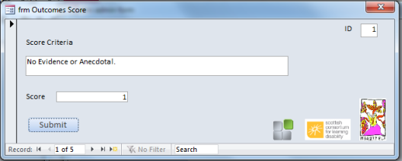
The three forms above can be used to change the different assessment parameters.

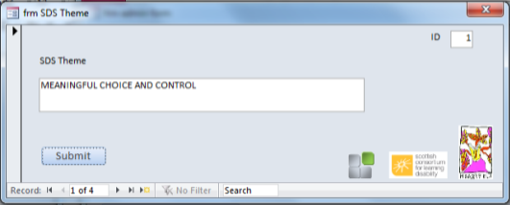

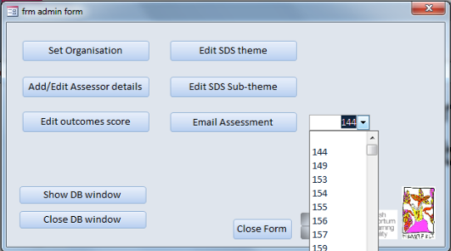
The email assessment button on the Admin Form can be used to email individual assessments. Select the appropriate assessment number from the drop down menu and click the Email Assessment button. This will open up an email dialogue box for you to enter the appropriate email address and send.
- Self-Assessment Form
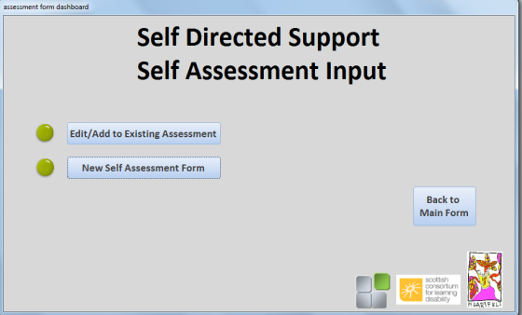
Click on New Self-Assessment Form button to open up new Self-Assessment

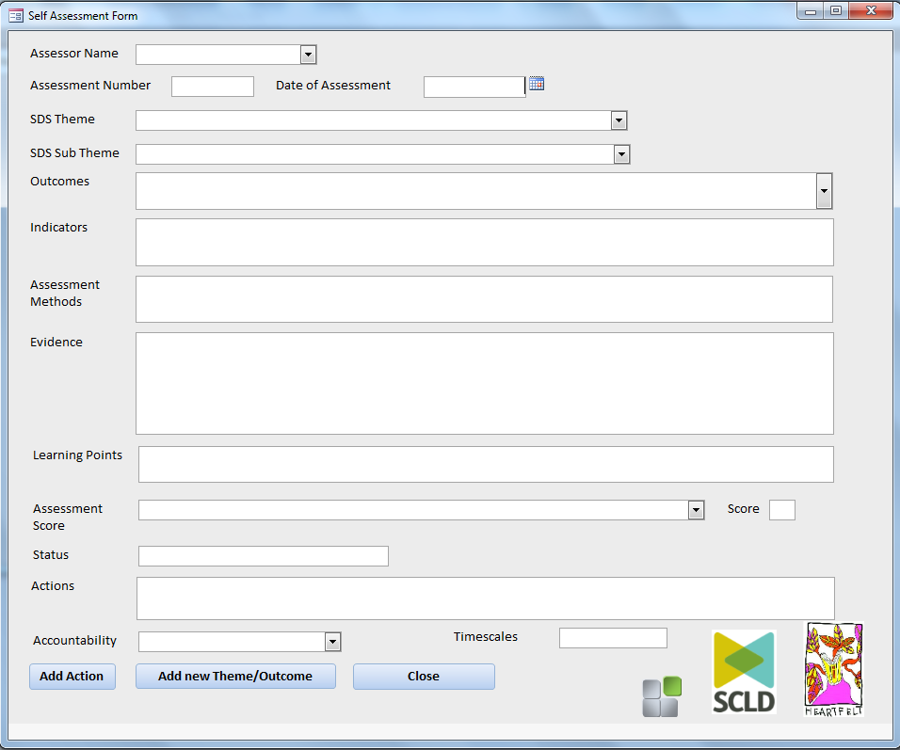
- Use the drop down boxes where supplied to generate the appropriate information. Once the Assessor Name has been selected the form will generate an Assessment Number. Note this for future reference.

- Completion of the SDS Theme and the SDS Sub Theme will generate the appropriate outcome selections.

- Selection of the appropriate Assessment Score text will generate a Score and Status.

- Any actions required following the assessment should be entered along with the person who has the accountability for that action and a timescale.

Add Action – Use this button to add an addition action to the assessment. This will generate a new sheet populated with your information, with the Action/Accountability/Timescales boxes blank. You will not be able to re-enter a score for this as you have already scored the assessment.

Add New Theme / Outcome – This will let you add new outcomes/themes to the same assessment number. You will be required to add a score for this

Close – Click here to save your record and close the form

Edit / Add to Existing Assessment

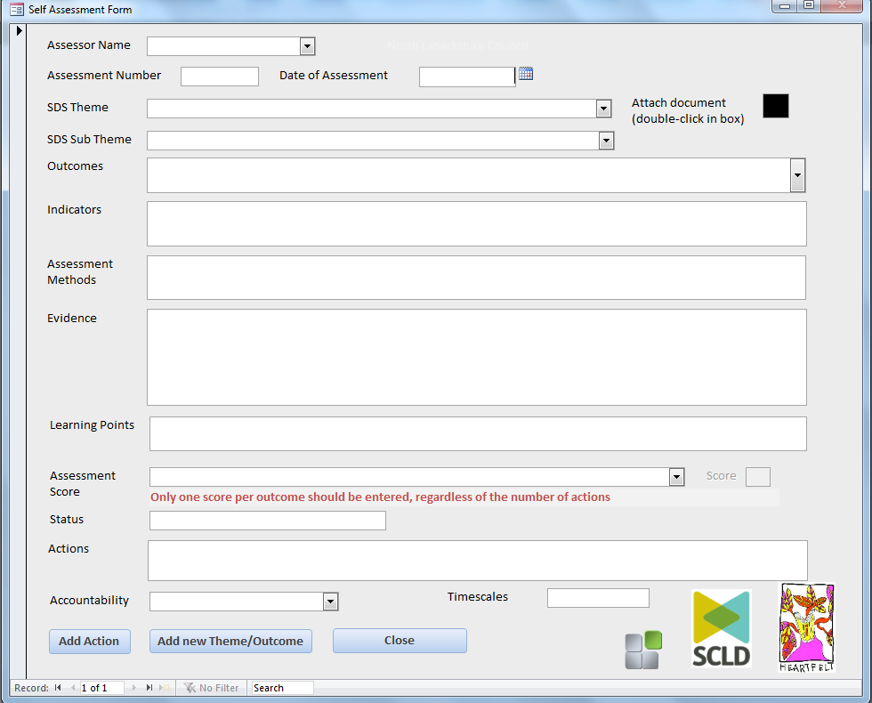
This form will allow you to make additions and edits to an existing Assessment. The form and buttons act in the same way as the previous form. When selecting this option from the Self-Assessment Form, you will be asked to enter the number of the assessment you wish to change. You can then scroll through the various outcomes and actions associated with that assessment

Attaching Documents
This form allows you to attach any relevant documentation to your assessment. Double click on the black box to enable the attachment dialogue box. It is important to only attach documents to record 1 of your assessment, this way they are easily recovered and added to. You’ll find this information in the bottom left hand corner of the form, and you can scroll through the record selector to get back to 1 if required.
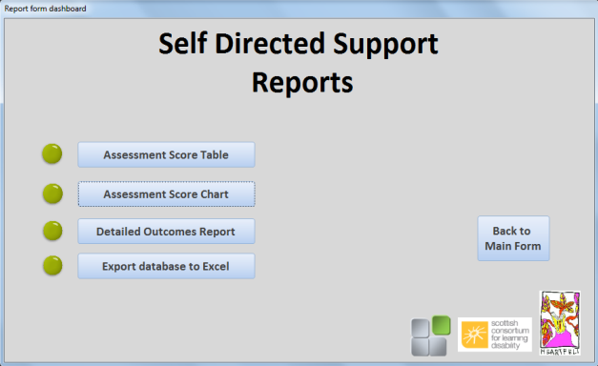
- Reports

Assessment Score Table
This table gives you average scores for each Theme and each Sub Theme, along with specific details relating to the performance of each Sub Theme within the various Themes. You can double click your mouse in each Theme category to resize each Column. Click on the Email Pivot Report button to email the report in excel format
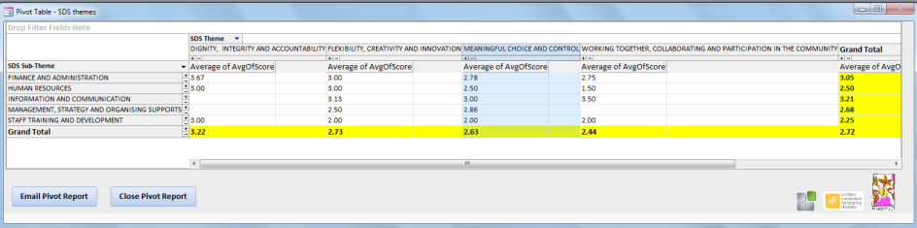

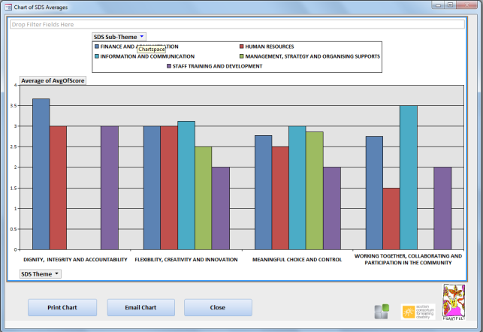
Assessment Score Chart
This chart graphically reports the performance of each Sub Theme within the Themes. There are options available to email or print your chart.

Detailed Outcomes Report
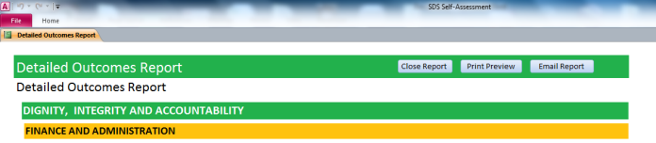
This report will feedback the scores, indicators and, evidence. Clicking on the print preview button will bring up a preview of the printable version of the report and allow you to print. You must minimise the screen then maximise again by clicking on the Microsoft Access icon on your desktop toolbar twice to gain full functionality. Click on the Print Preview tab, then the Close Print Preview button to return to the report screen
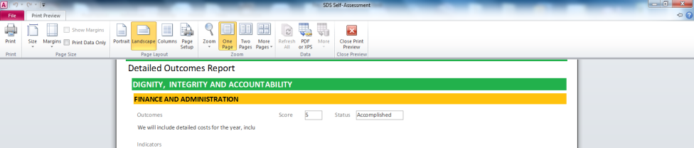

Export Database to Excel
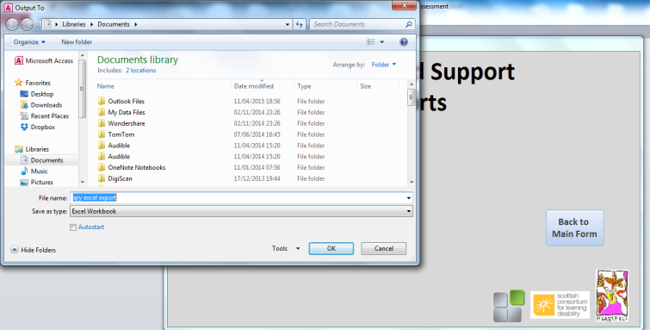
Clicking the export button on the Reports Form to export sections of the database to allow you to make a number of comparisons between assessments. Select the file name and location you want to save to and click ok.

This will open the excel file as shown below:
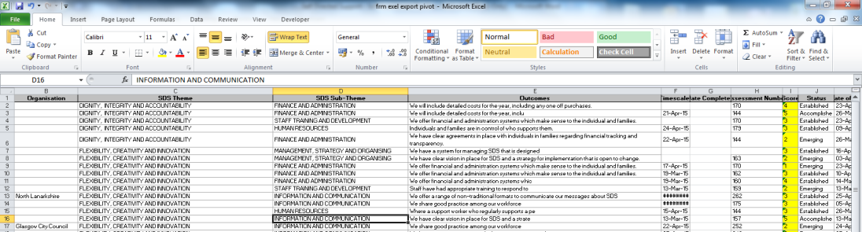
The Assessment Score (highlighted yellow) are currently in text format. To get these into number format select all values in the column and then click the warning symbol indicated by arrow 1, followed by the convert to number option at arrow 2. Then save the file to your desired location.

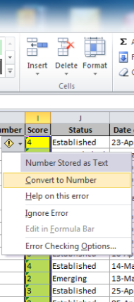
2
1

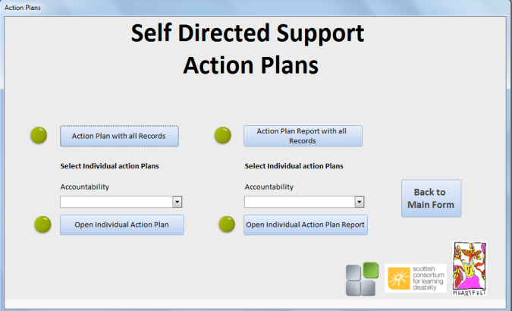
- Action Plans
The Action Plan form allows you to view and edit action plans, and full action plan reports.

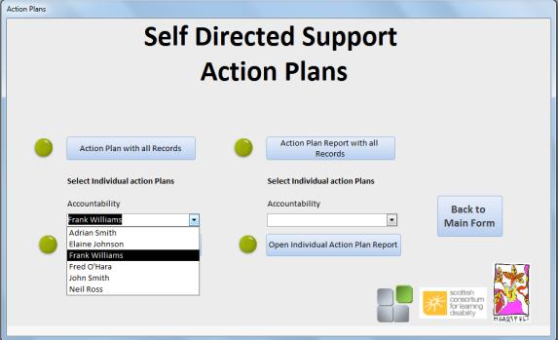
Both of the top buttons will report on all records for the action plan and action plan report. You can view the plans and reports of individual staff members by selecting them from the accountability drop down list and then clicking the corresponding button below.

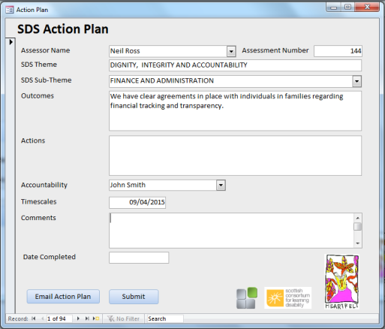
Action Plan
The action plan will allow you only to enter details in the comments and date completed sections. You can email the action plan directly from this form

Action Plan Report
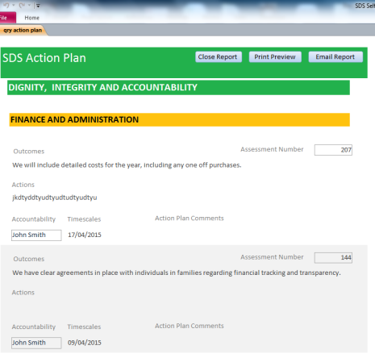
The report form gives a printout of either the full or an Individuals Action Plan. Clicking on the print preview button will bring up a preview of the printable version of the report and allow you to print. You must minimise the screen then maximise again by clicking on the Microsoft Access icon on your desktop toolbar twice to gain full functionality. Click on the Print Preview tab, then the Close Print Preview button to return to the report screen

Audit Scotland, Assess Yourself, Using Self-Assessment for Performance Improvement

